**STRENGTHENING CHARACTER EDUCATION**

**IN ADIWIYATA SCHOOLS**

### Tri Astuti1*, Eko Handoyo2, Pranichayudha Rohsulina3

1 Universitas Negeri Semarang, INDONESIA

Received 10 Desember 2022 ▪ Revised 15 Desember 2022 ▪ Accepted 20 Desember 2022

**ABSTRACT**

The young generation's low concern for the environment and rampant anti-social behavior were reasons for implementing character education, especially in Adiwiyata schools. Strengthening character education in schools was very important. This study aimed to analyze the strengthening of character education at Adiwiyata schools, especially at Keturen 01 State Elementary School Tegal. The research method was qualitative, a type of case study. The subjects were students of class 4 Keturen 01 State Elementary School Tegal. Researchers collected data through in-depth interviews, observation, and documentation; he tested the validity of the data using technique and source triangulation. Data analysis included collecting data, sorting data, categorizing the data, and concluding. Based on research results, strengthening character education at Adiwiyata schools was developed based on the environment. Character education was carried out by implementing the dimensions of the Pancasila student profile. Teachers became facilitators in character education in schools, while students were trained and accustomed to thinking and behaving following Pancasila values and caring for the environment. These activities were carried out through learning activities and habituation activities at school. Based on this, the conclusion was that strengthening character education in schools had been going well. Students and teachers could overcome the obstacles.

**Keywords:** Adiwiyata School, Students, Character Education.

# INTRODUCTION

The thinking ability of Indonesian students can be illustrated from the results of the PISA 2015 test and evaluation [1]. The average score of achievement of Indonesian students for science is 403 which is ranked 62 out of 69 countries evaluated [2]. This shows that the performance of Indonesian students' thinking is still relatively low, as well as evidence that Indonesian students are still dominant in low levels, or more in their ability to memorize in science learning [3]. The questions contained in PISA very demanding reasoning and problem solving skills. One of the factors is the lack of training of students in working on questions that suggest reasoning and problem solving abilities [4]. Besides that, the characteristics of PISA questions also require students' analytical, evaluation and creative thinking skills [5].

Character education can be carried out in the school, family, and community environment. These components must synergize so that educational goals can run well. One of the characters that must be developed is the character of caring for the environment. It is because people's awareness of the environment is starting to fade. The younger generation does not maintain the environment properly. Environmental damage is an issue that must be resolved through awareness of caring for the environment through formal education. This effort is made to avoid environmental damage. The government must make laws that regulate environmental protection so that people obey and pay attention to the environment (Alotaibi et al., 2020). The law is binding and binding. Firm rules are usually effectively enforced in society. All elements of society must be involved because environmental damage is a common problem. The government can also make schools effective as a means of strengthening educational character, one of which is the character of caring for the environment.

Adiwiyata schools are a means of overcoming environmental damage and caring for the environment (Afriyeni, 2018). Keturen 01 State Elementary School is one of the Adiwiyata schools in Tegal that has developed environment-based learning. Adiwiyata is one of the programs of the Ministry of Environment. This program aims to encourage the creation of knowledge and awareness among school members in efforts to preserve the environment. The Keturen 01 State Elementary School teachers in Tegal teach students to protect and care for the environment through the school environment. In addition to students, teachers and all school members are also accustomed to having concern for the environment. Adiwiyata schools are developed based on the environment (Permana & Ulfatin, 2018). Students are accustomed to caring for the environment through various activities at school. They learn from the environment to understand the subject matter. Caring for the environment must be accustomed from elementary school age so that they become accustomed to it. This habit is strengthened by the teacher as a role model for students. They can learn the teacher's behavior.

In addition to the low awareness of caring for the environment, the issue of anti-social behavior by elementary school-aged children is also a reason for strengthening character education in schools. Anti-social behavior is behavior that deviates from social values and norms in society, for example, drinking, smoking at elementary school age, and having free sex. Deviant behavior can be influenced by friends and the surrounding environment (Sa'idah, Fajriyah & Cahyadi, 2019). Students hanging out with the wrong friends without adult supervision is a trigger factor for this deviant behavior. It is a problem that must be resolved immediately because it involves the future of the nation. If this problem is not immediately resolved, then it is likely that deviant habits among adolescents will occur. They become immoral people. It is very dangerous for maintaining the life of the nation and state.

In the Kurikulum Merdeka, character education is developed in the dimensions of the Pancasila student profile. School movers become pioneers in implementing these dimensions. Keturen 01 State Elementary School is also a school mover. School movers prioritize the evaluation process and results by realizing the Pancasila student profile (Hidayati et al., 2022). This school was early in implementing the dimensions of the Pancasila student profile through school activities. The school's activities include learning activities and extracurricular activities as well as habituation activities. The teacher carries out learning in the classroom as well as learning values originating from the dimensions of the Pancasila student profile. The dimensions of the Pancasila student profile were adapted to the material being studied in class at that time; not all dimensions were directly conveyed as a whole in learning activities. The teacher chooses the dimensions of the Pancasila student profile that are relevant to the material being studied at that time.

Character values must be instilled in students at Adiwiyata schools (Novianti & Mushafanah, 2019). These values are not only concerned with the environment but also other values originating from the dimensions of the Pancasila student profile, for example, having faith and piety to God Almighty, reasoning critically, being creative, working together, having global diversity, and being independent. These values are very important to be developed through school activities because they can become provisions for students in facing global challenges. These values are related to one another. Strengthening character education at Adiwiyata schools, especially at Keturen 01 State Elementary School Tegal has been carried out based on the environment and has been going well. Teachers also use innovative strategies in implementing character education in schools. This is very important to study and analyze so that it can be used as a model for other schools.

# MATERIAL AND METHODS

The research method is qualitative with a case study type. In qualitative research, the data obtained is in the form of words and sentences. The phenomenon studied is casuistic in nature because it is different from phenomena elsewhere. The research location is The reason for choosing the research location is because the school is one of the Adiwiyata schools as well as a school mover in Tegal which has implemented character education in the form of implementing the dimensions of the Pancasila student profile. Character education in this school is developed based on the environment. This elementary school is also a school mover and an Adiwiyata school in Tegal. The research subjects were 25 fourth-grade students of Keturen 01 State Elementary School Tegal. Grade 4 students are high-grade students who have implemented the Kurikulum Merdeka and environment-based character education. The main informants were grade 4 students while additional informants were teachers and school principals. The main information comes from students because they are subjects in this study. If the information is not enough, the researcher obtained it from additional informants. The data obtained complement each other. The focus of this research is on strengthening character education at Adiwiyata schools in Tegal. Character education is the cultivation of values originating from the dimensions of the Pancasila student profile.

Data collection techniques include in-depth interviews, observation, and documentation. The researcher conducted interviews with grade 4 students. The interviews were conducted at school. Researchers looked for students' free time. This is done so as not to interfere with their activities at school. Interviews were conducted during breaks and after school hours for students. Researchers also make observations or observations inside and outside the classroom. This is done to observe student activities at school. This observation requires a long time so that the data obtained is valid. Researchers made observations when students were carrying out learning in the classroom, class pickets, and other activities outside the classroom. The last data collection technique is documentation. The documents that the researchers used were school documents in the form of data on the number of students, student backgrounds, and teaching modules used by the teacher in learning. In the teaching module, the teacher makes a learning plan which includes the environmental-based dimensions of the Pancasila student profile. The teacher also uses various learning methods and media written in the teaching module. Researchers use these documents to match whether the learning design is in accordance with the implementation of learning.

Data validity uses source and method triangulation. In the source triangulation technique, the researcher cross-checks data from different sources. For example, the researcher gets data from student A, then the researcher cross-checks the truth with data from students B, C, D, and so on. Data obtained from one source is not immediately said to be valid, because the data may be subjective. In technical triangulation, the researcher cross-checked the data using observation, interview, and documentation techniques. The data obtained from indirect interviews can not be concluded directly but needs to be verified or checked for truth through observation techniques. During an interview, some students do not know the answers to the questions; others give good answers to all questions. They have the assumption that if they answer with good answers, they will also get marks in each subject. In fact, the interview is not related to their mark on the subject matter. Though this has nothing to do with their value. Based on this, the researcher really needs to do technical triangulation. Data obtained from interviews cannot be used as the only source of truth. Based on this, the researcher needs to check the data using observation and documentation techniques.

The data analysis technique consists of several stages, including the data collection stage, the data sorting stage, the data category stage, and the conclusion drawing stage. All these steps are carried out so that the data can be analyzed properly. The first step is to collect data. Data were collected by interview, observation, and documentation techniques. The research data are then selected according to the focus of the problem because the data obtained in the field is not in accordance with the research problem. The next step is to categorize the data so that the data can be interpreted. After the data is categorized, the next step is to conclude the research results. The conclusion of the research results is the answer to the research problem. This data can be said to be valid because it has passed a series of data validity and analysis.

# RESULTS AND DISCUSSION

Keturen 01 State Elementary School Tegal is an Adiwiyata school and also a school mover. The school is a model for other schools in implementing The Kurikulum Merdeka, especially character education. Character education in this curriculum is carried out by implementing the dimensions of the Pancasila student profile. Students are trained and accustomed to thinking and behaving in accordance with Pancasila values. In this school, strengthening character education is carried out based on the environment.

**Strengthening Pancasila Student Profiles at Adiwiyata Schools**

Based on the observation results, Keturen 01 State Elementary School is an Adiwiyata school and one of the school movers in Tegal. In 2021, the school has adopted The Kurikulum Merdeka for grades one and four. In this research, grade 4 was studied. This was because grade 4 was the high grade at the elementary school which had developed the dimensions of the Pancasila student profile well.

Learning in the classroom relates to the student profile of Pancasila. Learning always prioritizes student character values. This school uses the living environment as learning material and this school is also a school that applies a new paradigm of learning, namely by implementing technology in learning. The implementation is learning using laptops, projectors, and so on. The following is an implementation of the dimensions of the Pancasila student profile at Keturen 01 State Elementary School Tegal.

**Faith, Piety to God Almighty, and noble character**

Learning at Keturen 01 State Elementary School Tegal is carried out not only in the classroom, but the teacher varies learning outside the classroom. The teacher invites students to study in the school garden, in the library, or in other open places. This is done so that students do not get bored. In learning, the dimensions of the Pancasila student profile are developed by the teacher. Students are accustomed to practicing it in everyday life. One dimension of the Pancasila student profile that can be applied through learning is Faith, piety to God Almighty, and noble character. The following is an example of implementing the dimensions of faith and piety to God Almighty in learning.

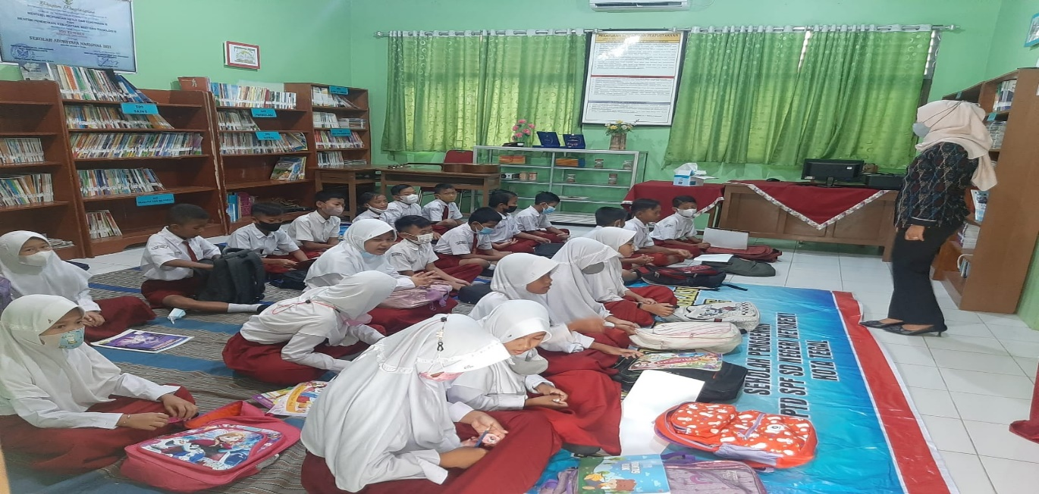

Figure 1. The teacher leads the class to start learning by praying

Figure 1 shows the teacher doing habituation before learning, namely praying together. It is a good habit for a religious person. According to Errohmah & Wahyudi (2021), praying can become a culture in schools. This process should run continuously; the continuous process makes students accustomed. Figure 1 shows the teacher and students participating Natural and Social Sciences learning process. Students are introduced to God through various subjects, for example, in learning Natural and Social Sciences. In this lesson, there is material about the earth and its inhabitants. Earth is one of the signs that God exists. God is the One who created the earth and everything in it. Humans, as God's creatures, must take care of the earth, in this case, the surrounding environment. The environment needs to be maintained, cared for, and preserved in order to be comfortable for human habitation. Students strive to be able to understand the concept.

Schools can also develop this dimension through religious education learning. This learning has a broad scope. The scope of the lesson is given in stages according to the class level of the students at school. This learning is given to students with the method. Elementary students are in a period of developing thinking power toward concrete, rational and objective thinking (Aziz et al., 2020). They learn the concept of God through concrete examples through objects that can be seen around them. Students are accustomed to understanding something with events or objects in the school environment.

Strengthening the dimensions of Faith, piety to God Almighty, and noble character at Keturen 01 State Elementary School Tegal is also carried out through habituation activities. Habituation is a process of forming behavior through activities that are repeated and carried out outside of class hours (Jasmana, 2021). Habituation activities in grade 4 are carried out before learning. The teacher allocates about 15 minutes to read short letters in the Al-Quran and makes it a habit to read prayers before and after learning. Grade 4 students are all Muslim, so religious-based habituation activities are not differentiated according to their religion and belief.

Teachers also get used to students giving infaq every Friday. Infaq is an activity of setting aside student allowances to be given to less fortunate people. The results of the infaq are distributed to their friends who need it. They are trained to share with other fellow humans. It reflects that students understand the teachings of religion and their beliefs and can apply this understanding in everyday life. Understanding the concept is not enough, it should be in real action.

**Global Diversity**

Global diversity is one dimension in the profile of Pancasila students. This dimension teaches students to have a spirit of nationalism and tolerance for others. One of the problems today is that they do not respect other people's cultures (Yasinta, Husniati & Affandi, 2022). Mocking each other's culture is a sensitive subject in schools. Students also do not know their own culture. Usually, local wisdom originating from rural area cannot be preserved by students. According to Shufa (2018), local wisdom must be learned at school. Students should know the local culture through various activities. Students who belong to this extracurricular should be able to understand the local culture and preserve it so that it is not eroded by the times. They should be able to keep up with the times and stick to their national identity. The purpose of this profile dimension is for Indonesian students to maintain their noble culture, locality, and identity, and remain open-minded in interacting with different cultures students, so as to foster a sense of mutual respect and the possibility of forming a noble culture that is positive and does not conflict with the nation's noble culture. Interaction with outside cultures is the key to success in socialization in the modern era.

Keturen 01 State Elementary School Tegal develops a global dimension of diversity through extracurricular activities. This activity is in the form of dance and macapat arts. Students are introduced to local wisdom so they can preserve it. Macapat song is one of Indonesian traditional arts which must be maintained by the younger generation (Daryanto, 2018). Students are directed by the teacher to take part in this extracurricular activity in order to understand the culture of ancestral heritage. Students taking part in this activity are trained by practitioners who are specially brought to school. The principal brings in teachers from outside the school to train students. The teacher is a humanist in Tegal. In carrying out this extracurricular activities, at first, students found it difficult because they were not used to learning culture. The humanist uses an innovative strategy to attract students' attention. Students are also asked to sing the song or macapat song and understand the meaning of the song. Macapat songs can be used as entertainment as well as education in a social context. The macapat songs that students learn are those with environmental themes. Through this song, there is an implied call to preserve the environment. It is in accordance with the vision and mission of Adiwiyata School.

Studying local culture can foster a spirit of nationalism in a person. They understand the importance of culture. Culture must be preserved and appreciated by all groups because it is a wealth that belongs to the nation. The global diversity dimension at Keturen 01 State Elementary School is also developed through ceremonial activities every Monday.

**Cooperative Dimension**

Cooperation is carried out by several people in order to achieve a common goal (Mulyani, Ghufron & Kasiyun, 2020). The dimension of mutual cooperation at Keturen 01 State Elementary School Tegal can be seen from the habits of students when they picket classes together. Every day students clean the classroom in turn according to schedule. Students divide the task of cleaning the classroom; there are those who sweep, clean the teacher's desk, clean the window glass, and clean other classroom facilities. It trains students to be able to care for the environment together. Cleanliness of the classroom and school environment is a shared responsibility. The teacher supervises the implementation of class pickets so that they can carry them out properly and seriously. The following is a picture of students working together to clean the classroom.

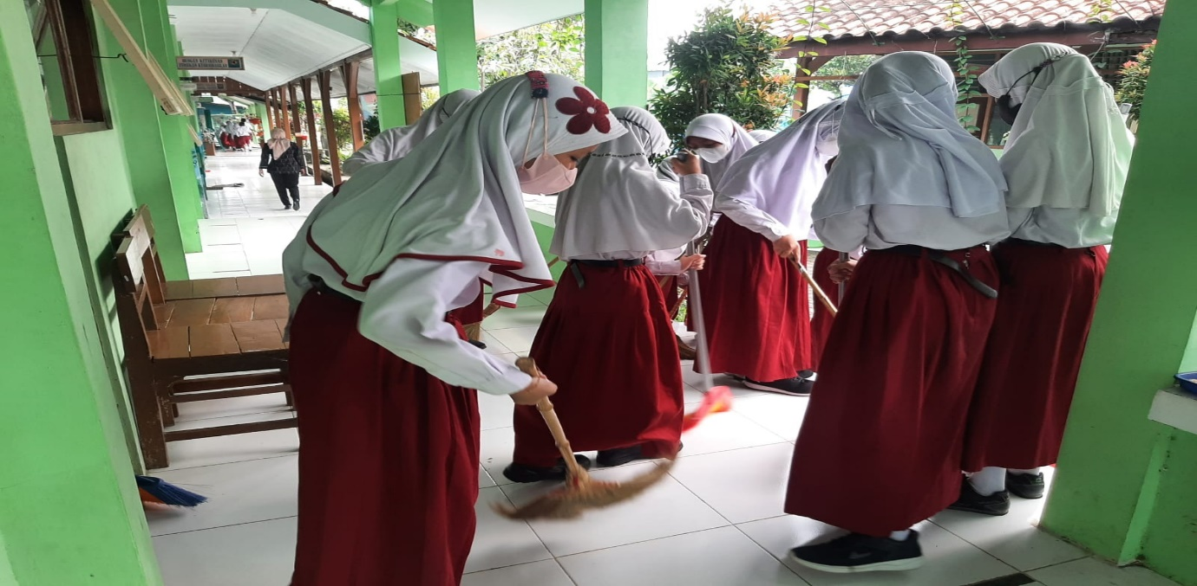

Figure 2. Students doing class pickets

Figure 2 shows grade 4 students carrying out the class picket. The teacher supervises the picket implementation. In addition to supervising, the teacher also helps students clean the classroom. The supervision carried out by the teacher is intended so that students are not joking in carrying out class pickets. The teacher also ensures that they don't have disagreements over the division of tasks to clean the classroom. Keturen 01 State Elementary School students are aware of caring for and keeping the environment clean. Attention to the environment can solve problems related to the environment (Bassi & Iseppi, 2019). Implementation of class pickets by students can make the environment clean and comfortable for learning. The habit of mutual cooperation is very beneficial for students. Through this habituation, students should have the habit of completing everything together. The end result of applying this dimension is that students can collaborate inside and outside the classroom. According to Sari (2020), students can collaborate by imitating the teacher's example. Students imitate their teachers in behaving and behaving at school.

In carrying out class pickets, students are also tasked with disposing of trash. Garbage that comes from the classroom is thrown into the trash can in front of each class. Plastic waste must be treated properly so that it does not pollute the environment (Rhein & Schmid, 2020). Students separate organic and organic waste so that it is easy to manage. Separation of waste is done to reduce odors and air pollution. Organic waste can be disposed of on vacant land so that it is easily decomposed on the ground. Organic waste, such as plastic is separated for recycling. Drink bottle waste can be used to make crafts and wall hangings.

In addition to these activities, students work together to fill water and provide nutrition for hydroponic vegetables grown in the school environment. This school is one of the Adiwiyata schools, so planting hydroponic vegetables is used as a school project. Nutrition for hydroponic vegetables is carried out in rotation between classes. Based on the results of interviews conducted with the homeroom teacher of grade 4, it was explained that Keturen 01 State Elementary School Tegal has a family medicinal plant garden. This garden is planted with traditional medicinal plants that are beneficial to life. These plants include ginger, turmeric, temu buffoonery, betel nut, and so on. The plant is efficacious for treating minor ailments, such as colds. It is very good for adding to students' insight about how to make a simple garden that is useful for growing plants useful for survival. The hope is that this garden can also inspire students to create their own gardens at home.

The availability of plants that can be used for medicine can familiarize students with the principles of natural use. They don't need to use chemicals as medicine. It can accustom students to a healthy life. School activities can train the younger generation to be healthier and more environmentally conscious (Proctor et al. Ini 2020). The environment can be managed and utilized for everyday life. In essence, everything that humans need has been provided by nature.

**Creative Dimension**

Creativity is one dimension of the Pancasila student profile. Students are expected to have a creative mindset. In instilling creative values in students, teachers must also use creative learning strategies. Character values are integrated into subjects, the learning process is carried out with active and fun learning principles (Rosita, 2018). Fun learning will create a comfortable learning atmosphere for students. Teachers can hold learning outside the classroom, for example in the school garden. This is done so that students can study while enjoying the beautiful school environment. The environment has been well cared for by all school members. Environmental awareness has an influence on the quality of the surrounding environment (Chen, Huang & Lin, 2019). Students at Keturen 01 State Elementary School Tegal have a high concern for the environment so that the school environment can be well maintained. Students and teachers are very creative in managing the surrounding environment. The development of student creativity is very important because elementary school-age children have a high curiosity. The teacher acts as a facilitator so that their abilities are well-honed. In learning, the teacher associates material with involving the environment (Pelita & Widodo, 2020). Teachers at Keturen 01 State Elementary School also use the natural environment as learning objects, for example in arts and crafts subjects. The following is an example of implementing the creative dimension in schools, especially in arts and crafts subjects.

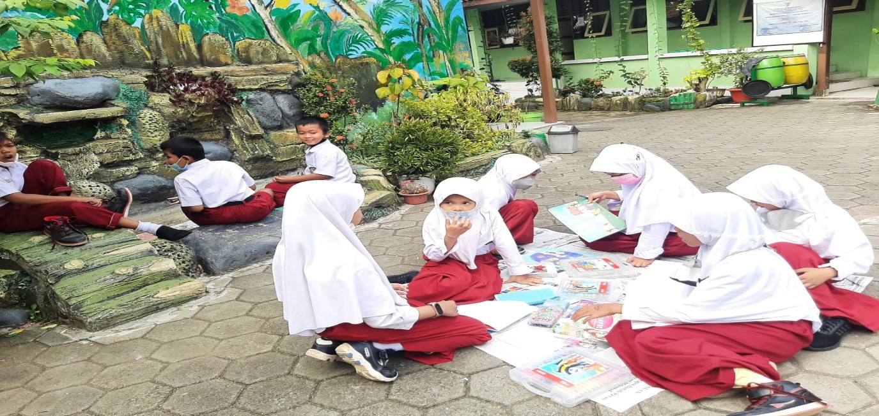

Figure 3. Students carrying out learning Arts and Crafts in the environment around the school

Figure 3 explains that schools develop creative dimensions through learning Arts and Crafts. Students are trained to be creative through drawing activities outside the classroom. They were directed by the teacher to draw in the school environment with objects around the school. Students are asked to look for image objects to increase creativity. Drawing objects, for example, draw a school garden, a trash can in front of the classroom, and a clean schoolyard. The main element of the creative dimension is creating original ideas and making original works and actions. Original work is part of the creative thinking of students. They can produce works that are different from each other, according to their respective ideas. According to Juliani & Bastian (2021), creativity is a character that teachers must develop at school. Teachers can develop this character in various ways, including in learning.

**Critical Reasoning Dimension**

Critical reasoning is a dimension that trains students' ability to think at a higher level in learning. Students are faced with certain problems, then asked to find solutions to these problems. Learning in this modern era must be carried out in an innovative way. Teachers must be able to invite students to think critically. Students not only understand the subject matter but should be able to provide analysis. According to Ismail et al. (2021), critical reasoning can be implemented by children in everyday life. Elementary-aged students need direction and assistance from the teacher to be able to reason critically, including in learning. Learning conducted at Keturen 01 State Elementary School Tegal is environment-based. It is intended that students can be closer to nature. One of the habits carried out by students before learning begins is reading a nature-themed storybook for 10 minutes. They gain knowledge about how to preserve the environment and keep the environment clean. Teachers can also provide questions and trigger statements about the environment to start learning. Someone who has high environmental knowledge has high environmental awareness (Munawar, Heryanti & Miarsyah, 2019). By reading nature-themed story books, students' knowledge increases. They can also explore knowledge through learning. The following is a picture of the teacher teaching in the classroom.

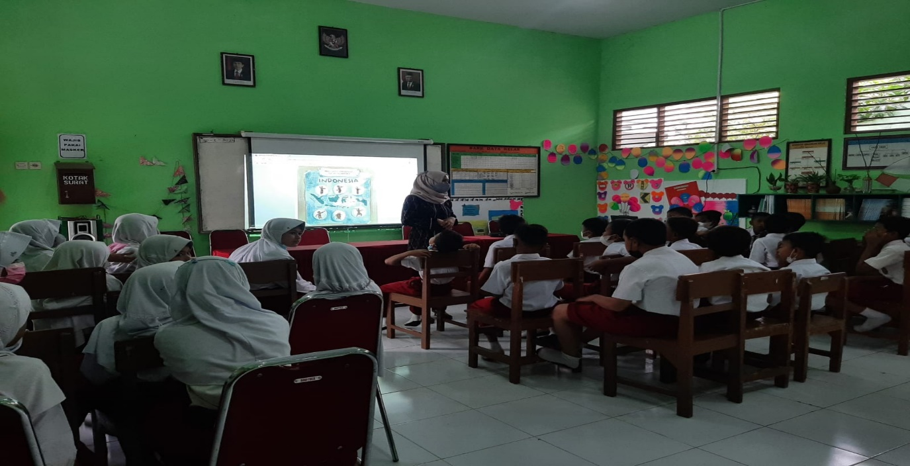

Figure 4. The learning process in the classroom

Figure 4 shows the teacher delivering material using innovative learning media. It is intended that students are interested in learning. The teacher gives questions to students to direct the material to be studied. The teacher does not directly convey the material, but students are asked to think in advance, about what the material learned is about. Students with critical reasoning can understand the material to be studied. Based on this, it can be concluded that students are encouraged to think at a higher level in learning.

**Independent Dimension**

Independence is an attitude that does not depend on other people, a person can stand on his own feet to achieve dreams and goals (Aprilianto & Arief, 2019). Independence in students needs to be accustomed from an early age. They should be able to do everything without depending on others. It is done to prepare them to be able to adapt to society. They will later become part of a society that has responsibility. Training students' independence at school can be done by giving them the opportunity to solve the problems they face with their own ideas. The following is the teacher's effort to train students to be independent.

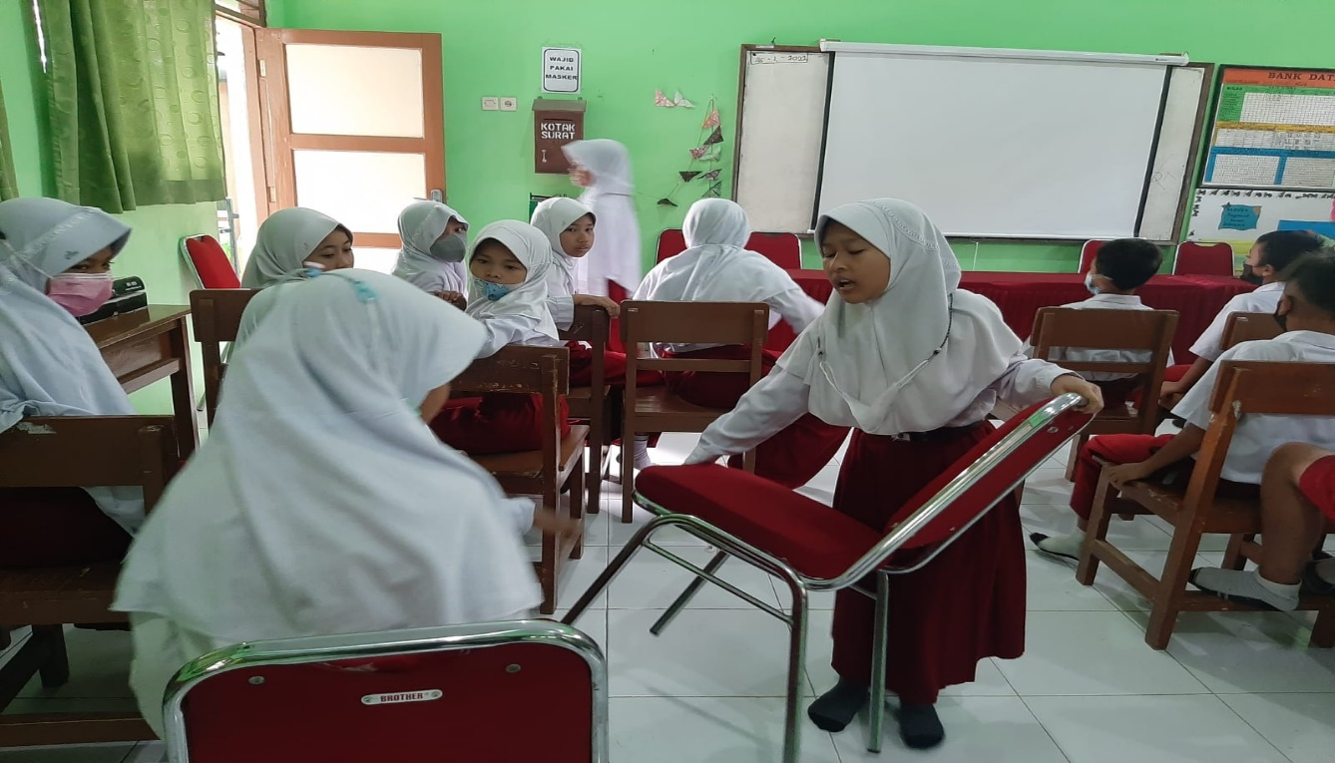

Figure 5. Students are tidying up their seats

Figure 5 shows female students being trained to be able to do the work themselves. Even though they are women, they should be able to do heavy work by themself. Students should tidy up the classroom before and after learning. Students are not distinguished between boys and girls; they get the same treatment. It is so those female students can also do the assignments or work of male students.

Another habit of being independent at Keturen 01 State Elementary School Tegal is that students submit assignments on time as a form of personal responsibility. The inculcation of independent character values is visible when students clean up messy classrooms before learning. Independent students are students who have responsibility for themselves and their environment. He wants to carry out his duties with full awareness without any pressure or coercion from anyone.

The implementation of character values based on the dimensions of the Pancasila student profile is inseparable from suggestions for school infrastructure and motivation from teachers. The facilities and infrastructure in this Elementary School are complete. The principal tries to provide what students need in order to strengthen character education in schools. The most important thing is the motivation of the teacher. Motivation from teachers can make students more enthusiastic about carrying out school activities.

# CONCLUSION

Strengthening character education at Adiwiyata schools, especially at Keturen 01 State Elementary School Tegal, is carried out based on the environment. The school is an Adiwiyata school and a School Mover, so strengthening character education refers to the dimensions of the Pancasila student profile. These dimensions are implemented well at school; some obstacles can be overcome by teachers and students supported by parents at home. The suggestions are that teachers should pay more attention to the students' characteristics in choosing character education models at school; teachers also have to be more able to manage the environment in an effort to be a model for students.

# REFERENCES

Afriyeni, Y. (2018). Pembentukan karakter anak untuk peduli lingkungan yang ada di sekolah adiwiyata mandiri SDN 6 Pekanbaru. *PAUD Lectura: Jurnal Pendidikan Anak Usia Dini*, *1*(2), 123-133.

Alotaibi, B. A., Kassem, H. S., Abdullah, A. Z., & Alyafrsi, M. A. (2020). Farmers’ awareness of agri-environmental legislation in Saudi Arabia. *Land use policy*, *99*, 104902.

Aprilianto, R. N., & Arief, A. (2019). Sekolah Adiwiyata Dalam Dimensi Karakter Dan Mutu Pendidikan. *TRIHAYU: Jurnal Pendidikan Ke-SD-an, 6 (1)*.

Aziz, A. A., Hidayatullah, A. S., Budiyanti, N., & Ruswandi, U. (2020). Pembelajaran Pendidikan Agama Islam (Pai) Di Sekolah Dasar. *Taklim: Jurnal Pendidikan Agama Islam*, *18*(2), 131-146.

Bassi, I., Gori, E., & Iseppi, L. (2019). Assessing environmental awareness towards protection of the Alps: a case study. *Land Use Policy*, *87*, 104028.

Chen, X., Huang, B., & Lin, C. T. (2019). Environmental awareness and environmental Kuznets curve. *Economic Modelling*, *77*, 2-11.

Daryanto, J. (2018). Penggunaan Media Pembelajaran Video Interaktif Untuk Meningkatkan Pemahaman Tembang Macapat Dalam Pembelajaran Bahasa Daerah Pada Siswa Sekolah Dasar. *Jurnal Pendidikan Dasar*, *6*(1).

Hidayati, N., Hidayati, D., Saputro, Z. H., & Lestari, T. (2022). Implementasi Pembelajaran Projek pada Sekolah Penggerak di Era Digital. *Journal of Education and Teaching (JET)*, *4*(1), 69-82.

Ismail, S., Suhana, S., & Zakiah, Q. Y. (2021). Analisis Kebijakan Penguatan Pendidikan Karakter dalam Mewujudkan Pelajar Pancasila di Sekolah. *Jurnal Manajemen Pendidikan Dan Ilmu Sosial*, *2*(1), 76-84.

Jasmana, J. (2021). Menanamkan Pendidikan Karakter Melalui Kegiatan Pembiasaan Di Sd Negeri 2 Tambakan Kecamatan Gubug Kabupaten Grobogan. *ELEMENTARY: Jurnal Inovasi Pendidikan Dasar*, *1*(4), 164-172.

Juliani, A. J., & Bastian, A. (2021, May). Pendidikan karakter sebagai upaya wujudkan Pelajar Pancasila. In *Prosiding Seminar Nasional Program Pascasarjana Universitas PGRI Palembang*.

Mulyani, D., Ghufron, S., & Kasiyun, S. (2020). Peningkatan Karakter Gotong Royong di Sekolah Dasar. *Lectura: Jurnal Pendidikan*, *11*(2), 225-238.

Munawar, S., Heryanti, E., & Miarsyah, M. (2019). Hubungan pengetahuan lingkungan hidup dengan kesadaran lingkungan pada siswa sekolah adiwiyata. *LENSA (Lentera Sains): Jurnal Pendidikan IPA*, *9*(1), 22-29.

Novianti, A., & Mushafanah, Q. (2019). Analisis nilai karakter pada siswa sekolah adiwiyata SD Negeri Pleburan 04 Semarang. *Elementary School: Jurnal Pendidikan dan Pembelajaran ke-SD-an*, *6*(2), 133-138.

Pelita, A. C., & Widodo, H. (2020). Evaluasi Program Sekolah Adiwiyata di Sekolah Dasar Muhammadiyah Bantul Kota. *Sekolah Dasar: Kajian Teori dan Praktik Pendidikan*, *29*(2), 145-157.

Permana, B. I., & Ulfatin, N. (2018). Budaya sekolah berwawasan lingkungan pada sekolah adiwiyata mandiri. *Ilmu Pendidikan: Jurnal Kajian Teori Dan Praktik Kependidikan*, *3*(1), 11-21.

Proctor, R., Guell, C., Wyatt, K., & Williams, A. J. (2020). What is the evidence base for integrating health and environmental approaches in the school context to nurture healthier and more environmentally aware young people? A systematic scoping review of global evidence. *Health & Place*, *64*, 102356.

Rhein, S., & Schmid, M. (2020). Consumers’ awareness of plastic packaging: More than just environmental concerns. *Resources, Conservation and Recycling*, *162*, 105063.

Rosita, L. (2018). Peran pendidikan berbasis karakter dalam pencapaian tujuan pembelajaran di sekolah. *JIPSI-Jurnal Ilmu Politik dan Komunikasi UNIKOM*, *8*.

Sa’idah, N. K., Fajriyah, K., & Cahyadi, F. (2019). Studi kasus perilaku menyimpang siswa di SD Negeri Gayamsari 01. *Indonesian Journal Of Educational Research and Review*, *2*(2), 117-124.

Yasinta, P., Husniati, H., & Affandi, L. H. (2022). Analisis Upaya Guru dalam Menanamkan Nilai Pendidikan Karakter Pada Siswa di SDN 1 Dopang Tahun Ajaran 2021/2022. *Jurnal Ilmiah Profesi Pendidikan*, *7*(2b), 680-685.

[**http://jurnalnasional.ump/index.php/dinamika**](http://jurnalnasional.ump/index.php/dinamika)