Integration of Self-diagnosis in Pascal Law Learning
Using STEM Approach

Siti Hannah Padliyyah1*, Irma Rahma Suwarma1, Agus Jauhari1
1 Universitas Pendidikan Indonesia, INDONESIA

Received 20th January 2020 ▪ Revised 17th Pebruary 2020 ▪ Accepted 24th September 2020

ABSTRACT
Indonesia is ranked 56th out of 65 participating countries in the Program for International Student Assessment (PISA) based on data 2015. According to PISA results, the average science score of Indonesian students is 403, where this number is categorized as low. This is because students are still in the process of understanding and have not yet fully recognized the location of their mistakes. Students can diagnose the location of their mistakes through self-diagnosis activities. Self-diagnosis activities require the active role of students during the learning process. One approach that can increase the active role of students is STEM (Science Technology Engineering Mathematics). However, research at this time is still rarely found self-diagnosis activities that are applied to the STEM approach. Therefore, this research has the aim to find out the increase in mastery of physical concepts and self-diagnosis of students on the STEM learning approach to the theory of poscal law class XI High School.This study uses a One-Group pretest-posttest design with a sample of 30 ini 11th grade highschool from one schools in Bandung. . Based on the findings, there is an increase in mastery of concepts [<g> = 0.51] from pre-test to post-test. In self-diagnosis activities identified that there are differences in scores [z = 1.75; p = 0.9599] student assessment results of researchers and self-scoring results. Deeper self-diagnosis triggers a series of implicit steps that encourage them to rearrange their cognition by correcting the mistakes they make when solving problems. So that learning activities using the STEM approach that involves self-diagnosis activities can improve students' mastery of concepts.
Keywords: Self-diagnosis, STEM, and Pascal Law

INTRODUCTION
Physics is a subject that consists of various concepts that can be felt in everyday life. Based on the standard content of Physics learning in schools at the high school level, Physics learning aims to develop reasoning ability in students' analytical thinking using Physics concepts and principles to explain events in daily life and solve problems both qualitatively and quantitatively [1]. So that learning objectives can be realized, it requires a good understanding of concepts and correct from students. According to the 2015 PISA results report, the average science score of Indonesian students is 403, where Indonesia ranks 56th out of 65 participating countries or in other words Indonesia ranks ninth in the bottom of all PISA participating countries [2]. The low education in Indonesia is the impact of the low mastery of students' concepts during the learning process.
Failure of students to master a concept can be because students are still in the process of understanding and students have not fully recognized the location of their mistakes. One of the activities that can be about the whole location of students' mistakes is the activity (self-diagnosis). Self-diagnosis is an activity where students diagnose the solution of a problem that has been solved independently. In this activity students determine the location of the errors of their own solutions. activities allow educators to know the extent of student mastery of a concept. Elementary activities contribute to learning activities by triggering a series of steps that encourage students to regulate their cognition and correct mistakes in an effort to master the concepts learned.
Self-diagnosis activities have stages that can help students to find solutions to existing problems. The stages of self-diagnosis among them are recognizing, acknowledging, understanding, and correcting existing problems that finally the students do self-scoring (giving value to their own solutions) so that students can master the concepts learned. Safadi [3] in his research found that self-diagnosis activities were effective in increasing students' mastery of concepts and learning achievement. Self-diagnosis activities require students to be directly involved and actively solve existing problems with systematic steps. This activity is more effective when compared to discussion activities on questions or assignments led by the teacher.
One learning approach that is suitable to be applied is the STEM (Science Technology Engineering Engineering Mathematics) approach. Student learning with the STEM approach is not only learning theory, but students are also involved in practice so that students experience the learning process directly [4]. The STEM learning approach can stimulate students to play an active role and have high curiosity. So, if students find irregularities or discrepancies between facts and theories they will do the stage of self-diagnosis. Therefore, this study aims to determine the increase in mastery of the concepts of physics and self-diagnosis of students using the STEM approach in high school class XI Pascal law material.

MATERIAL AND METHODS

Methods
The research to be conducted is quantitative research using several research instruments to measure the results obtained. The research method used was a quasi-experimental method with a one-group pretest-posttest design. The research design can be presented schematically as follows:
Table 1. One-group pretest-posttest design
Pretest | Treatment | Posttest
O₁ | X | O₂
In the design of this study students did a pretest before being given treatment and posttest after being given treatment. The treatment reported in this study was learning with the STEM Approach and self-diagnosis activities. in self-diagnosis activities, students conduct in-depth diagnoses and analyze their own pre-test answers. Analysis of students' problem solutions is done by matching their answers with the completion rubric in the self-diagnosis activity sheet. The design of this study is in accordance with the objectives of the study, which is to find out the improvement of students' mastery of concept after giving STEM approach that involves self-diagnosis activities. The sample of this study was 30 students of class XI one of the schools in Bandung.

Procedures
The procedure of this research starts from the pre-test, treatment, self-diagnosis, and post-test. Pretest activities are carried out to identify students' initial concept mastery. After the pre-test is conducted students will conduct self-diagnosis activities where students will diagnose their solutions to the problems that have been given. In self-diagnosis activities students will be redistributed their own pre-test answer sheets and self-diagnosis worksheets, then students will match their answers with the assessment rubric in the self-diagnosis work twins to score their own answers . This activity encourages students to diagnose their own mistakes which subsequently raises the self-explain and self-repair stages to themselves so students learn from mistakes. Furthermore, students will be given treatment in the form of STEM based learning. This STEM-based learning treatment takes place in 4 meetings and is carried out in small groups of 5-6 people in each group. Furthermore, students conduct posttest activities to identify students' mastery of concepts after giving treatment.

Instrument
The instruments used in this study were concept mastery tests and self-diagnosis worksheets. The concept mastery test in the form of a description of questions relating to the material of Pascal law is 5 questions. Post-test questions are isomorphic question, the concept questions, indicators question and the same way to solve them. Whereas the self-diagnosis worksheet contains steps for solving the questions. At the top of the self-diagnosis, the researcher notes the steps that the students must take when the self-diagnosis activity take. This can be seen in the following image:
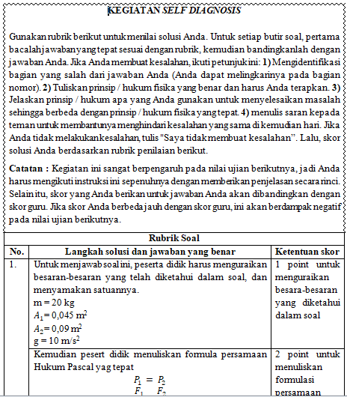
Figure 1. Self-diagnosis worksheet

Data Analysis
To find out the improvement in students' mastery of concepts, a gain score calculation is normalized from the first and final tests. Normalized gain scores <g> can be expressed in the following equation:
$$<g> =\frac{\left(M posttest score- M pretest score\right)}{\left(Ideal score- M pretest score\right)}$$
Interpretations of normalized gain values ​​are shown in the table:
Table 2. Interpretations of normalized gain values
<g> | Klasifikasi
<g> ≥ 0,7 | Tinggi
0,7> <g> ≥ 0,3 | Medium
<g> <0,3 | Rendah
To find out the difference in students 'scores from the researchers' assessment results and self-scoring results, a Mann-Whitney U statistical test was performed. This statistical test can be obtained through the equation:
$$Z=\frac{U-\frac{\left(n_{1}n_{2}\right)}{2}}{\sqrt{\frac{n_{1}n_{2}(n_{1}{+n}_{2}+1)}{12}}}$$
The results of the Z_{hitung} calculation are then compared with Z_{table}. If Z_{hit}> Z_{tabel} then H₀ is rejected, and if Z_{hit} <Z_{tabel} then H₀ is accepted.

RESULTS AND DISCUSSION
The improvement of students' mastery of concepts after the implementation of STEM learning which involves self-diagnosis activities can be determined through N-Gain data processing. The recapitulation results of students' pretest, posttest and N-Gain scores are presented in Table 4.2.
Table 3. Recapitulation of Student N-Gain Results in Mastery of Pascal Law Concepts
Tes | (χ_{min}) | (χ_{max}) | (χ_{rata-rata}) | (χ_{ideal}) | <g> | Interpretasi
Pretest | 20,00 | 64,44 | 43,11 | 100 | 0,51 | Medium
Posttest | 40,00 | 88,89 | 72,00 | 100 | 0,51 | Medium
Based on the results of the acquisition of N-Gain it can be stated that STEM-based learning by involving self-diagnosis activities in it can improve students' mastery of concepts in Pascal Law material with the acquisition of N-Gain by 0.51 with moderate interpretation.
This shows that STEM-based learning is effectively used to improve students' mastery of concepts. These results are relevant to the results of the study material, where the direct involvement of students in each learning activity helps students understand the material being studied. Where in this STEM based learning students not only involve mind-on activity but also involve hand-on activity. This activity causes students to play an active role in the learning process, so that various abilities that students have is evolve by trained and developing students such as creativity, communication, critical thinking, and student collaboration to facilitate students in understanding each material being studied.
Increased mastery of students' concepts can be observed based on the increase in value acquisition from pre-test to post-test both the results of self-scoring and the results of the assessment of researchers.
Graph 1. Increased student grades from pre-test to post-test

Based on the graph of increasing student scores above, revealed that student scores significantly increased from pre-test to post-test both on the value of the results of researchers and self-scoring results. For the score of the assessment results of researchers increased from pre-test (mean = 43.11) to post-test (average = 72.07). Meanwhile, based on the results of self-scoring, it increased from pre-test (mean = 36.89) to post-test (mean = 66.59). This increase in student scores informs that students' mastery of concepts has increased after treatment was given.
In self-diagnosis activities, students involve self-explain or explain themselves to the steps of the solution to the existing problem. In self-explain, students explain the part of the process of improving themselves with students recognizing, acknowledging, and solving the given problem. In this self-diagnosis activity can be seen from the student pre-test answer sheet.
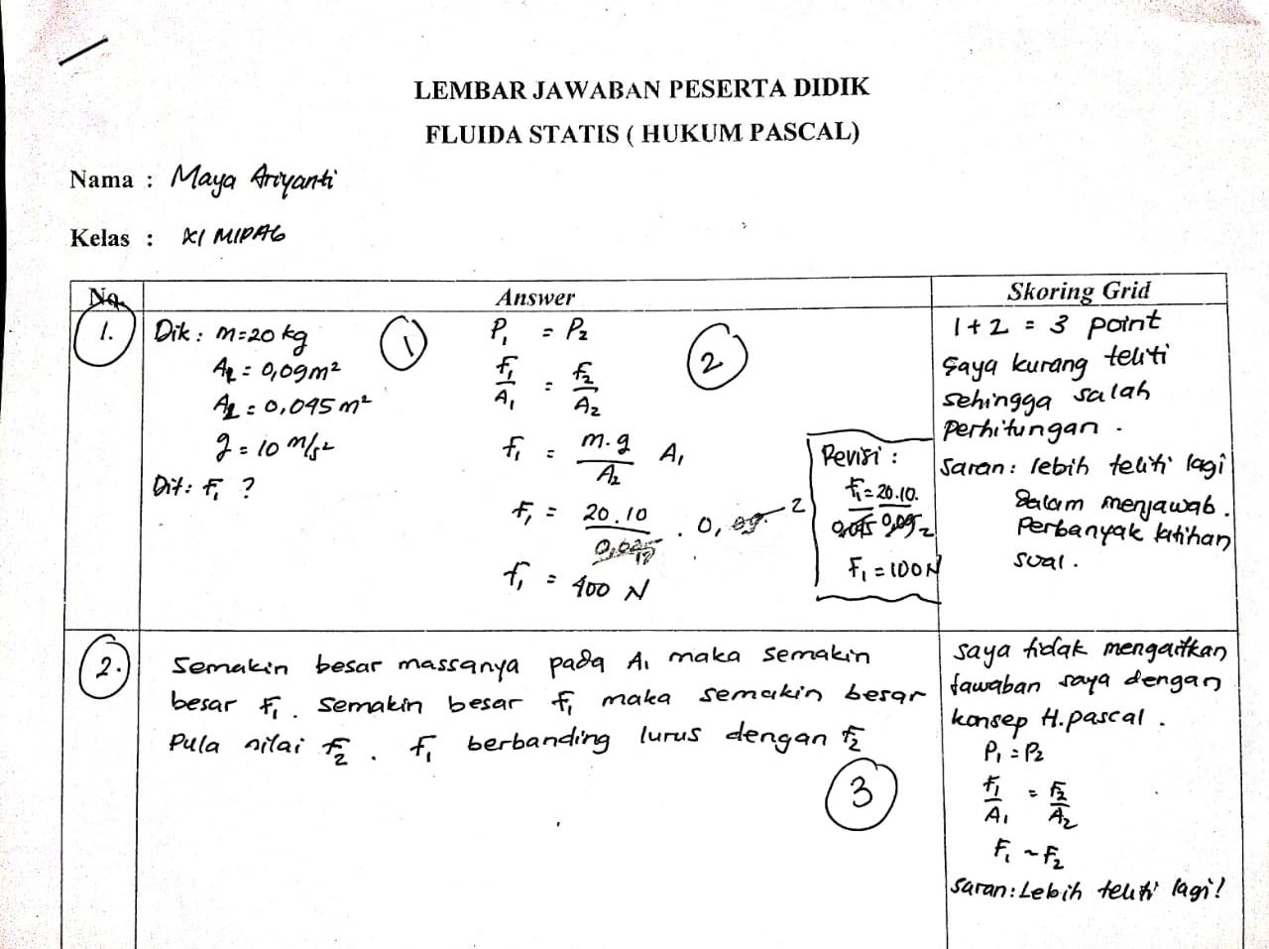
Figure 2. Examples of student answer sheets from self-diagnosis activities
One example of the student answer sheet above shows one of the students who has performed a stage of self-diagnosis activity. In the example case above the student named Maya on the pre-test answer sheet encircles number 1 because the answer is incorrect. The answer is not right because the wrong number entered to solve the problem. Maya's action encircles number 1, indicating that Maya successfully detected a mistake she had made. Then in writing Maya explained the reason for the answer was not quite right, showing that Maya admitted the mistake she had made. Furthermore, Maya wrote the answer should be to complete the answer that is not right, this indicates that Maya corrected the answer that was not right. Maya also wrote a suggestion that her friends do not make similar mistakes in the future.
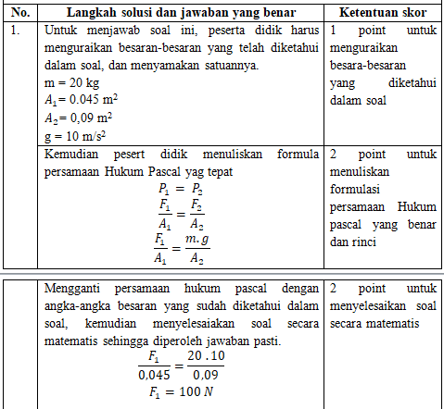
Figure 3. Evaluation rubric Number 1 in the self-diagnosis worksheet
The maximum score on question number 1 is 5 points, on number 1 Maya gives 3 points on the answer. This is because in the rubric guide students answer questions that describe the quantities that have been known to the problem will be given 1 point, and students who write the Pascal law equation formula correctly get 2 points, Maya did it. Maya lost 2 points due to incorrect identification of the amount contained in the problem resulting in an incorrect answer. So the score obtained by Maya for question number 1 is only 3 points.
One of the cases above can show that students can find, admit, and correct the mistakes they have made when answering the questions given. From this the students can analyze, diagnose, and score their own answers. Then make a series of improvements to the next test so that similar errors are not repeated.
However, based on the findings of the majority of students not following the instructions for self-diagnosis activities, students tend not to explicitly explain their answer sheets. The percentage of feasibility aspects of self-diagnosis observed from the student answer sheet can be seen on the graph
Graph 1. Percentage of workability aspects of self-diagnosis

Based on the graph above, the effectiveness of each aspect of self-diagnosis is different. This shows that all students involved did not carry out the self-diagnosis activity instructions completely or did not explicitly admit their mistakes. However, researchers suspect students implicitly explain the location of their mistakes to themselves which further involves self-improvement without expressing it in writing. One example of cases of students who do not explicitly carry out self-diagnosis activities is in Figure 4.8.
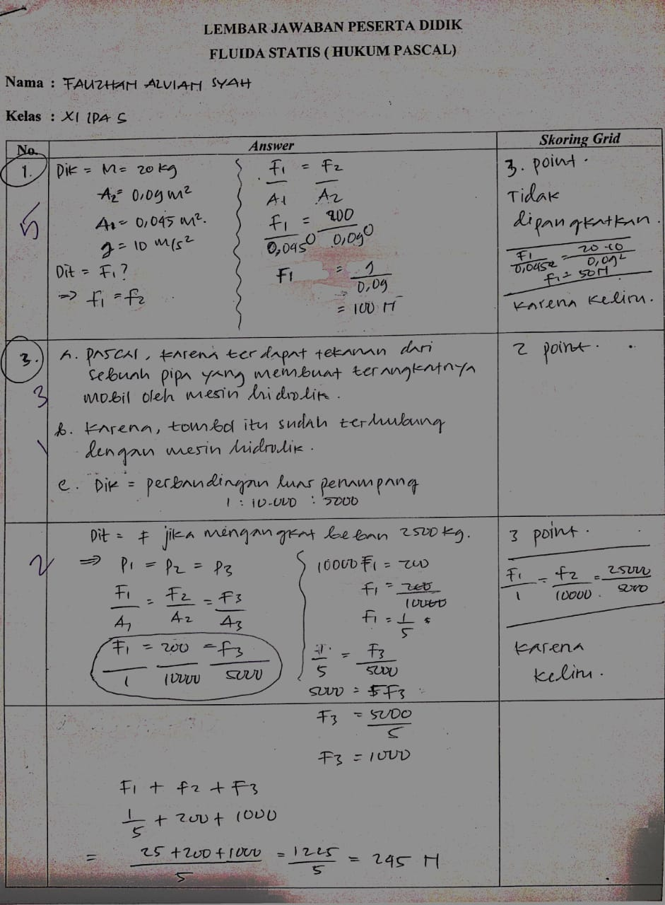
Figure 4. Student answer sheets the results of self-diagnosis activities
One student made a mistake at number 3, but he did not explicitly explain the location of the error in the answer. The student only gave a score of 3 for question number 3 and gave a reason that he did not understand the problem. This can occur due to several factors including:
- Students who do not read the instructions for self-diagnosis activities carefully that cause students to not understand the activities to be carried out.
- Student enthusiasm in learning is minimal resulting in a lack of student focus when studying.
- There is a factor of differences in intelligence and character between one student and other students even though they are in the same class.
- Psychological conditions of students and environmental conditions that can affect the results.
Self-diagnosis activities undertaken by students play an important role in the learning process, because students have detected enough of their mistakes to correct mistakes they make in the pre-test, without having to explicitly explain it. Students who detect their own mistakes trigger a series of implicit steps that encourage students to regulate themselves. Student performance in self-diagnosis activities also relates to their performance when solving isomorphic problems on post-test exams. The greater the error detection they make, the greater the chance of increasing their grades in the post-test.
The value of the results of self-scoring by students on the pre-test is more (average = 36.89; Sdev = 11.16) lower than the value given by the researcher (average = 43.11; Sdev = 11.91) . However, based on the Mann-Whitney U statistical test (Z = 1.75; p = 0.9599), it informs that there are differences in student scores from the researchers' assessment results and self-scoring results. Student scores of self-scoring results tend to be smaller than the scores of researchers' assessment results, this is not in accordance with the literature. Where Safadi (2019) in his journal revealed based on the results of his research students tend to overestimate their grades when doing self-scoring. But based on the findings in this study stated the opposite. This can occur due to several factors, such as students who do not understand self-diagnosis activities, students who are less thorough, minimal student motivation, learning environment factors surrounding students and other factors.

CONCLUSION

Based on the findings and discussion of the answers to the formulation of general problems, information is obtained that STEM-based learning that involves self-diagnosis activities in it can improve students' mastery of concepts in pascal legal material. The following are conclusions from the findings of this study:

STEM-based learning that involves self-diagnosis activities in it can improve students' mastery of concepts in pascal legal material with the result <g> of 0.51 being in the moderate interpretation.

Most students implicitly explain to themselves the mistakes in their solutions, this encourages students to make various improvements in themselves that affect the increase in students' mastery of the concept of pascal legal material.

There is a difference in student scores (Z = 1.75; p = 0.9599) from the researchers' assessment results and self-scoring results. With the results of self-scoring tend to be smaller than the results of the assessment of researchers.

REFERENCES

[1] Eva, W. (2018). Penerapan Model Pembelajaran Inkuiri Terbimbing untuk Meningkatkan Pemahaman Konsep Fisika Siswa SMA. Inovasi Pendidikan Fisika Vol.07. 2302-4496.
[2] OECD. (2016). Programme for International Student Assessment (PISA) Results from PISA 2015. Retrieved from: https://www.oecd.org/pisa/PISA-2015-Indonesia.pdf.
[3] Safadi, R., & Saadi, S. (2019). Learning from Self-Diagnosis Activities when Contrasting Students’ Own Solutions with Worked Examples: the Case of 10th Graders Studying Geometric Optics. Research in Science Education (1-24).
[4] Bybee, R. W. (2013). The case for STEM education: Challenges and opportunity. Arlington, VI: National Science Teachers Association (NSTA) Press.
[5] Hake, R. R. (1998). Interactive-engagement vs. traditional methods: a six-thousand-student survey of mechanics test data for introductory physics courses. American Journal of Physics, 66, 64–74.
[6] Lawshe, C.H. (1975). A Quantitative Approach to Content Validity.Personel Phsycology, Vol. 28, 563-575
[7] Safadi, R., & Yerushalmi, E. (2013). Students’ Self-Diagnosis Using Worked-Out Examples. Creative Education, 4, 205-216.
[8] Safadi, R., & Yerushalmi, E. (2014). Problem solving vs. troubleshooting tasks: The case of sixth-grade students studying simple electric circuits. International Journal of Science and Mathematics Education, 12(6), 1341– 1366.
[9] Safadi, R. (2018). Knowledge-integration processes and learning outcomes associated with a self-diagnosis activity: The case of 5th-graders studying simple fractions

