a
Burn wound
Burn injury
Antibiofilm
OR
AND
143
PubMed

Identification

EBSCO
Cambridge Core

Limitation :
Last 10 year
English

280
345

Title and abstract screening

45
Screening

5
Full text screening
16
Duplication

Eligibility

Included

Figure 1. PRISMA Flowchart for studies.

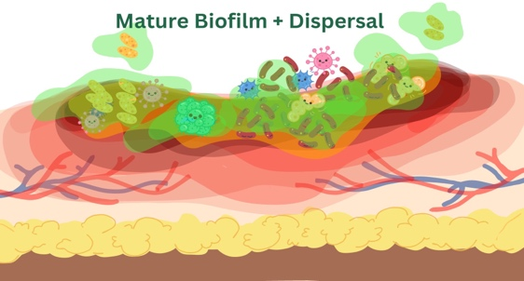
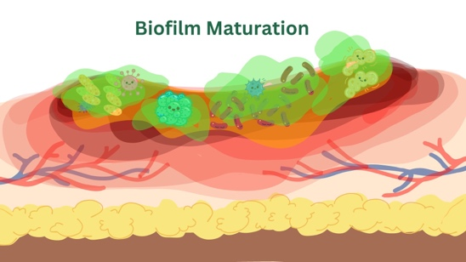
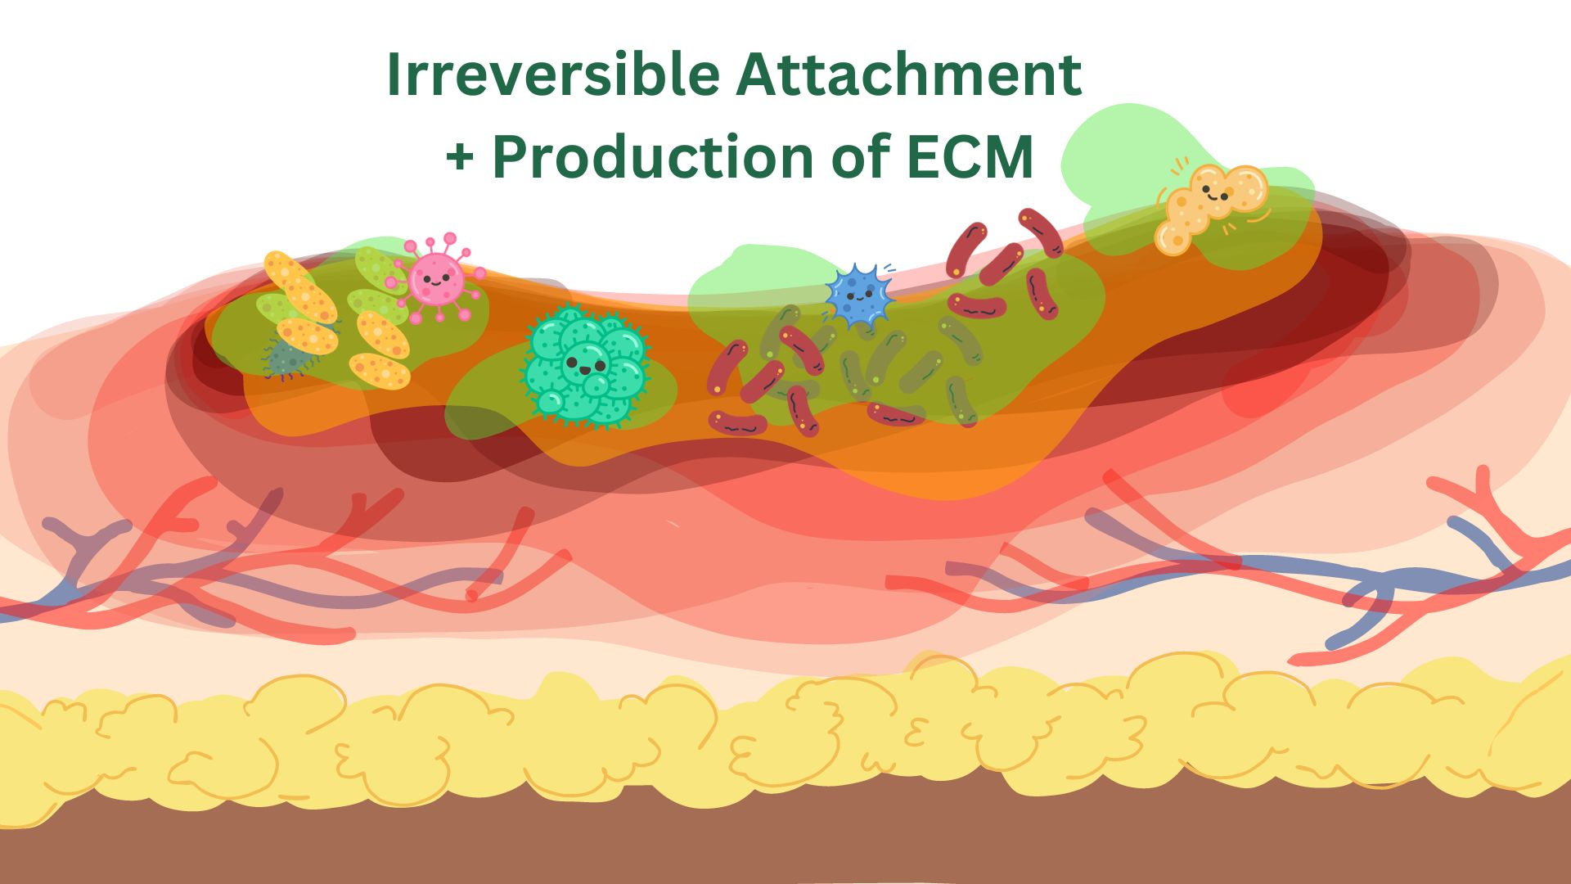
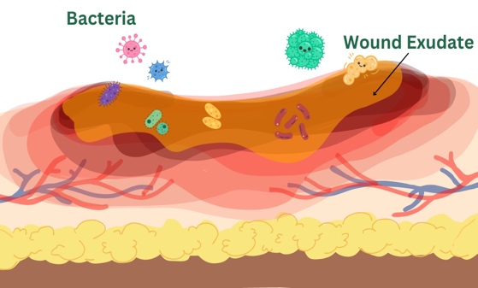
1
2
3
4

Figure 2. Biofilm formation (The image source was originally produced by the author)

