**Gambar**

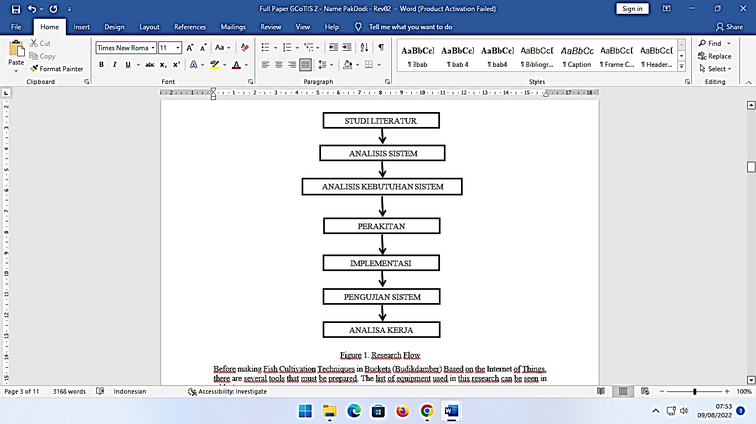

Gambar 1. Alur Penelitian

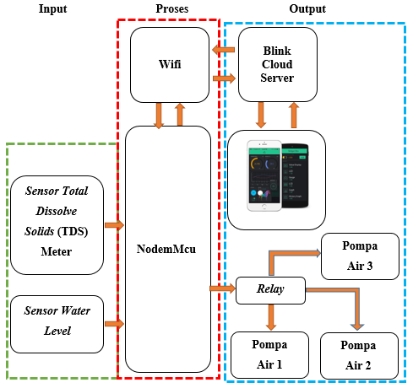

Gambar 2. Blok Diagram Sistem

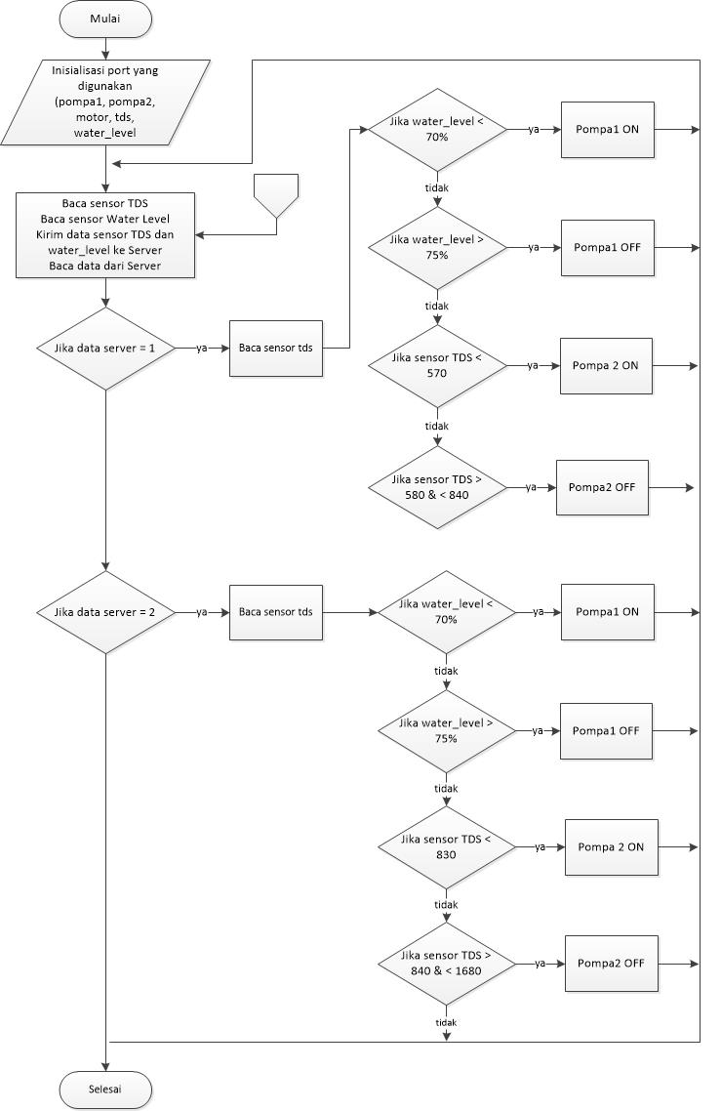

Gambar 3. Flow Chart Rangkaian Perangkat Keras

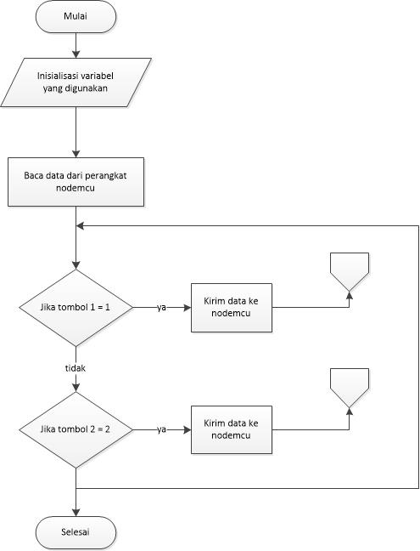

Gambar 4. *Flowcart* Sistem pada Perangkat Lunak

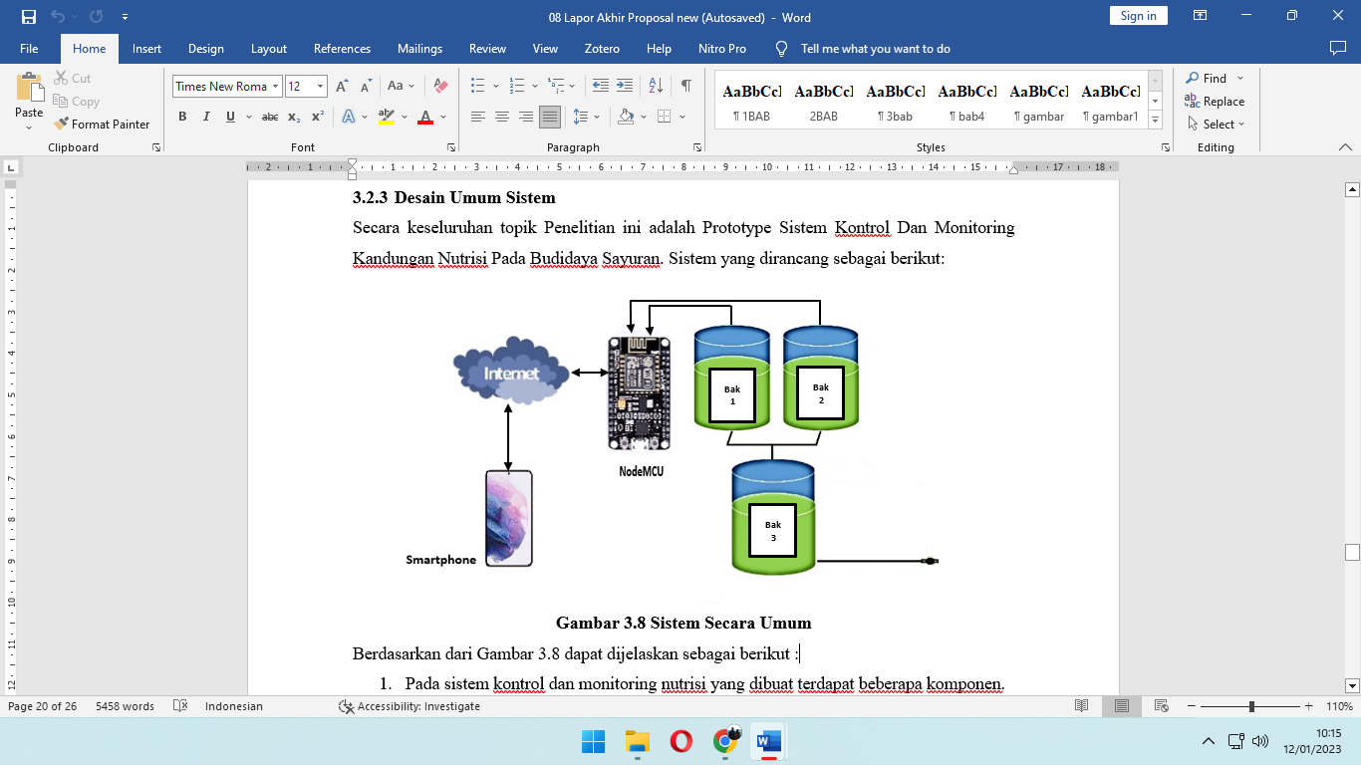

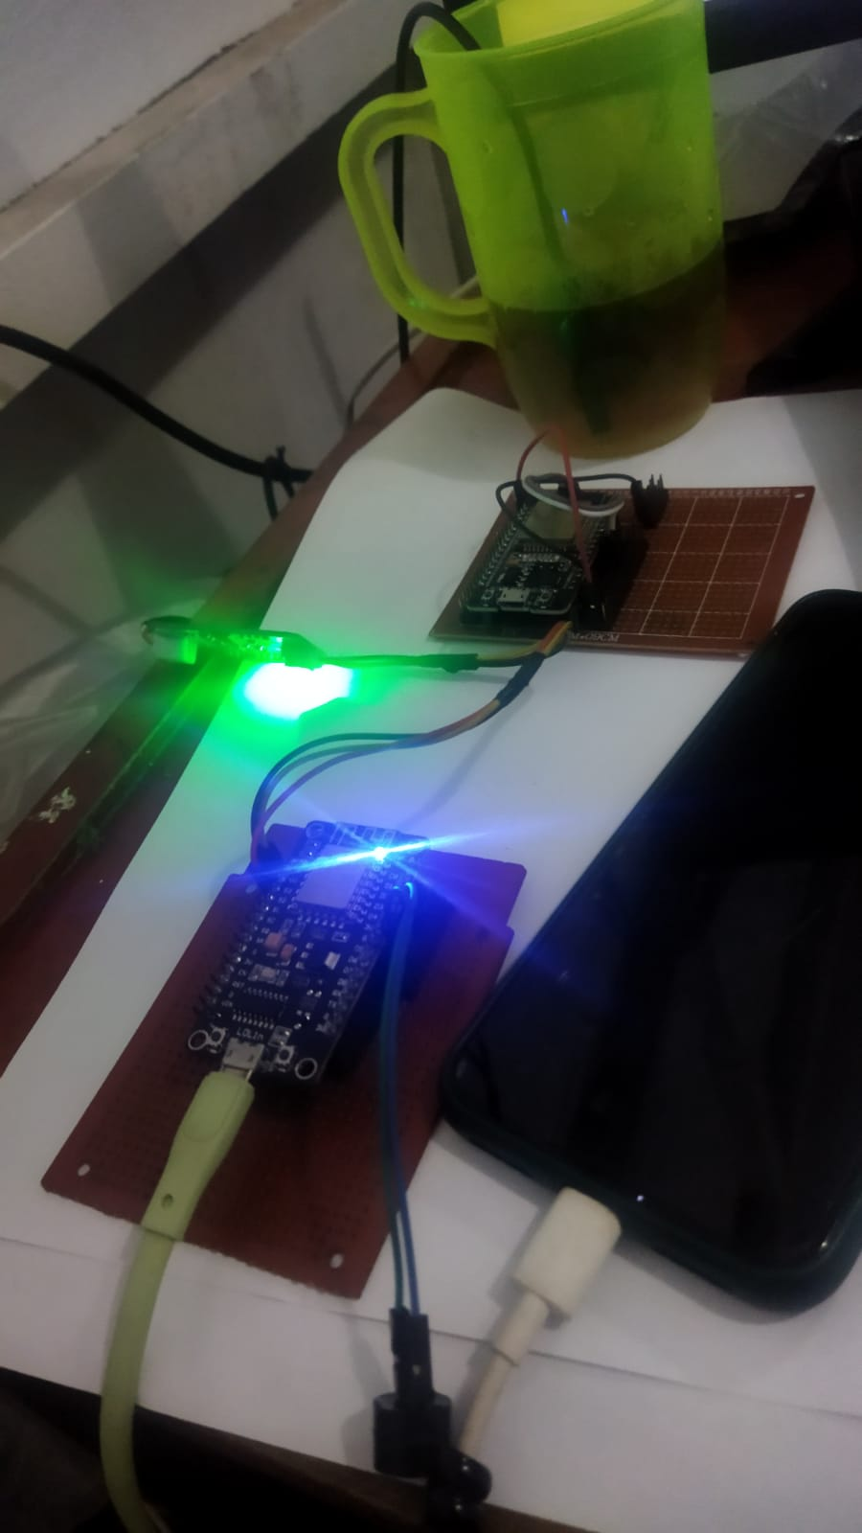

Gambar 6. Sistem Secara Umum.

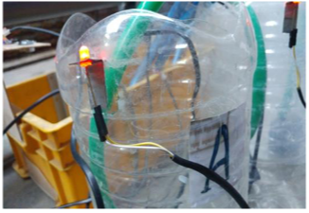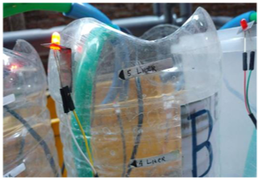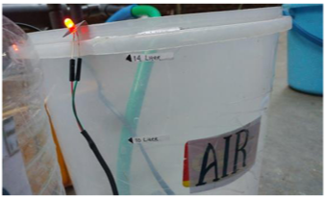

**Gambar 7. Tabung Pencampuran Pupuk.**

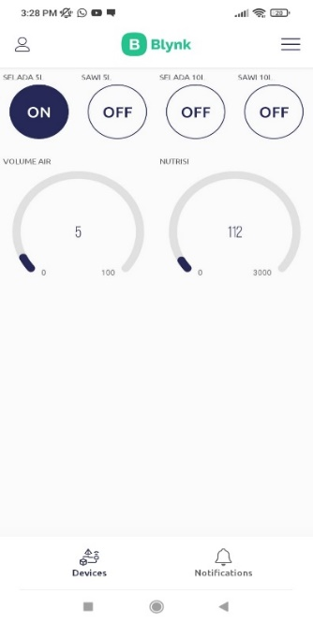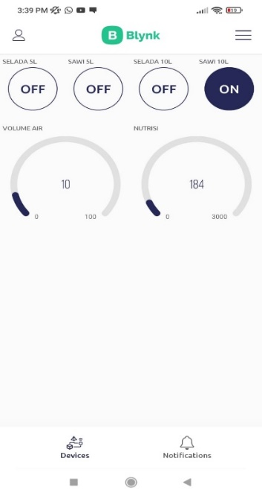

**Gambar 8. Tampilan Pada Aplikasi Blynk.**

**Tabel**

|  |  |  |  |  |
| --- | --- | --- | --- | --- |
| Data | Nilai PPM | | Selisih | Error |
| Sensor TDS | Manual (TDS Meter) |
| 1 | 515 | 530 | 15 | 0.0283 |
| 2 | 514 | 530 | 16 | 0.0302 |
| 3 | 512 | 514 | 2 | 0.0039 |
| 4 | 512 | 532 | 20 | 0.0376 |
| 5 | 513 | 532 | 19 | 0.0357 |
| Rata-rata Error | | | | 0.02714 |

**Table 1. Rata – rata nilai error**

|  |  |  |  |  |  |  |
| --- | --- | --- | --- | --- | --- | --- |
| Percobaan | Tombol | Volume  air | Lama Pengisian | | Nilai  Nutrisi | Kesesuaian |
| Pompa A | Pompa B |
| 1 | Selada | 5 liter | 1 menit 42 detik | 1 menit 42 detik | 680 PPM | Sesuai |
| 2 | Selada | 10 liter | 2 menit 23 detik | 2 menit 23 detik | 680 PPM | Sesuai |
| 3 | Sawi | 5 liter | 2 menit 06 detik | 2 menit 06 detik | 1260 PPM | Sesuai |
| 4 | Sawi | 10 liter | 3 menit 13 detik | 3 menit 13 detik | 1260 PPM | Sesuai |

**Table 2. Hasil Pengujian Keseluruhan Alat**