**Netizen’s reaction on an Indonesian Female Artist’s Academic life**

Gilang Aprillio SB, *Khristianto, Widya Nirmalawati

Faculty of Cultural Sciences and Communication, Universitas Muhammadiyah Purwokerto

Email: khristianto@ump.ac.id

|  |  |
| --- | --- |
| **Keywords:** netizen, judgment, attitude, public figure, appraisal. | **Abstract.** Presenting our life to the public is a common practice today through a social media. It is just so easy and very practical and it can be done anytime. A similar ease is also on the public side to follow through and react to that presentation. This paper is to reveal the judgement of the public to a video presenting a young and talented Indonesian celebrity, Maudy Ayunda, in her academic journey abroad. This applied a qualitative study on text, making use of CDA framework to portray the public opinion on the video presentation. The data are the public comments following the video, broadcasted in the actress’ official *Youtube* channel. Based on the analysis, Indonesian publics have been proved to have a positive impression on Maudy’s education live in Stanford University. This is evidence from their affect, showing their positive emotion in the verbs *like, love, adore,* and adjectives *proud* and *happy*. They also have a positive assessment on her with positive values like *smart, perfect, wonderful, humble,* or in a metaphor *a definition of beauty, brain and behavior*. Thus, it can be concluded that Maudy has been represented a female idol for Indonesian public. |

**I. INTRODUCTION**

Nowadays, people communication is easy, even when they are *in absentia.* Cyberspace is an online media for direct and reciprocal communication. Among of them is social media like *Instagram, WhatsApp, Facebook*, *Youtube,* or websites. Here, a user can post anything, to which the public (followers, or friends) can see (or read).

In addition, social media also provides menu/tool by which the public can send message or put a comment on every post created by a user account. One of the accounts which are actively responded and commented are those belong to public figures.

The comments are not only in words, but also other signs like emoticon and stickers, showing their feelings or attitudes. They can say that they like a post, or otherwise. Thus, the comments represent public judgment on the user’s posts, which usually contain the story of their life. In other words, the posts are their life presentation, and the comments are the public views on it.

This study focuses on how Indonesian public views an academic life of a female Indonesia celebrity, Maudy Ayunda in her video shared in *YouTube*, as one of the most popular social media in the world.

Some studies on attitude have focused on different objects like song lyrics (Arif, 2017). It describes the composer’s attitudes, the social relation among the participants, the context of the situation, and the power relation in the discourse. Another object analyzed is news (Asad, et al: 2021). They reveal the attitudinal stances of two Pakistani Online newspapers. The newspaper’s inclination was identified through its language, applying Martin and White’s (2005) Appraisal framework. Another study (Putriyantina and Said: 2018) shows the realization of attitude analysis on male and female second-year student’s narrative text. All of these studies reveal the attitude in a mainstream text, which tend to be more structural and well-planned. This recent study is on public comments that are more spontaneous and authentic, which are led by an instant feeling based on their immediate perceptions on the video post.

For knowing the meaning of the text representation, this research used Critical Discourse Analysis towards Appraisal. According to Martin (2005) initiated appraisal theory as evaluative use of language by focusing one metafunction of language that is interpersonal meaning. Appraisal concerns with the interpersonal in the language, with subjective presence of writer and speakers in the texts as they adopt stances toward both the material they present and those with whom they communicate. In this case, appraisal is a part of interpersonal metafunction. The goal is to analyze the relationship between speakers and hearers as well as writers and readers.

According to Martin and White, appraisal theory is divided into three subsystems: attitude, engagement, and graduation. Attitude is divided into three aspects i.e. affect, judgment and appreciation. **Affect** is the emotional evaluation related to the things, person, state of affairs, etc. It is about whether people feel happy or sad, confident or anxious, interested or bored.

Judgment is evaluation of attitudes and the way behave or the characters. Judgment of social esteem deals with “normality” means how special someone is, “capacity” means how capable they are and “tenacity” means how resolute one is. Social sanction deals with “veracity” that means how truthful someone is and “propriety” means how ethical someone is.

Appreciation is the evaluation of things of natural and phenomenon implicit and explicitly. As Martin and White state, appreciation can be divided into reaction (do they catch our attention or not), composition (balance and complexity) and valuation (how innovative, authentic, timely).

**II. METHOD**

In this research, the writer chose the comment in one of videos from *YouTube*. The data are the comments to one of the videos in Maudy Ayunda’s official *YouTube* channel. She is one of the graduate students in Stanford University, entitled *My Graduation- what I learned.* This video was published on July 12th, 2021. There are about than 5,200 comments responding to this video. This study chose 20 comments in English. The comments are taken randomly by choosing the first twenty comments written in English. All of the comments taken were posted between January – March 2022. The data were analyzed on their attitude, using Martin and White ‘s appraisal framework (2006). It will seek the expressions of affect, judgment and appreciation evoked by the public through their comments.

**III. FINDINGS AND DISCUSSION**

The writer has described the findings attitude distribution in 20 texts from column’ section in the video of Maudy entitle “My Standford Graduation, What I learned”. Dealing with the result, those could be summed up that the realization of attitude covered affect, judgment and appreciation. There are 18 items about affect, 31 items of judgments and 6 items of appreciation. The representation is displayed in Table 1.

Table 1. Netizen’s attitude on their comments to the Post

|  |  |  |  |
| --- | --- | --- | --- |
| Comments | Affect | Judgment | Appreciation |
| 1 | * Make all of us **smiling** | * Shining |  |
| 2 | * Proud (1) * Crying | * Pretty * Smart * Humble |  |
| 3 | - | - | Such a **great goal** |
| 4 | Hit me to deep |  |  |
| 5 |  | Inspiring |  |
| 6 | * Proud (2) * Happy * Hug | * Beautiful * Smart * Humble * Education oriented | Beautiful motivation |
| 7 |  | * beauty, * brain and * 4behavior |  |
| 8 |  | she does not waste her privilege | * She used it **well** |
| 9 | Proud (3) | Gorgeous |  |
| 10 | Proud (4) |  | Favorite campus |
| 11 | Proud (5) | * inspiring, * special,, * amazing, * perfect, * humble | So precious |
| 12 |  | * dream girl, * pretty, * smart, * kind, * talented, * humble, * inspiring |  |
| 13 | * Got goosebumps * Love | * Great inspiration |  |
| 14 | * goosebumps, * proud (6) |  |  |
| 15 | Love | Inspiring |  |
| 16 | Smiling all the way up | Inspiring |  |
| 17 |  | * wonderful person, * so talented, * inspirational | So powerful |
| 18 | - | - | - |
| 19 | Crying |  |  |
| 20 | Adore | * inspiring, * smart, (4) * beautiful, (5) * so talented |  |
|  | 18 (33%) | 31 (56%) | 6 (11%) |

According to the table above, the attitudes’ affect only found in text 1,2,4,6, 9,10,11, 13, 14,15, 16, 19 and 20. From those text, there are some attitudes affect word or phrases was found in some texts. While the attitude’ judgment was the dominant found in those 20 texts. Also, there are some similar words that indicate people attitude’s judgment in the texts. The last is appreciation, there were just 6 words found in the text.

Text 1

Text 1, there is a phrase “making all of us **smiling**” and a word “shining”. The phrase is an affect in categorized in happiness, because the word “smiling” there indicates people who are in happy vibes, in this case Maudy made people smile or feeling pleasant. Smiling is the express of feeling happiness. From the content of the video, what makes people are smiling here because of Maudy’s achievement being a Stanford Graduate student. The word “shining” means someone who has brilliant or excellent at something. In this context, Elisabeth (name who type the comment in text 1) has an opinion that Maudy has set of shining. This word is a judgment categorized in admiring someone.

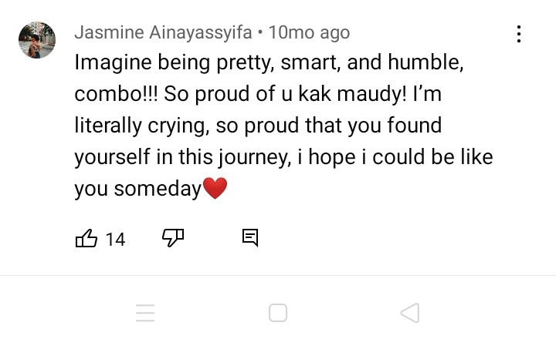

Text 2

Then, text 2, “imagine being **pretty, smart, and humble**, combo! Those words are adjective word. Pretty means an attractive in a delicate way without being truly beautiful or handsome. As an actress and model, Maudy became an ambassador of some products, it means she is an attractive person that is beautiful. The word smart means having or showing a quick-witted intelligence. Being a graduate student from two the best campus is a dream of some people, how people reach it is not easy and surely should has intelligence. Jasmine judge Maudy is a smart person. The word humble means having or showing a modest or low estimate of one’s own importance. Those words categorized in judgment of Jasmine to Maudy. There are also “So **proud** of you kak Maudy, I’m literally **crying**..”. There are word “proud” and “crying”. The word “proud” also found in other text repeatedly in text 6,9,10,11 and 14. Proud is an adjective word that means feeling deep pleasure or satisfaction as a result of one’s own achievements, qualities or possessions or those of someone with whom one is closely associated. This is also affect categorized in happiness. It is a positive affect that people felt to her. Many people are proud of maudy. As an actress, Maudy still concern in education so well. Even she accepted in two the best campus in the world that is a dream of many people, especially in Indonesia. Then, the word “crying” is a negative affect which is categorized in unhappiness. It reflects to what Maudy’s achievement. It is actually not a sad crying; people feel so happy for Maudy until they are touched. The writer also find this word in text 14 “Idk why I’m crying”.

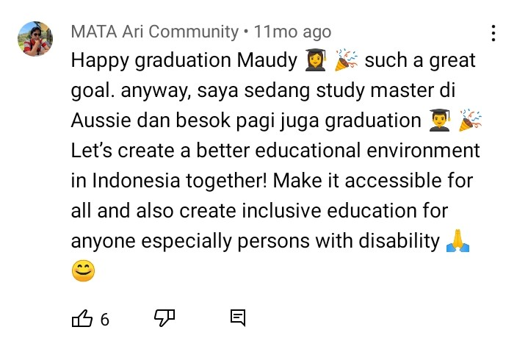

Text 3

The phrase “great goal” refers to Maudy’s accomplishment as a graduate student from Stanford. It is a positive appreciation that MATA Ari Community’s comment to Maudy’s achievement that categorized as reaction.

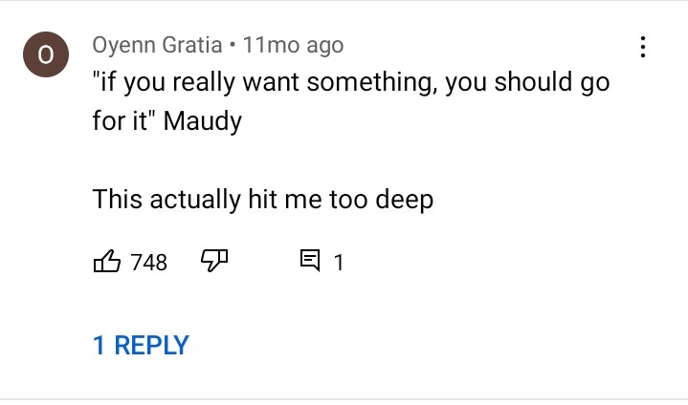

Text 4

Text 4, “hit me too deep” refers to quotes of Maudy Ayunda “if you really want something, you should go for it”. If someone used this phrases means something that affected them emotionally. It indicates that this phrases is affect. In this case,

People who typed the comment is touched by the quote because it is a good quotes for Oyenn. Maybe she/he is in the same feeling or situation that relates to the quotes by Maudy.

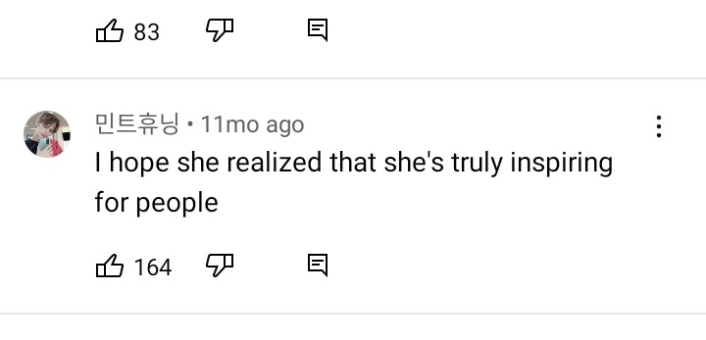

Text 5

In the text 5 “I hope she realized that she’s truly **inspiring** for people”, the word inspiring is an attitude of she/he that is a judgment categorized of positive judgment related to admire someone’s behavior. this word is from the word “inspire” that means something or someone that is inspiring is exciting and makes you feel strongly interested and enthusiastic. This judgment word appeared in some texts, such as in text 12,13 15,16,17 and 20. It means Maudy Ayunda is an inspiring woman/actress/student since many people judge her as inspiring person. Not only succeed in education, she also achieved many of trophies as an actress in some categories. She also one of the Forbes Asia 30 Under 30 years old in 2021.

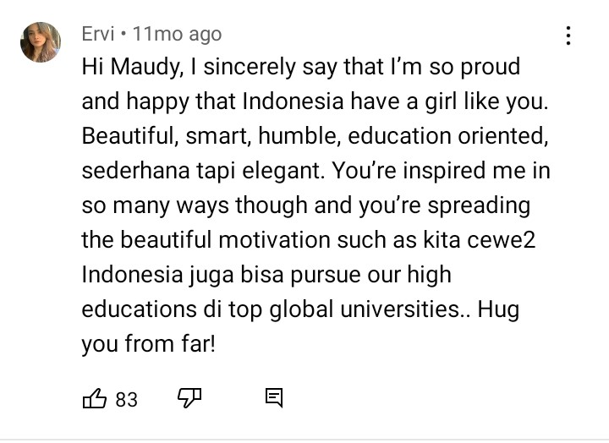

Text 6

Text 6, “I’m so **proud** and **happy** that Indonesia has the girl like you..” and “..**hug** you from far”. There are three affects in this text, there were “proud”, “happy”, and” hug”. Proud has been explained in the previous text. Happy means feeling or showing pleasure or contentment or people feel satisfied with the quality or standard on someone or something. Hug is an action for express affection, in this context that word refer to a positive affect related to affection. Those three words are the positive affect that Arvi gave to Maudy. There is also attitude’s appreciation appear, that is “**beautiful** motivation”. It is a positive appreciation refer to the motivation that Maudy gave to other people. “beautiful” here could means great, wonderful motivation.

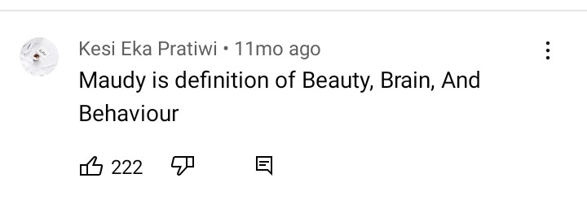

Text 7

There are words “Beauty, brain and behavior” with all of those words is an adjective that is a judgment that Kesi Eka Pratiwi said to Maudy. Besides, beauty, she also has a great brain which means smart and behavior. Those words categorized in positive judgment related to capacity of Maudy.

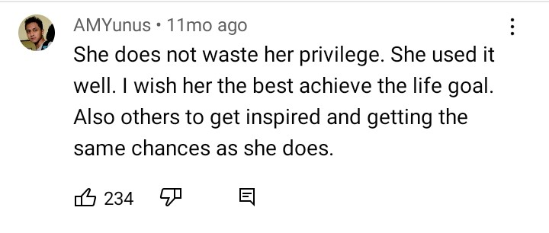

Text 8

The first sentence “she does not waste her privilege” is a positive judgment of AMYunus said to Maudy. Privilege means a special right, advantage or immunity granted or available only to a particular person or group. It means Maudy take an advantage of her time and her intelligence very well. So she could achieve her goal that according to some people as their dream to do it too. Then the next sentence “she used it well” is an appreciation related to reaction to the quality. It refer to the previous sentence, especially in word “privilege”.

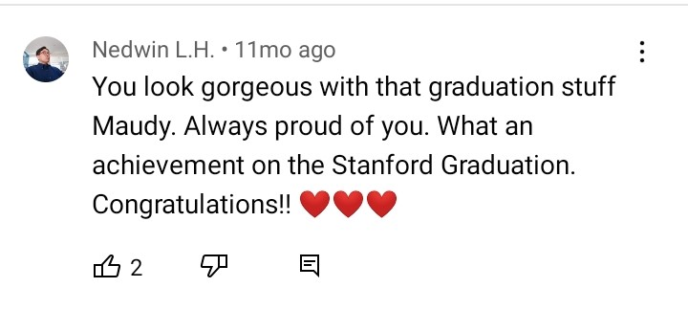

Text 9

The first attitude is the word “gorgeous” that is a judgment of Nedwin to Maudy’s appearance or look with the graduation stuff. Gorgeous has a similar meaning to beautiful and pretty that has been explained above. That word is a positive judgment categorized in admiring someone’s behavior, in this case Maudy’s behavior. In this text also has the word “proud” that refer to Maudy’s accomplishment.

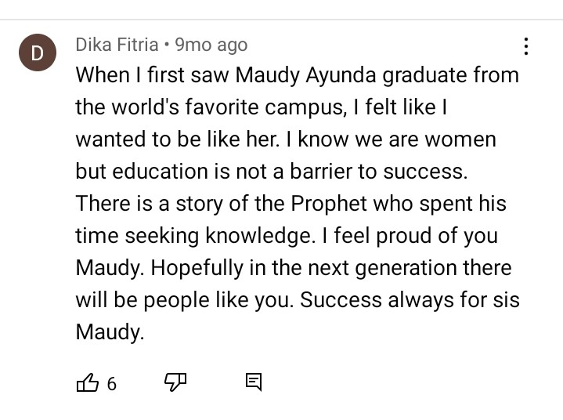

Text 10

In this text, there are also has the word “proud” and a phrase “favorite campus”. “favorite campus” categorize in appreciation of Maudy’s campus, Stanford University. It is a positive appreciation related to quality.

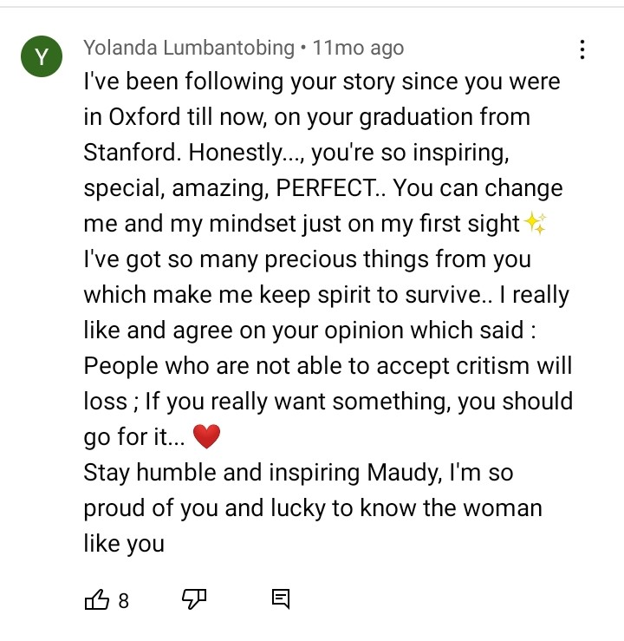

Text 11

The word include to affect is “proud”, it is a positive affect. The words that categorized in judgment are inspiring, special, amazing, perfect and humble. Some of those words has been explained in previous text. All of those words is expressing admire of Maudy’s behavior. Inspiring, amazing and humble are judgment related to capacity because it is about how capable Maudy is, while the word “special” related to normality that is about how special Maudy is.

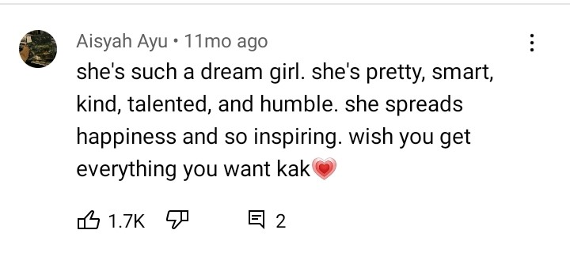

Text 12

There some adjective indicates a judgment which are a dream girl, pretty, smart, kind, talented, humble and inspiring. All of those judgments are positive judgment.

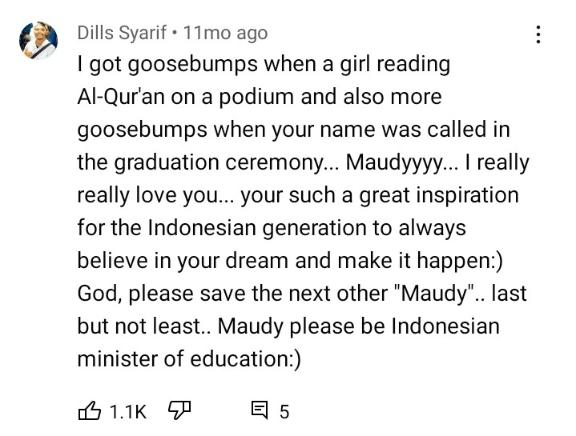

Text 13

The attitude’s affect is “got goosebumps” and “love” and the attitude’s judgment is a great inspiration. Goosebumps is a roughness of the skin produced by erection of its papillae especially from cold, fear or a sudden feeling of excitement. In this case, it is categorized as a sudden feeling excitement because Dills Syarif felt goosebumps when a girl reading a holy Qur’an and when Maudy was called to the front.

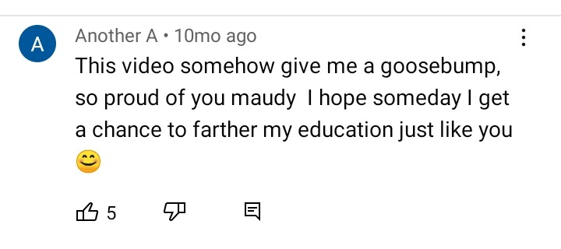

Text 14

The word of attitudes appeared in this text is the same with the attitudes in a previous text, that is goosebump and proud. For text 15 also has similar attitudes to the other text.

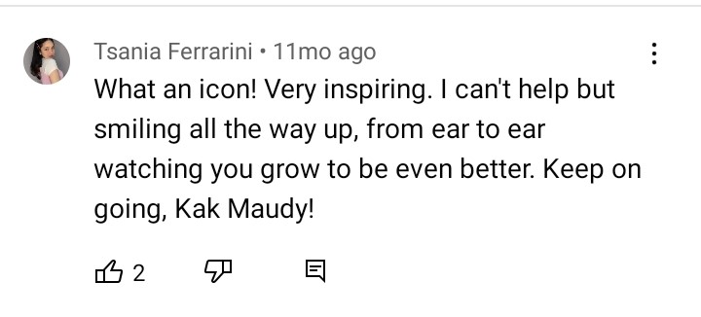

Text 16

Besides “inspiring” that indicates a similar judgment to the attitudes in the text before, there is a phrases related to affect that is “smiling all the way up”, it is also include the expression of someone’s happiness.

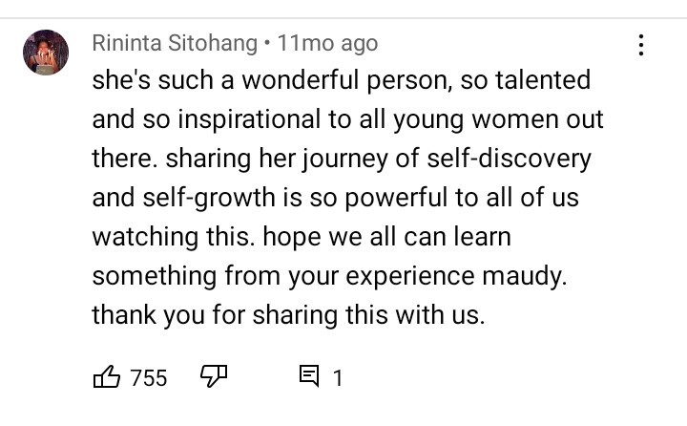

Text 17

There are “wonderful person, so talented and so inspirational” categorized in positive judgment in admiring someone’s behavior. Then there is an attitude’ appreciation “so powerful”, it is a positive appreciation refer to Maudy’s journey that Rininta gave to Maudy in her text. For the attitudes in text 18-20 is similar with the previous text above.

From the explanation above, the most common word appeared in 20 text are: the most appeared word categorized in affect is “proud”, there are six appeared from 20 texts. The attitudes categorized in judgment, the most dominant word appeared are inspiring, pretty/beautiful and smart. While in category appreciation, there are different words found in the text. All of the attitudes found in 20 text are positive that people gave to Maudy, whether the attitudes to her appearance, her spirit, her impact, and her intelligence.

**IV . CONCLUSION**

Based on the analysis, it was identified there are 55 kinds of attitudes, realized in words and phrases. Among the expressions of attitude, 31 items represent judgments; 17 items words indicates affect; 6 items are appreciation. All of the publics commenting on the video show positive attitude on Maudy Ayunda’s academic journey. It means that the netizens are happy with what the video presents as shown in the positive adjectives like *proud* which is repeated a lot, and *happy,*  or verbs *like, agree, adore, love.* They also see that the figure has good characters and capacity as found in the expressions *smart, brain, beauty, inspiring, wonderful, perfect, humble* and many others. Furthermore, their positive appreciation on Maudy’s life are seen in the phrases like *so powerful, so precious, favorite campus,* *a great goal,* and *beautiful motivation.* This is, further, proved by the dominant finding of the lexicon “inspire” in the data. In sum, Indonesian public has a good impression on her figure and academic career.

**References**

Anwar, Asri Laraswati & Ridhani. 2020. *Critical Discourse Analysis in Media Studies: A Review Research on its Application in Indonesian Context.* Journal of English Language Studies Vol. 2, No. 1, pp. 32-36.

Arif, Muhammad. 2017. *Appraisal and Critical Discourse Analysis in “Baby Shark” Song Lyric.* Conference on Language and Language Teaching. Yogyakarta State University.

Asad, Saira, et.al. 2021. *Attitude Realization in News reports: An Interpretation through an Appraisal Analysis.* Al. Indonesian Journal of Applied Linguistic Vol. 11 No. 1, pp. 177-186.

Ertyas P, Clara. 2011. *An Appraisal Analysis of Gossip News Text Written by Perres Hilton from Pereshilton.com (A Study Based on Systematical Functional Linguistic).* Sebelas Maret University.

Dahlan, Suhendi, et.al. *Analysis Attitude terhadap Penunjukan Basuki Tjahaja Purnama sebagai Komisaris utama Pertamina dalam Kolom Komentar Instagram Harian Kompas.* Jurnal Ilmiah Ilmu Sosial dan Humaniora Volume 6 (1).

Nur, Adam Muhammad & Armando Satriani Hadi. 2016. *Realisasi Appraisal dalam Aspek Attitude pada Media Online Instagram.* Jurnal Sasindo Unpam, Volume 3, Nomor 2.

Martin, J. R., & White, P. R. R. 2005. *The language of evaluation*. Palgrave Macmillan.

Putriyantina, Vivi & Ishak Asad. 2018. *The Realization of Attitudes Analysis on Male and Female Second-Year Students’ Narrative Text.* Journal of Applied Linguistics and Literacy Vol 2 No. 1.

Sangka, Dewa Wicak. 2017. *Appraisal Theory of Attitude in Michelle Obama Speech Towards Presidential Candidates of the United States 2016.* State IslamicUniversity Syarif Hidayatullah:Jakarta.

Wei, Yakun, et.al. 2015. *An Analysis of Current Research on the Appraisal Theory.* Linguistics and Literature Studies 3(5): 235-239.