Design of Intelligent Automated Quest Control System in the Covid-19 Era
Yahfizham¹, Irwan Yusti²
^{1*}Department of Mathematic Education, UIN Samatera Utara, Medan, Indonesia (2 - 5 authors)
²Department of Engineering, STTIND, Padang, Indonesia

^{1*}Corr-Author: yahfizham@uinsu.ac.id, ²irwanyusti@gmail.com

Abstract- The rapid spread of corona virus disease 2019 (COVID-19), throughout direct of the human-to-human interaction makes the virus massively infect humans in all around the world. Until now, there has not been found the right way of healing it. This study aims to design of the intelligent automated quest control system capable for detecting COVID-19 by the body of temperature. The method approach was taken applied research, beginning with determining of the hardware using the ArduinoTM UNO microcontroller, the MLX90614 infrared thermometer, the TCRT5000 infrared reflective sensor, motor driver L293D, the output was displayed on a Liquid Crystal Display (LCD) screen, interaction control using Roller Limit Switch and instruction using the C programming language with Arduino IDE user interface. The system testing is done by comparing the temperature sensor readings infrared thermometer versus standard thermometer. Based on the results of a limited scale trial of 5 volunteers, an average error of 2.72% was obtained and the system worked well (opening or locking the door) in accordance with the temperature limits that had been set for detecting COVID-19. This research novelty that the simple and inexpensive design of the device system prevented and minimize the spread of COVID-19. The last, limitations of the system not being tested by the experts and large sample.

Keywords: ArduinoTM UNO, MLX90614 thermometer, TCRT5000 reflective sensor, Motor driver L293D
- INTRODUCTION
The World Health Organization (WHO) identified corona virus (COVID-19) could infect animals and humans through direct interaction of the face, which was first discovered in China, Wuhan Province around the end of December 2019 [1-4]. The virus as a new virus which was then called CoV-2019 or better known as COVID-19 in February 2020 [5]. The rapid spread of COVID-19 through direct human-to-human interaction makes the virus massively infect humans throughout the world [6]. Data released by WHO in 2020, explained that more than 10 billions of the world population were infected with COVID-19 and spread in 216 countries [7]. The COVID-19 include high body temperature, dry cough, sore throat, diarrhea and fatigue [8,9]. The initial temperature condition of humans with high fever ranging from 38⁰ - 39⁰C lasts for 5 days, has a dry cough for 7 days, and the breath indicator from both lungs sounds harsh [10]. In certain conditions, some infected people do not show these symptoms. COVID-19 disease is very dangerous for people who are in the range of more than 45 years and have a history of serious illness, although about 80% of people infected with COVID-19 can recover without special treatment [11,12].
The opinion [13], in terms of applied scientific technology such as engineering or information, communication and technology, it has the potential to be a rational strategy for controlling and detecting the spread of the disease. Research was conducted [14,15] offers an approach to using digital technology devices (internet of things/IoT) as an effort to detect and diagnose the symptoms of the virus early. The study was conducted [16] built a real-time based medical system that was connected to the internet. Research by [17–21], have developed the artificial intelligent technology. The idea [22,23] made x-ray technology based on artificial neural networks and CAAD models. According to [24] have proposed virtual-based telecommunication medicine. In accord with [25] have developed medical image processing technology based on machine learning.
All countries in the world until now have tried to find and develop vaccines or anti-serum that are effective for the treatment of COVID-19, but have not shown optimal results. Therefore, it is necessary to apply a technique that is able to reduce and sever the spread of COVID-19 such as maintaining human interaction, using disinfectants, maintaining hygiene by washing hands with soap, maintaining healthy and fit body conditions and reducing the number of people in house, one space/hall, so human crowed control occurs. The places like malls, supermarkets, markets, schools, places of worship and places of public service become the center of ongoing interaction, because human economic and social activities must continued. In these places violations often occur because they are not disciplined in followed health protocols, so that infected people can enter and possibly infect others who are in the space. In the other side, several researchers have been designed of intelligent automated control systems COVID-19, but they need to expensive method include high cost and high sensitivity, see the articles [34–36].
This is a challenge that must be found a solution to prototype of design an electrical assisted of intelligent devices that could be control the open or close of the door automatically, simpler and inexpensive. The security system alert automated visitor control, capable to detecting and diagnosing COVID-19 based on body temperature, and limiting the number of visitors in the home and others public services based on using the ArduinoTM UNO microcontroller, the MLX90614 infrared thermometer, the TCRT5000 infrared reflective sensor, motor driver L293D, the output was displayed on a Liquid Crystal Display (LCD) screen, interaction control using Roller Limit Switch and instruction using the C programming language with Arduino IDE user interface.
The rigid of this paper: Section 1 prepare a introduction and a short of the literature review; Section 2 a brief explicated of the methodology; Section 3 provide results and discussion; and the last Section 4 produced a conclusion.
- method
This section explains the schematic of the block diagram (research method) that case out with an approach beginning with determining hardware using the ArduinoTM UNO micro- controller, MLX90614 is the digital non-contact infrared thermometer sensor, TCRT5000 is the infrared reflective sensor units system, motor driver L293D, 12V DC Motor, Roller Limit Switch and the output is displayed on a Liquid Crystal Display (LCD) type screen. The instruction control system, using the C programming language with Arduino IDE user interface. The intelligence visitor control system consists of 3 main components namely the input system, the data processing and finally the output device system. The diagram block of the hardware intelligent quest control system shown in figure 1.
- Diagram Block
This type of infrared thermometer uses MLX90614 which is a non-contact sensor to measure temperature with high precision with a low working voltage has a temperature range that can be measured between -40⁰ and 125⁰C, must be compatible with the ArduinoTM UNO microcontroller [26,27]. To detect the number of visitors using the TCRT5000 sensor which is an infrared-based reflective (IR) sensor that can be used as a limit switch [30,31], the LCD is used to display the body temperature output that will enter the room and display the number of visitors who are in the room.
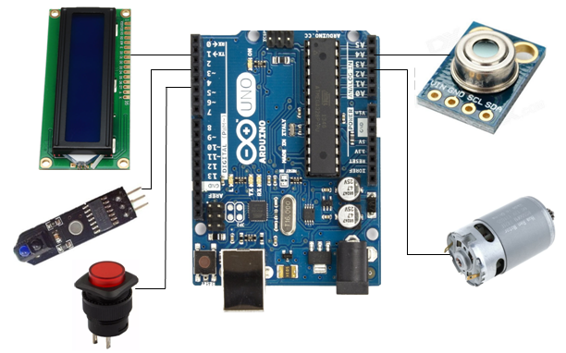
Fig. 1 Diagram block

- The Hardware specifications
The brain control system units uses ArduinoTM UNO which is integrated between a series of components to create a stand-alone interactive object. The user interfaced with the Integrated Development Environment (IDE) is open source, so that it can be used freely. IDE is a special application program that is able to run on the computer systems by utilizing the C programming language to make the coding of the instruction to the system [32–38]. Table 1 provides of the hardware specifications.
TABEL I
THE HARDWARE SPECIFICATIONS
COMPONENT | SPECIFICATION
Arduino | UNO
Temperature Sensor | MLX90614
LCD Display | 1602 I2c LCD
Infrared Sensor | TCRT-5000
Motor Driver | L293D
Switch  Motor | Roller Switch  12V DC Motor
- Flowchart System
The prototype of hardware component specification has their respective work functions. Each device will be arranged according to the work unit. ArduinoTM UNO is the main system unit as a circuit that works to receive input data from temperature sensors, infrared sensors with motor drive. The temperature sensor works to obtain body temperature data and then forwarded to the other sensor. Data is saved to the temporary memory system on the processing unit. The results of data processing is displayed via the LCD screen. The door will open if the specified conditions was fulfilled. The intelligent automated visitor control system of the flowchart, shown in figure 2.
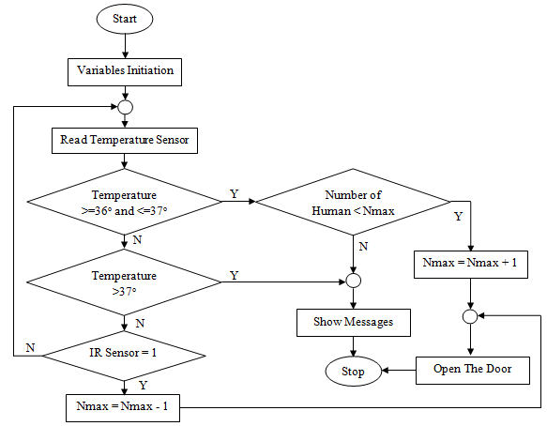
Fig. 2 Flowchart system

A quest who will enter the mall or other crowded places must pass the infrared temperature sensor. The temperature data obtained from the sensor will be compared with the temperature limit that has been set, if the visitor’s body temperature is less than 37⁰C it is believed to be not infected with COVID-19 then the door will open. If, the number of visitors who have been in the room is less than the capacity that has been determined. If otherwise the detected body temperature is more than 37⁰C then on the LCD screen will display a notification that the visitor may not enter even though the number of visitors in the place were less from the capacity of the building. If, the number of visitors meets the capacity, a notification will appear on the LCD screen that the capacity of the room is “Full”. The number of visitors who are in that place will decrease, if there are visitors who pass the IR sensor (located at the exit).
- results and discussion
The circuit schematic is a diagram block consisting of a series of blocks connected by lines describing detailed but concise hardware creation and planning diagrams that can be viewed and analyzed from the circuit scheme image. The analysis begins with a power supply, which serves as a supplier of electrical voltage sources. The analysis is continued by decrypting the working principle of each tool that can be read from its specifications, price and ease of connection with other devices. The design drawings of the visitor control system circuit scheme shown on figure 3. The design circuit scheme for intelligent automation of visitor control systems in the era of COVID-19 is a prototype or blueprint that is carried out to obtain the desired objectives. Aspects that have been thought of such as ease in purchasing hardware components and testing are pursued at a low cost but do not reduce the maximum results and are available in local and international markets.
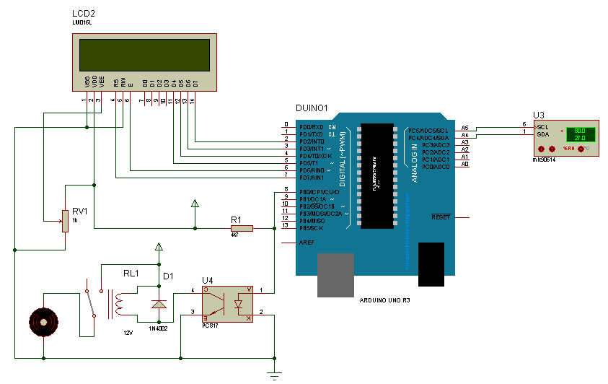
Fig. 3 The circuit scheme

Based on the circuit schematic design, it’s described that the controlling of the processing data unit system to the body temperature and visitors function as the main circuit. The ArduinoTM UNO processor is in the center of a series of systems connected with MLX90614 and TCRT5000 sensors. The body of the temperature sensor and visitor control have included in the detection system. When all devices are working as expected, the body temperature output and the number of visitors will be displayed on the LCD screen. This is of an alert or notification to visitors that the condition of his/her body meets the criterion that has been set or vice versa and also at the same time as a warning to the visitors who are inside the home.
ArduinoTM UNO is multi platform device for any operating system Windows, Linux and the other’s based on Integrated Development Environment (IDE) interface. The IDE is java based software that has been specifically prepared to give commands. Java has loaded modules that are equipped with C and C ++ libraries which are usually called wiring. Wiring is used for setting input, conditioning and output commands. C programming code have done in the text editor and the written program is called the sketch [39]. The following C programming code snippets for library declarations, to open the door.
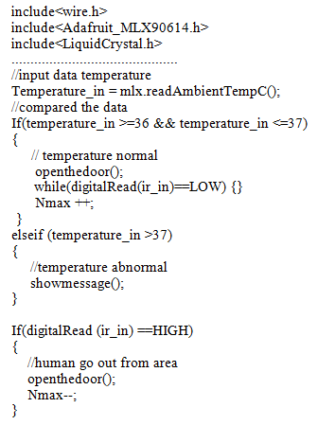
Fig. 4 C programming code snippets

Before the results were obtained, the limited scale test of 5 volunteers was required to design the circuit scheme by analyzing all the devices used. This is done to obtain an initial assessment, that all hardware according to the specifications of its working principle and the need for use between tools are one against another. Then also to obtain proof that the system has had the right performance so that it is easy to make circuit repairs to the tool that experienced connection failure. The analysis begins with the design of the circuit scheme by checking the match of the circuit images per block of each tool so that no hardware installation errors occur, as already in the circuit scheme concept image. The assessment is proof and ensures that the overall design of the circuit scheme image is in accordance with the desired objectives. Testing of prototype performance was conducted by comparing the results of the prototype temperature readings with infrared-based thermometers that are commonly used by the public. The readings results of the two sensors (both) are shown in table 2.

TABEL II
THE RESULTS OF COMPARISON
Sample | Input Temperature (⁰C) |  | Error (%)
Sample | Prototype | Thermometer Infrared | Error (%)
1 | 36,2 | 36,5 | 2,74
2 | 36,8 | 36,6 | 2,73
3 | 36,5 | 36,4 | 2,74
4 | 37,1 | 36,8 | 2,72
5 | 37,4 | 37,3 | 2,68

From the test results using 5 samples, the average error between the temperature reading of the prototype and the standard thermometer is around 2.72%, these results indicate that the performance of the prototype is very good. In general, this control system will work if the detected temperature ranges from 36⁰-37⁰C, when the temperature is detected by the temperature sensor then the system will check the number of people who have been in the room (indoor), if the number of people in the indoor has not reached the maximum number then the motor will be active and the door will open and the system will release data on the number of people who are in the indoor, if the number of people has met the maximum number or the detected temperature exceeds the set temperature then the door will not open, the LCD will display a notification according to the conditions that occur. When people who are in the indoor want to get out then they have to pass through the infrared sensor, when this sensor is passed then the door will open and the system will reduce the data on the number of people in the indoor. From the trial it appears that when the temperature is above 37⁰C the door is not open, temperatures of 36⁰ - 37⁰C are active and below 36⁰C are not active, meaning that when the selenoid door lock is active, the door can be opened and when it is not active the door cannot be opened.
- CONCLUSION
The designed is a process that has been prototype in the detail and specifically in the manufacture of tools, so the end of the result was finished in accordance with the blueprint. The design consists of making block diagrams and circuit schematic and specifications of the tools used. According to the explanation on the results and discussion, it can be concluded that the design of the intelligent quests control system automation in the COVID-19 era was able to achieve the desired goal of detecting COVID-19 based on body temperature and limiting the number of people indoor, and others public services. This research shows that the simple and inexpensive design of the device system prevented and minimize the spread of COVID-19. The implementation and feasibility of the system is indeed untested by the experts, and large the sample, that will be the focus of further research.
REFERENCES
[1] F. He, Y. Deng, and W. Li: Coronavirus disease 2019: What we know ?. J. Med. Virol., Vol. 9, pp. 719–725, 2021.
[2] E. Dong, H. Du, and L. Gardner: COVID-19 in real time. Lancet Infect. Dis., Vol, 20, No. 5, pp. 533–534, 2020.
[3] H. A. Rothan and S. N. Byrareddy: The epidemiology and pathogenesis of coronavirus disease (COVID-19) outbreak. J. Autoimmun.,Vol. 109, pp. 1-4, 2020.
[4] K. Leung, J. T. Wu, D. Liu, and G. M. Leung: First-wave COVID-19 transmissibility and severity in China outside Hubei after control measures, and second-wave scenario planning: A modelling impact assessment. Lancet, Vol. 395, pp. 1382–1393, 2020.
[5] J. Yang., et al: Prevalence of comorbidities and its effects in patients infected with SARS-CoV-2. Int. Jour of Inf. Dis, Vol. 94, pp. 91–95, 2020.
[6] B. Udugama., et al: Diagnosing COVID-19: the disease and tools for detection. American Chemical Society (ACS)., Vol. 14, No. 4, pp. 3822-3835, 2020.
[7] Tang Y-W., J. E. Schmitz, D. H. Persing., and C. W, Stratton: Laboratory diagnosis of COVID-19: current issues and challenges. J Clin Microbiol., Vol. 58, No. 6, pp. 1–9, 2020.
[8] L. E. Wee., et al: The role of self-reported olfactory and gustatory dysfunction as a screening criterion for suspected COVID-19. Oto-Rhino-Laryngology, pp. 20–21, 2020.
[9] C. Baunez., et al: Sub-National Allocation of COVID-19 Tests: An Efficiency Criterion with an Application to Italian Regions. HAL., pp. 1-18, 2020.
[10] D. Das and K. C. S. Umapada: Truncated inception net: COVID-19 outbreak screening using chest X - rays. Phys. Eng. Sci. Med., pp. 1-10, 2020.
[11] M. Rahimzadeh and A. Attar: A New Modified Deep Convolutional Neural Network For Detecting Covid-19 From X- Ray Images. arxiv., pp. 1-10, 2020.
[12] T. Ozturk, M. Talo, E. Azra, U. Baran, and O. Yildirim: Automated detection of COVID-19 cases using deep neural networks with X-ray images. Computer in Biology and Medicine., Vol. 121, pp. 1-11, 2020.
[13] R. M. Elavarasan and R. Pugazhendhi: A review on potential technological strategies to control the COVID-19 pandemic. Science of the Tot. Env.., Vol, 725, pp. 1-18, 2020.
[14] R. Vaishya, M. Javaid, I. Haleem, and A. Haleem: Artificial Intelligence (AI) applications for COVID-19 pandemic. Diabetes & Metabolic Syndrome: Clinical Research & Reviews., Vol. 14, pp. 337-339, 2020.
[15] D. Shu., et al: Digital technology and COVID-19. Nature Medicine., Vol. 26, pp. 2019–2021, 2020.
[16] T. Yang, M. Gentile, C-F. Shen, and C-M. Cheng: Combining Point-of-Care Diagnostics and Internet of Medical Things (IoMT) to Combat the Pandemic. Diagnostics., Vol. 10, pp. 4–6, 2020.
[17] K. C. Santosh: AI-Driven Tools for Coronavirus Outbreak: Need of Active Learning and Cross-Population Train/Test Models on Multitudinal/Multimodal Data. Journal of Medical System., Vol. 44, No. 93, pp. 1–5, 2020.
[18] F. Shi., et al: Review of Artificial Intelligence Techniques in Imaging Data Acquisition, Segmentation and Diagnosis for COVID-19. IEEE Review in Biomedical Engineering., pp. 1–11, 2020.
[19] M. E. H. Chowdhury., et al: Can AI help in screening Viral and COVID-19 pneumonia ?. IEEE Access., Vol, XX, pp. 1-12, 2020.
[20] F. M. Salman., et al: COVID-19 Detection using Artificial Intelligence. International Journal of Academic Engineering Research (IJAER)., Vol. 4, No. 3, pp. 18–25, 2020.
[21] I. D. Apostolopoulos and T. A. Mpesiana: Covid-19: Automatic detection from Xray images utilizing transfer learning with convolutional neural networks. Phys. Eng. Sci. Med., Vol. 43, No. 2, pp. 635–640, 2020.
[22] J. Zhang., et al: Viral Pneumonia Screening on Chest X-ray Images Using Confidence-Aware Anomaly Detection. Manuscript., pp. 1–11, 2020.
[23] J. Health, M. Sinai, and K. Permanente: Virtually Perfect ? Telemedicine for Covid-19. The New England Journal of Medicine., Vol. 382, No. 18, pp. 1679–1681, 2020.
[24] S. G. M. Pereira, F. A. S. Medina, and D. S. D. Santos: Software Project for Remote Monitoring of Body Temperature. IEEE Latin America Transactions., Vol. 15, No. 11, pp. 2238–2243, 2017.
[25] F. Yazdani and F. A. Mohammadi: Intelligent testing for Arduino UNO based on thermal image R. Comput. Electr. Eng., Vol. 58, pp. 88–100, 2017.
[26] K. Xie, H. Zhang, L. Ding, and B. Hu. 2014. Design and implementation of shield state detection system for charging pile port. Applied Mechanics and Materials., 556-562, pp. 3027–3030.
[27] A. Al-Yemni: An Arduino based smart faucet design. COMPUSOFT, An international journal of advanced computer technology., Vol. 7, No. 5, 2018, pp. 5–8.
[28] I. Yusti : Pengontrolan Pintu Pagar Otomatis menggunakan Android, Jurnal Sains dan Teknologi., Vol. 21, No. 1, 2021, pp. 97–101.
[29] I. Yusti and A. Bachtiar: Kontrol Lampu Menggunakan Voice Recognizer Berbasis Android, JPTK., Vol. 2, No. 4, 2020, pp. 140–143.
[30] O. V. Vovna., et al: Study of metrological characteristics of low-cost digital temperature sensors for greenhouse conditions, Serbian Journal of Electrical Engineering, Vol. 17, No. 1, pp. 1-20, 2020.
[31] M. Milošević, et al: Lighting control using Raspberry Pi and OBLO living home automation system, Serbian Journal of Electrical Engineering, Vol. 16, No. 1, pp. 45-54, 2019.
[32] U. Jovanović, et al: Low-cost teslameter based on hall effect sensor MLX90242, Serbian Journal of Electrical Engineering, Vol. 15, No. 2, pp. 225-232, 2018.
[33] Y. Li and M. Sun: Generating Arduino C Codes, Springer International Publishing AG, part of Springer Nature., pp. 174–188, 2018.
[34] P. Teikari., et al: An inexpensive Arduino-based LED stimulator system for vision research. J. Neurosci. Methods., Vol. 211, No. 2, pp. 227–236, 2012.
[35] N. Ni, S. Hlaing, and S. S. Lwin: Electronic Door Lock using RFID and Password Based on Arduino. International Journal of Trend in Scientific Research and Development (IJTSRD)., Vol. 3, No. 3, pp. 799–802, 2019.
[36] B. M. Amine, C. F. Zohra, H. Ilyes, A. Lahcen, and A. Tayeb: Smart Home Automation System based on Arduino. International Journal of Robotics and Automation (IJRA)., Vol. 7, No. 4, pp. 215–220, 2018.
[37] S. M. Almufti., et al: Real Time face-mask detection with Arduino to prevent spreading of COVID-19, Qubahan Academic Journal, Vol. 1, No. 2, pp. 39-46, 2021.
[38] A. Kaur and A. Jasuja: Cost Effective Remote Health Monitoring System Based on IoT Using Arduino UNO. Advances in Computer Science and Information Technology (ACSIT)., Vol. 4, No. 2, pp. 80–84, 2017.
[39] R. Turner: Arduino Programming: 2 books in 1 - The Ultimate Beginner’s & Intermediate Guide to Learn Arduino Programming Step by Step. Nelly B. L. International Consulting Ltd, 2018.

