LEKSIKA – UMP - CTAF

LEKSIKA: JURNAL BAHASA, SASTRA DAN PENGAJARANNYA ISSN 1978-1695 (http://jurnalnasional.ump.ac.id/index.php/LEKSIKA/index)

COPYRIGHT TRANSFER AGREEMENT FORM

Name of Principal Authors: Dhitya Faradilla

Address of Principal Authors: Jalan Kapten Piere Tendean, Gang Arjuna, No.16, Wirobrajan, Yogyakarta

 | Tel: 0821-3521-6877 | Fax:
 | E-mail: dhityafaradilla@gmail.com

Author(s) Name: Dhitya Faradilla

Manuscript No.

Manuscript Title: Character resistance as an compliance homosexual desires
In Elisa y Marcela Movie by isabel coixet: a slavoj žižek
Psychoanalysis-historical approach

Date Received

- I/We submit to the Leksika: Jurnal Bahasa, Sastra dan Pengajarannya for the above manuscript. I/We certify that the work reported here has not been published before and contains no materials the publication of which would violate any copyright or other personal or proprietary right of any person or entity.

- I/We hereby agree to transfer to Department of Chemical Engineering, Diponegoro University the copyright of the above - named manuscript. I/We reserve the following:
(1) All proprietary rights other than copyright such as patent rights. (2) The right to use all or part of this article in future works of our own such as in books and lectures.

Dhitya Faradilla, S.Pd.
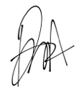
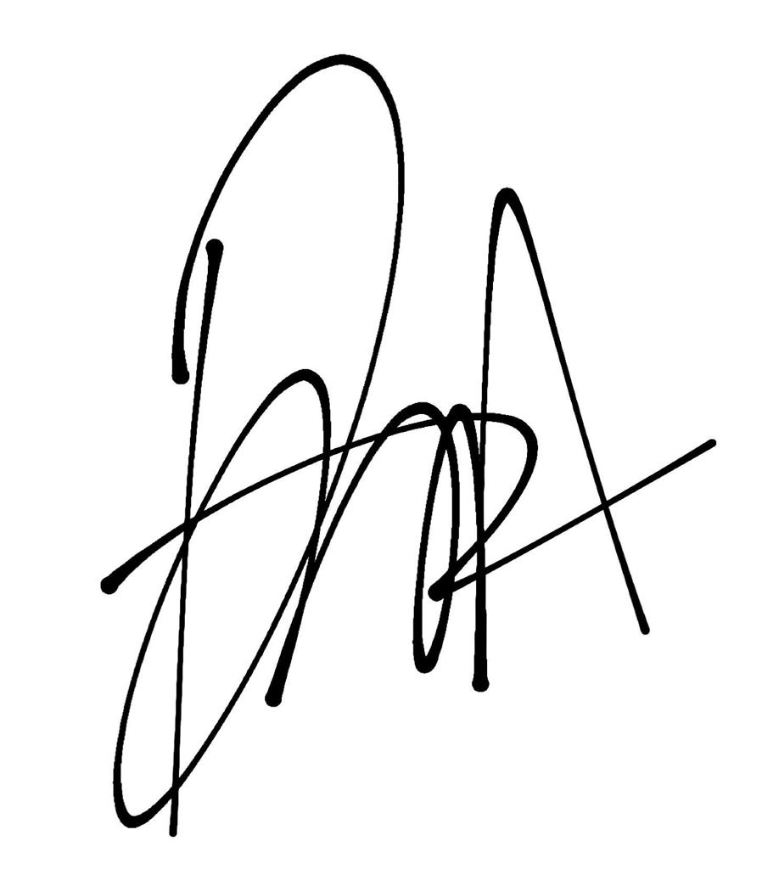

Date: March 02, 2023
(When there is more than one author, only one signature will suffice.)

