Linguistic Landscapes in Purwokerto:
Native and Non-Native Language Varieties on Soeharso’s street
Eko Pamuji & Wikku Nugroho
Faculty of Letters, University of Muhammadiyah Purwokerto
Abstract
This paper is about linguistics phenomenon that is the existence of monolingualism, bilingualism, and slightly multilingualism in Purwokerto. The languages are used as store names, eateries, restaurants, cafes, slogans, and as other signs along Soeharso’s street. The phenomenon of existing language will be focused to be delivered with the division of the use of the native language and the non-native language (foreign language). This difference will be linked to the application of language used by the government and the utilization by private parties or the public. Furthermore, it will be traced on the existence of monolingual language that points solidarity. Meanwhile, the use of two languages, using foreign language will emphasize the power of language as a high value market language.
Keywords: native language, non-native language, power, solidarity
Introduction
Rapidly progress occurred in the city of Purwokerto. This makes this city being one of the most developed cities in western of Central Java Province. Continuously developments in various sectors making this city increasingly crowded. One of the factors is the number of education centers such as university and college. According to banyumas.dapodik.org (2011), 21 campus established in Purwokerto (Pascalia, 2002:2) which mainly inevitably have brought thousands of students from outside the city and the region to study in Purwokerto. The cool weather condition due to the geographical which is located at the foot of the mountain also makes a lot of entrepreneur open investment in this town as its treaties are premised on two elemental propositions: foreign investment tends to spur economic development, and fundamental legal protections tends to encourage and promote foreign investments (Barton, 2005:2). Consequently, many hotels, malls, shopping centers, restaurants, and various tourist objects established that seem to attract visitors to spend money in the city of Purwokerto.
In relation to the number of sectors that have sprung up in Purwokerto city area, the researchers take samples from various names of shops, eateries, restaurants, or signs that exist in the hotel in one of the bustling streets, Dr. Soeharso’s street which the majorities are restaurants and cafes to be analyzed about the use of the language related to linguistics landscape. As Gorter (2006) says that linguistics landscape is the representation of the language relates to identity and cultural globalization to the growing presence of English and to revitalization of minority languages. Through the language phenomenon, researchers want to know what kind of language used by them in attracting the buyers. Then, how the effect of the use of English as a global language and what kind of store that uses it. Researchers also try to find out when they use their local language in advertisements or signs. By doing this research, the researchers hope that later will know the description of usage of store name and advertisements language that exist in Purwokerto.
Many similar studies have been conducted in various cities around the world. The research about linguistics landscape and minority language in Friesland, Netherland and Basque, Spain examined by Jason Cenoz and Durk Gorter (2006). They analyzed the using of English and the bilingual and multilingual signs in both cities. Then, Collin and Slembrouck (2004) discuss variable ways of perceiving and construing multilingual shop signs in immigrant neighborhoods in Ghent, Belgium. Another similar study also conducted by Peter Backhaus (2006) who investigates the usage of language of official and non-official signs in Tokyo, Japan. Looking at the previous studies, the most important variable in the linguistic landscape in a city is the official signs (vitro) written by the authority such as name of the road, for example traffic rules signs and non-official signs (vivo) written by the citizens such as name of shops, graffiti, commercials (Calvet in Backhaus, 2006).
The use of language variations used in official signs and non-official signs in Purwokerto has contributed greatly in the development of linguistic landscape. Especially the non-official languages used by various stores as advertisements have appealed to anyone. The phenomenon of native language and non-native language varieties will be found easily in every corner of Purwokerto. Therefore, the researchers are interested to contribute in observing the language from the available samples which are sufficient to represent the native and non-native language variety as the linguistic landscape condition in that town.
The Soeharso street Survey
The survey was conducted in September, 2017 on the Soeharso street which is a busy street stands various types of restaurants, cafes, and shops. Researchers try to uncover more in how native and non-native language variety used as the store name and how many it is used. Survey is done by taking pictures of various names of shops and restaurants as samples of the research. Photos taken totaling 52 items which reflected the use of the language, from only use the Indonesian, only use English, or both. Moreover, the use of local language is also encountered, even though in a very little amount.
Native language |  | Non-native language
Language | Counted Sign | Language | Counted Sign
Indonesian | 31 | English | 26
Javanese | 5 | Japanese | 1
 |  | Chinese | 1
 |  | Korean | 1

Official versus Nonofficial Signs
The basic qualitative research that distinguishes from other studies within linguistic landscape is to distinguish between official signs and non-official signs (Backhaus, 2006:5). On Soeharso street, rarely met the official sign, but it will be more easily find the non-official signs. Although it is extremely seldom, there is any existence of the official signs, for instance as the name, the slogan of a government office, and then the laws written on the roadside boards. Government as the party having authority, they only allow to use Indonesian only to name a place, sign, or slogan as the national language. The example given in Figure 1 which is slogan of one of State Owned Enterprises in how they service people using the slogan abbreviation of Purwokerto. It would be nice if it was added the translation of the slogan using English.
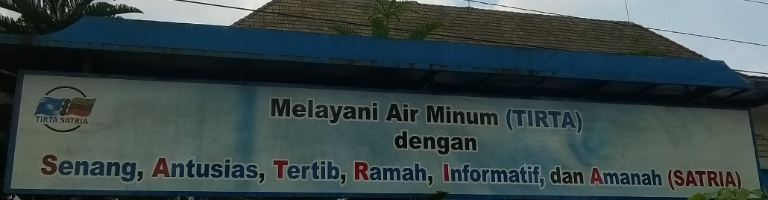
Figure 1. The slogan of Local Water Supply Utility
By seeing the example, it is rarely found that the government buildings which use a foreign language, such as English. This may be based on patriotism, yet on the other hand, Purwokerto is not a tourist destination of foreigners, thus it is surely difficult to find the official signs in bilingual. In other words, the use of language in official signs only use the native language, Indonesian as national language. This phenomenon will be found in the same circumstances throughout the city of Purwokerto.
Unlike the official signs, there are many non-official signs founded written by the citizens on the Soeharso street. As mentioned before, this street stands a lot of street vendors, shops, small and big restaurants, cafes, and hotels. This makes the linguistic landscape more complex. The street vendors in Figure 2 use banners as a place to put names, and all kinds of menus. The place where they occupy is only temporary, and after the merchandise runs out they will bring it home. With a background where the street vendors peddle their merchandise on the sidewalk, they use their name, sign and menu using only Indonesian. Meanwhile, for eateries that offer affordable prices and already have their own permanent place, they also use Indonesian language with an attractive and persuasive style of advertising language as we can see in Figure 3.
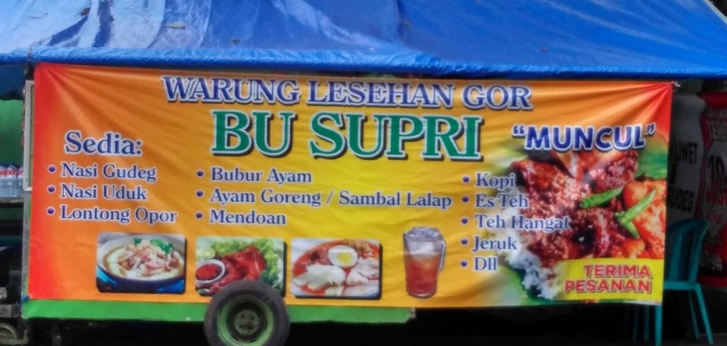
Figure 2. Street vendor’s banner
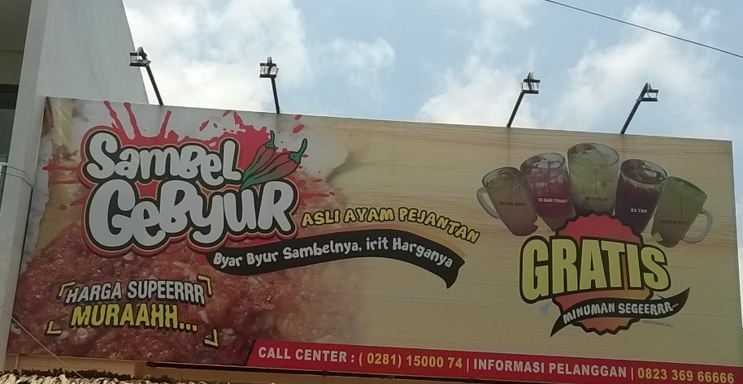
Figure 3. Persuasive on Eatery’s banner
This will be very different from the café where the price of menu is quite expensive and offers the very visible luxury place reflected in Figure 4. All the cafés on the Soeharso street have their name by using English. It is inevitable that English brings its own prestige in a society and believed that English brings the economic prosperity. Apart from the café, automotive repair shops also use English for goods sold. Similarly, computer accessories store use English a lot as well, due to people will be more familiar terms of computer and automotive devices in English. English is also a mainstay for distro in naming the clothing store as well as barbershops and laundry as depicted in Figure 5.
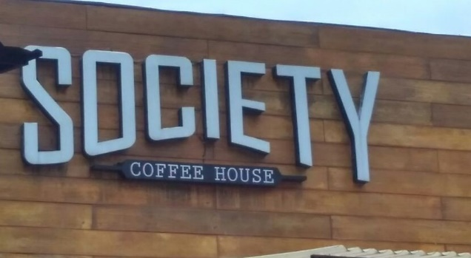
Figure 4. English on names of café
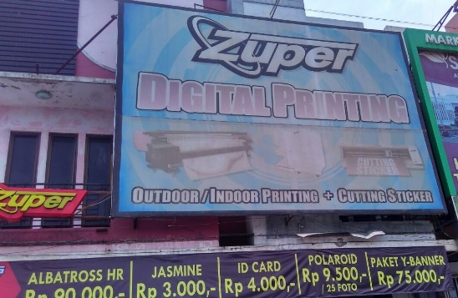
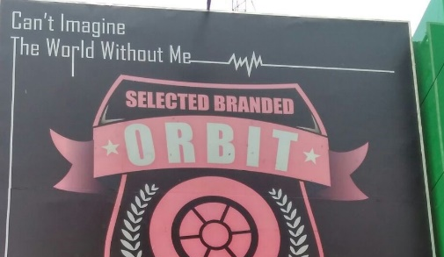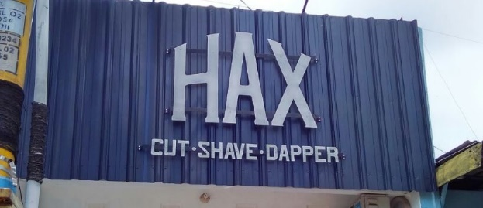
Figure 5. English on Printing house, Automotive, Distro, Barbershop
The other non-official sign in Figure 6 is also reflected in the banner advertisements in one of the hotels which uses three languages (multilingual) at once, and one of them is the Javanese called ngapak banyumasan used only in one word to attract the attention of anyone who see the banner. In fact, the use of English never lags behind and even takes the most vast place in the advertisement. We can see after that word, within the price, time, and description of the place where everything uses English. This proves that English remains the prestige of the main number in the trade field, such as a luxury hotel. It would rarely find the big hotel which does not use English.
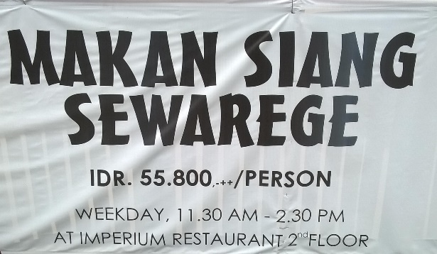
Figure 6. Javanese on hotel ads
From the above observations visible Indonesian language becomes the most widely used language in various sign. As this language is a national language that goes as well as natively. Then, English as a non-native language becomes the second most widely used language, but the exception is more widely used in more luxurious and prestigious places and requires a lot of money if you want to enjoy it. Last is the original language, Javanese that becomes like minority language in an advertisement or name for a store and restaurants. In fact, this language is the native language and even their mother tongue.
Direction of Translation
Phenomenon of language in Indonesia, specifically in Purwokerto have difference in translation to other country where in Indonesia, translation from Indonesian to foreign language happened in non-official signs. It is contrary to the phenomenon in Tokyo, Japan where they use other four languages, Japanese, English, Chinese, and Korean in official signs (Backhaus, 2006:6). In Indonesia, government only limit the use of one language in official signs that is Indonesian language yet inevitably allows to use English as a translation from Indonesian text to foreign language as it is in the current legal document which is bilingual. As we can see in Figure 7 where it is about the linguistics landscape in a hotel. It uses the direction translation from Indonesian to English, Korean, Japanese, and Chinese. Meantime, in public space such as stations in Indonesia, there is very seldom a sign uses translation with four languages. But it is precisely in the hotel where it is a private company. This landscape includes in non-official signs due to the writer comes from the company not government. Meanwhile, a service that does not need to get out of the vehicle is called drive thru, but in front of the government offices there is English term “drive thru” yet clearly translated means “enter/in”.
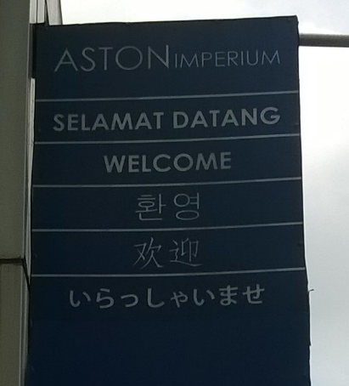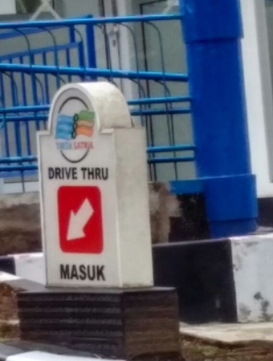
Figure 7. Greeting and sign “in”.
It is very little encountered the use of indonesian language and then translated into foreign language in a store name, advertising, or in the restaurants. Most of indonesian people only use familiar english term and easy to understand by many people. Although they include the english menu specialization under the restaurant name, but there is no sentence provided translation. Instead they use the indonesian language only when the menu that if translated into English will become unfamiliar, hence they only mix the term only without translating. We can more understand by seeing the picture in Figure 8.
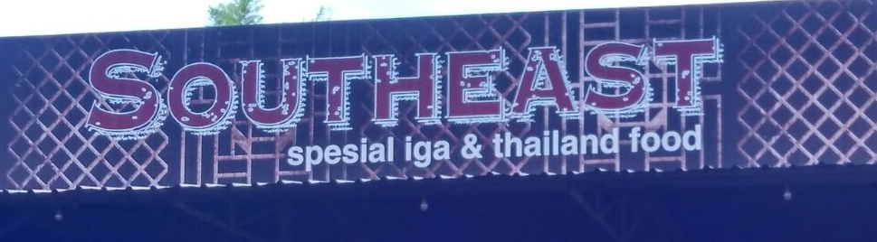
Figure 8. Thai food restaurant
Power and Solidarity
Language is capable of persuading and influencing a person. By using a good and interesting adverstisement language, there will be a response by anyone who witnessed it. Therefore, with a good choice of words and understanding of a cultural background of society, an advertisement will succeed in persuading people. This kind of thing can be found in various store names and food stalls in Purwokerto as the use of this language to obtain the solidarity of prospective buyers. As Spolsky and Cooper (1991) derived:
Its value from a desire to assert power (by controlling the languages of the sign, I declare power over the space designated) or to claim solidarity or identity (my statement of socio-cultural membership is in the language I have chosen).
The restriction on the use of language in the official sign by only using indonesian language is one example of power created by the government. The government tries to control people to love the national unity language through the application of language in the official signs. To get the impression that the seller has solidarity and relationships with buyers, many restaurants and eateries in Purwokerto using the name of the restaurant with a person’s name. We can observe it in Figure 9 which is often found in street vendors and restaurants. By naming a eatery or restaurant using person’s or owner’s name, it will give the impression that the quality is well known to the public and potential buyers will be easy to remember. For eatery like this, they still only use the indonesian language as a language of solidarity and because their target is from any circle, so it is easy to understand and remember without scaring about the price tag.
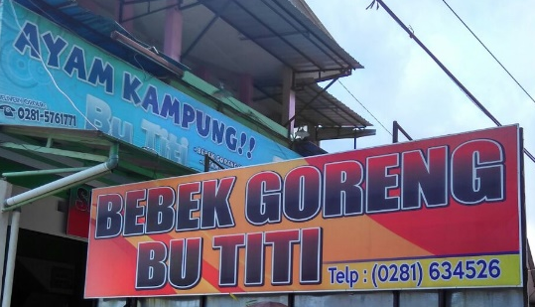 Figure 9. Diner’s name is person (owner) name
Due to the large number of people come from the outside of Purwokerto, there cannot be denied many merchants who include the name of their region or city as their food origin into the name of their shop or restaurant as reflected in Figure 10. This kind of thing is also often found from street vendors and restaurants. This strategy is used to attract buyers who are migrants from the other region as if to show identity and solidarity together. Moreover, the inclusion of regional names also aims to attract buyers to try what kind of taste from the original cuisine of the city or region. Everything is closely related to socio-cultural conditions in a region.
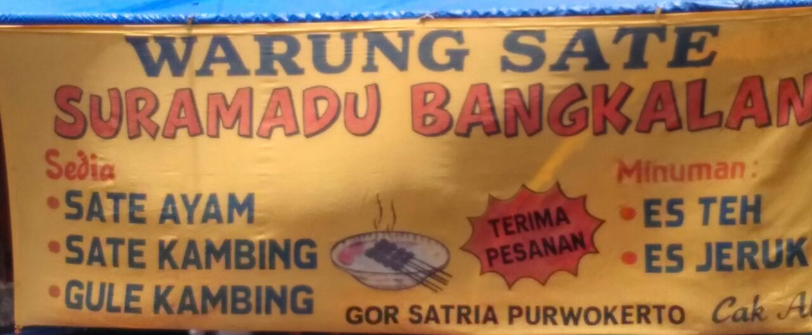
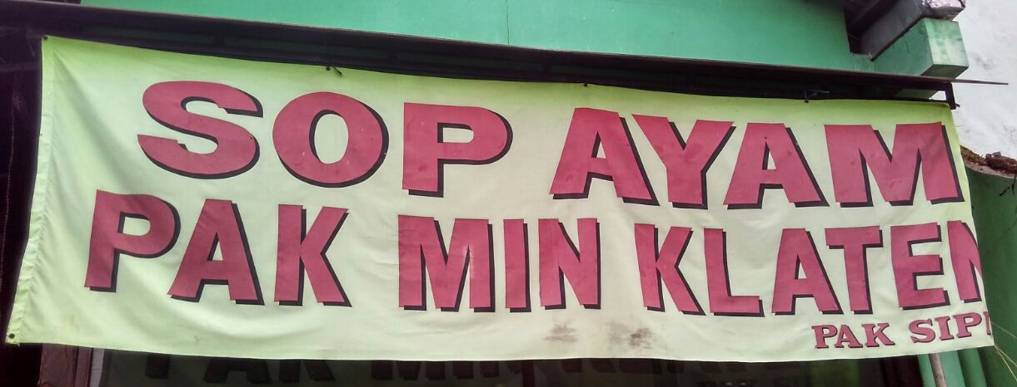
Figure 10. Original regional name

Conclusion
In this paper, researcher share the use of native language and non-native language scattered in various shops, restaurants, cafes, and hotels. Through this research can be concluded that the use of native language, Indonesian is the most widely used by various parties, ranging from the government in making official signs and the citizens who make non-official signs. Then, non-native language is English becomes the second language most widely used by the community in giving a name for the shops, restaurants, and advertising. Still, English dominates its use by luxurious and expensive places such as cafes and star hotels because it is considered prestigious and classy. Meanwhile, the use of native language, Javanese which is the original and as mother tongue Purwokerto citizens is extremely rare. And even then only found in the inserts in addition to the name of shops and advertising to attract people’s attention. The use of the name of the person as the name of the store and accompanied the origin of the food area is also easily found in Purwokerto. This is a manifestation of solidarity and relationship between the seller and the prospective buyer. The use of language for the shop and restaurant also use Indonesian language to eliminate the expensive price tag assumption. Through this research, the researcher hope people who will open the shops or restaurant to use the mother tongue of Javanese as a cultural preservation. The outline is the three languages, namely Javanese, Indonesian, and English are equally important. Thus, cultivated from various parties to be able to apply them in balance. Do not get it later, the language of Javanese ancestor is not used anymore.

References
Backhaus, Peter. 2006. Multilingualism in Tokyo: A Look into the Linguistic Landscape. Tokyo
Cenoz and Gorter. 2006. Linguistic Landscape and Minority Language. Basque, Amsterdam
Gorter, Durk. 2006. Linguistic Landscape: A New Approach to Multilingualism. Toronto: Multilingual Matter
Legum, Barton. 2005. Defining Investment and Investor: Who is Entitled to Claim. Paris
www.banyumas.dapodik.org accessed on October 10

