THE IMPACT OF SHORT VIDEOS FEATURE ON SOCIAL MEDIA TOWARD INDONESIAN’S ENGLISH ACQUISITION
Dwi Lia Rakhmasari, Berlin Insan Pratiwi
Universitas Putra Bangsa
dwiliarakhmasari@gmail.com, bipratiwi@gmail.com
ABSTRACT
Social media is able to make an individual can get information, entertainment even jobs easily from their home. Learning language through social media become popular method for some people. Most famous social media platforms like Instagram, YouTube and TikTok use short video to give entertainment toward internet users. Using short video in social media tent learners to have unintentional or unplanned learning since many uses the applications almost every day. This study explained the impact of short video features on social media toward Indonesian English acquisition. It used a descriptive qualitative design. Descriptive qualitative design is research designed to obtain information about current status phenomena. The respondents consist of 494 Indonesian from different age 13-15 y.o, 16-18 y.o, 19-25 y.o, 26-35 y.o, >35 y.o Once the data was collected, all the answers were reviewed and analyzed, and conclusions formulated. This research found out that TikTok become the most popular application for Indonesian in the age 13-25 y.o followed by Instagram YouTube. Instagram become the most popular application for Indonesian in the age 26- > 35 y.o followed by TikTok and YouTube. This study found out that Indonesian believe the most significant impact toward their English are vocabularies. 94,1% respondents said that they get a lot of vocabularies from the video. 87.9% respondents said that since they get a lot of vocabularies from the video it is helpfull for themto easily understand about what they read. Besides, 87.4% respondents said that they improve their speaking skill after watching short video. 83,6 % respondent said that they imitate what they hear from the short video on social media and unconsciously improve their listening skill after watching short video. The last, 69.8% respondents believe that their writing improve.
Keywords : Short Video, Influence, English Acquitition
Article History:

INTRODUCTION
Nowadays, social media has become a very important tools in human life. Socil media has also become addiction for some people since it used mostly to provide contentment and entertainment (Sood, S. et al, 2020). This phenomanon also brings people to effortless accomplishment era which people tent to get maximum gain but minimum effort (Roshdi, N.I.A., & Rahmat, N.H., 2023). This is able to make an individual can get information, entertainment even jobs easily from their home.
Association of Indonesian Internet Network Providers, or Asosiasi Penyelenggara Jaringan Internet Indonesia (APJII) in Bahasa Indonesia reve aled that more than half of Indonesia's population has now been connected to the internet (APJII, 2017). Most of internet user use internet to open social media. Indonesia, as the biggest social media users in south east asia use it as a medium to connect and communicate with other people across the globe. For some users like teachers, often take social media advantage not only a place to communicate and connect with people, but also a platform for learning. Some experts reveal that the usage of social media is a beneficial tool of classroom learning for students and it also has changed the delivery style of teaching and learning (Shahril, A. et al, 2018)
Knowing that learning a language especially english is not an easy task. People are taking both formal and infromal learning to improve their language usage. In formal learning, the activity is sequenced and arranged by a teacher. The activities are usually carried out by teachers in the classroom. In informal learning, none sequenced the activity. The learning process naturaly happen without arranged beforehand (Fathqi, 2021). Learning language through social media become popular method for some people. Most famous social media platforms like Instagram, YouTube and TikTok can be used as a learning platform. Those are quite popular to learn language especially English. Moreover, those applications have very popular features called short video. In the development of internet quality with 5G technology, short video explosion become a very happening situation recently. The characteristics of short video applications are a low entry threshold, convenient viewing, and perfect social functions (Duan, 2022).
Nowadays, since the demand of short videos increase, besides TikTok, some applications compete to make this feature for example Instagram with Instagram reels, and YouTube with YouTube short. Among them, English, as one of the mainstream languages, has become the choice of most language video creators and viewers. Short video in TikTok, YouTube and Instagram provided an endless supply of English content which enabled them to continuously practice their English skills especially listening, expanding their vocabulary, and improve their pronunciation knowledge (Duan, 2022). Using social media tent learners to have unintentional or unplanned learning since many uses the applications almost every day. With all the short video explosion era, this research explains
- the most used application for Indonesian and Indonesian attitudes toward the applications,
- the impacts of using the application toward their English language acquisition
- what English language acquitition that get the most significant impact from the application.
Some researchers have done multiple studies about learning language through videos in social media. This research is significantly inspired by the theories about motivation and the success of learning language through videos especially short videos in social media. Learning language through social media can give motivation toward learners since social media is part of entertainment. It is supported by Omar and Dequan (2020) that examined the use of TikTok in terms of consuming, participating and producing behaviours. This theory was incorporated in the study and through a survey involving 385 participants, it was revealed that users’ motivations have a significant influence on TikTok use. Based on their study, the motivations for using TikTok include archiving, self-expression, social interactions, and escapism. Besides, there was also a study from Bossen and Kottasz (2002) that applied this theory to examine the motivations of pre-adolescents and adolescents’ TikTok usage. They found that passive consumptive needs like surveillance, relaxation, gathering information and seeking for entertainment are the most important gratifications sought when using TikTok.
Learning language trough short video on social media also give a significant influence toward learners. Xiuwen & Razali (2021) did a study about TikTok and how it impacts on English language communication competence acquisition among Chinese international undergraduate students by reviewing previous and recent studies focusing on TikTok as well as other social medias such as Facebook, YouTube, WeChat and so on. Roshdi and Rahmat (2023) also explored the influence of TikTok on form and meaning among undergraduates. The research revealed that TikTok have influence on form and meaning. Findings also showed that there is a positive moderate relationship between TikTok motivation with form as well as meaning. The findings gathered in this study show that TikTok can be used as an alternative to teach and improve language learners’ vocabulary and TikTok videos can be integrated in lesson plans as a complementary material by educators to teach language learners vocabulary.
Even though this study inspired by some of those studies, it has significant difference among those studeis. This reasearch focus on Indonesian English acquitition toward the use of social media in their daily life. This explored how instagram reels, TikTok and YouTube short give significant unintentionally impact toward indoneisian’ English aquitition.

METHOD
This study explained the impact of short video features on social media toward Indonesian English acquisition. It used a descriptive qualitative design. Descriptive qualitative design is research designed to obtain information about current status phenomena. In qualitative research, there is little or no statistics. Based on this theory, the research design in this research is a descriptive design with a qualitative approach (Nassaji, 2015).
In gaining the data, researchers used questionare. A questionnaire previously used to investigate influence of cartoons on foreign-language acquisition (Postic, 2015) and influence of video games on the acquisition of the english language (rudis and postic, 2018) was heavily modified to examine the impact of short video toward Indonesia English acquisition. The research consists of 494 Indonesian from different age 13–15-year-old, 16–18-year-old, 19–25-year-old, 26–35-year-old, >35-year-old. Each respondent is questioned 16 different questions related to the most used social media application and their attitudes toward the application, the impact of the application toward their English acquisition and what English learning that get the most significant impact toward the application. Once the data was collected, all the answers were reviewed and analyzed, and conclusions formulated.

RESULT AND DISCUSSION
The most used application for Indonesian
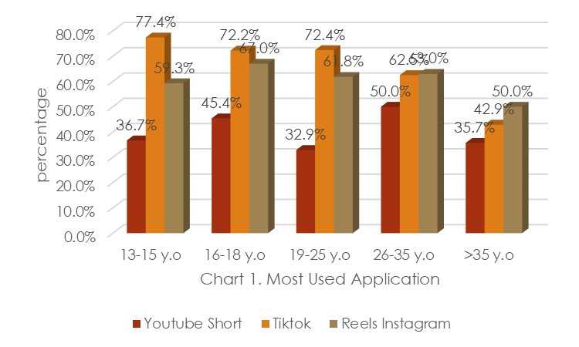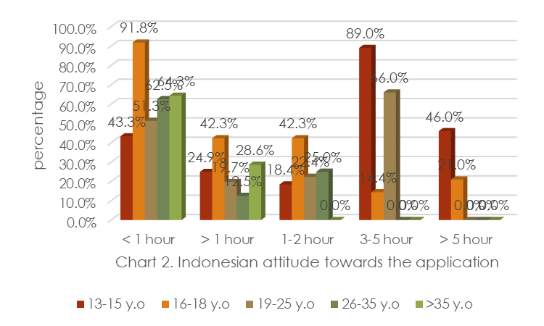

This research gathered the data from Indonesian who use social media in mist of their free time. Data are divided into several age variation. They are 13–15-year-old, 16–18-year-old, 19–25-year-old, 25–35-year-old and more than 35-year-old. The questions given to the respondent were to see what application that is the most used in their free time. This research found out different answers from different age variation. TikTok become the most popular application for Indonesian in the age of 13-25 followed by Instagram and YouTube. Instagram become the most popular application for Indonesian in the age 26->35-year-old followed by TikTok and YouTube.
From the questioner questions asked, it found out that most of respondent believe that social media especially TikTok, Instagram and YouTube are useful for their life. Most of them also spend most of their free time using social media. They also answer that they use social media to watch short video about 1- 5 hours a day. 93% respondent believe that watching short video on social media give positive impact toward their life.

The impacts of using Instagram reels, TikTok, or YouTube short for Indonesian’s English language acquisition
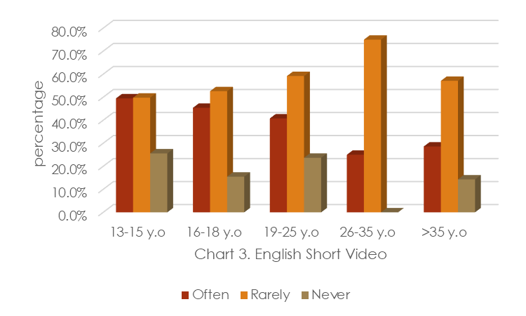
Short video explosion happens in almost all of popular social media application in Indonesia. TikTok as the pioneer and followed by Instagram with Instagram reels and YouTube with YouTube short. This is kind of marketing competitions since TikTok with short video become more popular recently. The impact of short video in social media toward their English acquisition starts from how often Indonesian try to find English video short on their social media especially YouTube short, Instagram reels and TikTok. It is actually not really hard since most of short video use English as the language medium. This research found out 46,6% respondents said that they frequently watch short video in English and 52,2% respondent said that they rarely watch short video in English. This mean exposure short video in English on social media is quite significant.
The questions asked in this research also explored how respondent get English exposure from the short video in social media. From the questions asked, 76,3 % respondents are exposed English from the video back sound, 68,8 % from the conversation on the video and the rest said that they found English from the meme, caption, quote, advertisement and description.
71,7 respondents explained that they mostly read English passage from the short video, 75,2% respondents listen English exposure from the short video, 24, 5 %, respondent tried to imitate the English exposure from the English short video in social media. Respondents also explained that after they got exposure from English short video in social media, they guessed the meaning of the English or translate it through google translate or dictionaries.
Surprisingly, the respondent also said that they unconsciously use the English that they learnt from social media in their daily life. They said that they frequently use English when they are talking to friends, playing games, being angry, singing, doing nothing in free time, talking to strangers on OMETV, talking to themselves in the mirror, being confused, and learning in English class.
English language acquitition that get the most significant impact toward Indonesian
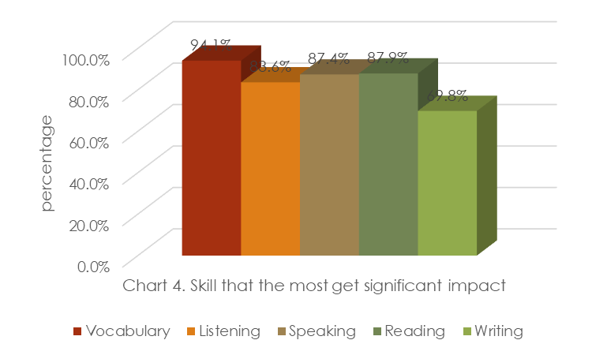
Learning English is not an easy task. Learning English could be from memorizing each word, making good sentences until using it in daily use or conversations. Overall, from all the answers given by the students, it appears that short video on social media have a considerable influence on language learning. 92,1 % respondents believe than short video on social media helps them to learn English.
This study gave several questions toward Indonesian in order to get their thought about English learning that get most significant impact through short video on social media. This study found out that Indonesian believe the most significant impact toward their English are vocabularies. 94,1% respondents said that they get a lot of vocabularies from the video. One thing that is very clear from the answers of this questionnaire is that short video are an undeniably great resource for vocabulary expansion, since almost everyone that took the questionnaire confirmed that short video provides a great number of new words to learn.
87.9% respondents said that since they get a lot of vocabularies from the video it is helpfull for themto easily understand about what they read. Short video on social media help people to read better than before since after they read, they tend to search the meaning on dictionaries or google translate. Besides, 87.4% respondents said that they improve their speaking skill after watching short video. It is proven by using English in their daily life especially in normal occasion like angry, being confused, talking to friends, playing games, being angry, singing, doing nothing in free time, and talking to themselves in the mirror.
More than that since the video also provide the way how English vocabularies pronounce, Indonesian tend to imitate the pronunciation from the short video. 83,6 % respondent said that they imitate what they hear from the short video on social media and unconsciously improve their listening skill after watching short video. They said that they often imitate the words or sentences that they listen from the video. The last, 69.8% respondents believe that their writing improve. From the open questionare asked by the researchers, some of them can show by their ability to write full sentences correctly. They explained that what they write in the open questionare are taken from what they read in the short video on social media.

CONCLUSION
Recently, more experts agree that short video on social media can influence language acquisition in a positive way. The questionnaire is one of the most helpful in determining the advantages in learning a language both in active ways and in the passive exposure to the language during watch. This research strengthens the theory talking about short video on social media can influence English acquisitions. The English short video explosions on social media become reasonable reasons on how Indonesian can get more knowledge about English language. Moreover, most of Indonesian internet users used more that 2 hours a day to open social media. Many people debated about good and bad impacts of social media. Here, researchers are trying to explain instead of focusing on bad impact, people can start take advantage of short video on social media as learning medium. This research obviously proves that English short video on social media can give positive impact toward Indonesian’s English acquisition. This research can become recommendation for language teachers to use social media as learning media. This research also can give different point of view for stake holders and content creators that what we create on social media can give very significant influence toward users.
References
Asosiasi Penyedia Jasa Internet Indonesia. Profil Pengguna Internet Indonesia 2014 (Profile of Indonesian Internet User 2016), 2017. APJII. Jakarta. 83-85.
Bernard, A. V. (2021). Expanding ESL students’ vocabulary through TikTok videos. Lensa:
Bossen, C., & Kottasz, R. (2020). Uses and gratifications sought by pre-adolescent and adolescent TikTok consumers. Young Consumers, 21(4), 463–478. https://doi.org/10.1108/yc-07-2020-1186
Cagas, R. L. D. (2022). The use of TikTok videos in enhancing the speaking and grammar skills of higher education students. Language Education Forum, 3(1).https://doi.org/10.12691/lef-3-1-
Iqbal, M. (2022, August 19). Tik Tok Revenue and Usage Statistics. Business of Apps. https://www.businessofapps.com/data/tik-tok-statistics/
Kajian Kebahasaan, Kesusastraan, Dan Budaya, 11(2), 171. https://doi.org/10.26714/lensa.11.2.2021.171-184
Nassaji, Hossein. 2015. Qualitative and descriptive research: Data type versus data analysis. Language Teaching Research.Vol. 19(2) 129–132. DOI: 10.1177/1362168815572747
Omar, B., & Dequan, W. (2020). Watch, share or create: The influence of personality traits and user motivation on TikTok mobile video usage. International Journal of Interactive Mobile Technologies (IJIM), 14(04), 121. https://doi.org/10.3991/ijim.v14i04.12429
P OŠTIĆ, S., 2015. Influence of Cartoon Network on the Acquisition of American English During Childhood. Verbum, 6, 188–195
Roshdi, N.I.A., & Rahmat, N.H.,.2023. How does Tiktok Influence the Acquisition of Form and Meaning in Language Use?. International Journal of Academic Research in Business and Social Sciences, 13(4), 1435-1450. http://dx.doi.org/10.6007/IJARBSS/v13-i4/16803
Rudis, Domas and Svetozar Postic, 2018. INFLUENCE OF VIDEO GAMES ON THE ACQUISITION OF THE ENGLISH LANGUAGE. Verbum, 8, 112
Safitri, M. (2021). Students’ Perception of the Use of Social Media for Learning English (A Case Study at the Eleventh-Grade Students of SMA Al-Hasra in Academic. 93.
Shahril, A., Hamid, R., Tarmudi, S., Chik, C. T., & Noh, I. (2018). Using social media as one of learning tool: Facebook enhances learning practices among higher learning students in Malaysia. International Review of Management and Business Research, 7(2), 380–386. https://doi.org/10.30543/7-2(2018)-7
Sood, S.; Verma, R.; & Pal. A.K. 2020.A Review of Use of Social Media and its Significance. Journal of Critical Reviews
Sun, Shengnan. (2022). Research on the influence of short video on oral English teaching in higher vocational colleges. Journal of News Research, 13(6), 71-73.
Xiuwen, Z., & Razali, A. B. (2021) An Overview of the Utilization of TikTok to Improve Oral English Communication Competence among EFL Undergraduate Students. Universal Journal of Educational Research , Vol 9(7), pp 1439-1452. https://www.hrpub.org/download/20210630/UJER10-19523501.pdf

