Hasil Uji Penghambatan Tirosinase
- Formula 1 (2%)

Tabel % Inhibisi Tirosinase Formula 1
Nama Uji | Konsentrasi (ppm) | Log Kons. (ppm) (X) | Abs | % Inhibisi | Probit (Y)
Blanko |  |  | 0,135
Kontrol Normal |  |  | 0,74 | 0
Kontrol Positif |  |  | 0,406 | 45,14 | 4,8769
Sampel Gel 25 ppm | 25 | 1,397940009 | 0,371 | 49,86 | 4,9975
Sampel Gel 50 ppm | 50 | 1,698970004 | 0,344 | 53,51 | 5,0878
Sampel Gel 75 ppm | 75 | 1,875061263 | 0,342 | 53,78 | 5,0954
Sampel Gel 100 ppm | 100 | 2 | 0,336 | 54,59 | 5,1156
Sampel Gel 125 ppm | 125 | 2,096910013 | 0,271 | 63,38 | 5,3425
Sampel Gel 150 ppm | 150 | 2,176091259 | 0,205 | 72,3 | 5,5918
Kontrol Negatif |  |  | 0,718 | 2,97 | 3,1192

Grafik % Inhibisi Tirosinase Formula 1
Perhitungan IC₅₀ :
a = 4,049111146 y = a + bx
b = 0,616803028 5 = 4,049111146 + 0,616803028 x
r = 0,801367805 x = 1,541640519
IC₅₀ = antilog x
= 34,80 µg/ml

- Formula 2 (2,5%)
Tabel % Inhibisi Tirosinase Formula 2
Nama Uji | Konsentrasi (ppm) | Log Kons. (ppm) (X) | Abs | % Inhibisi | Probit (Y)
Blanko |  |  | 0,135
Kontrol Normal |  |  | 0,74 | 0
Kontrol Positif |  |  | 0,406 | 45,14 | 4,8769
Sampel Gel 25 ppm | 25 | 1,397940009 | 0,365 | 50,67 | 5,0175
Sampel Gel 50 ppm | 50 | 1,698970004 | 0,339 | 54,19 | 5,1055
Sampel Gel 75 ppm | 75 | 1,875061263 | 0,321 | 56,62 | 5,1662
Sampel Gel 100 ppm | 100 | 2 | 0,305 | 58,78 | 5,2224
Sampel Gel 125 ppm | 125 | 2,096910013 | 0,299 | 59,6 | 5,243
Sampel Gel 150 ppm | 150 | 2,176091259 | 0,287 | 61,21 | 5,2845
Kontrol Negatif |  |  | 0,702 | 5,14 | 3,3668

Grafik % Inhibisi Tirosinase Formula 2
Perhitungan IC₅₀ :
a = 4,533461235 y = a + bx
b = 0,341337657 5 = 4,533461235 + 0,341337657 x
r = 0,996817866 x = 1,366795475
IC₅₀ = antilog x
= 23,27 µg/ml

- Formula 3 (3%)

Tabel % Inhibisi Tirosinase Formula 3
Nama Uji | Konsentrasi (ppm) | Log Kons. (ppm) (X) | Abs | % Inhibisi | Probit (Y)
Blanko |  |  | 0,135
Kontrol Normal |  |  | 0,74 | 0
Kontrol Positif |  |  | 0,406 | 45,14 | 4,8769
Sampel Gel 25 ppm | 25 | 1,397940009 | 0,355 | 52,02 | 5,0502
Sampel Gel 50 ppm | 50 | 1,698970004 | 0,334 | 54,86 | 5,1231
Sampel Gel 75 ppm | 75 | 1,875061263 | 0,319 | 56,89 | 5,1738
Sampel Gel 100 ppm | 100 | 2 | 0,311 | 57,97 | 5,2019
Sampel Gel 125 ppm | 125 | 2,096910013 | 0,283 | 61,75 | 5,2976
Sampel Gel 150 ppm | 150 | 2,176091259 | 0,275 | 62,83 | 5,3266
Kontrol Negatif |  |  | 0,697 | 5,81 | 3,4282

Grafik % Inhibisi Tirosinase Formula 3
Perhitungan IC₅₀ :
a = 4,539316143 y = a + bx
b = 0,350138973 5 = 4,539316143 + 0,350138973 x
r = 0,965343474 x = 1,315717165
IC₅₀ = antilog x
= 20,69 µg/ml

Kurva Aktivitas Inhibitor Tirosinase Gel Ekstrak Daun Teh Hijau pada Formula 1

Kurva Aktivitas Inhibitor Tirosinase Gel Ekstrak Daun Teh Hijau pada Formula 2

Kurva Aktivitas Inhibitor Tirosinase Gel Ekstrak Daun Teh Hijau pada Formula 3

Surat Keterangan Determinasi Tanaman

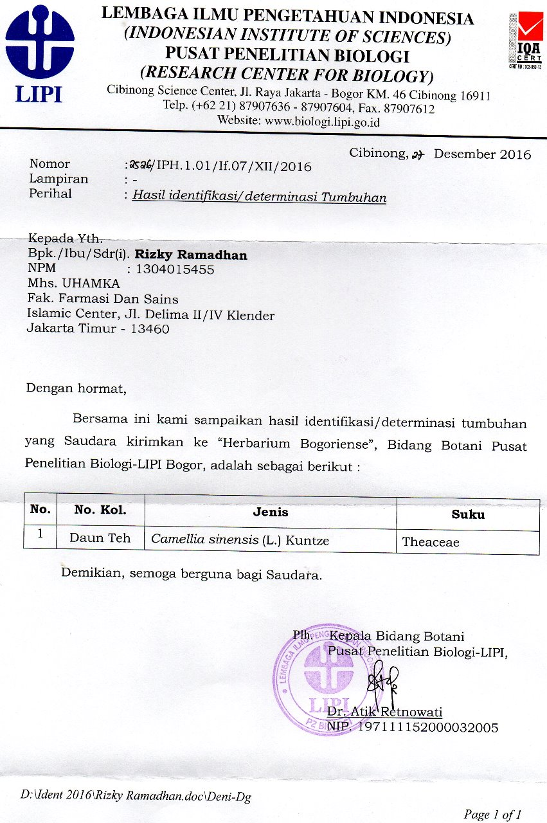

Certificate of Analysis Enzim Tirosinase

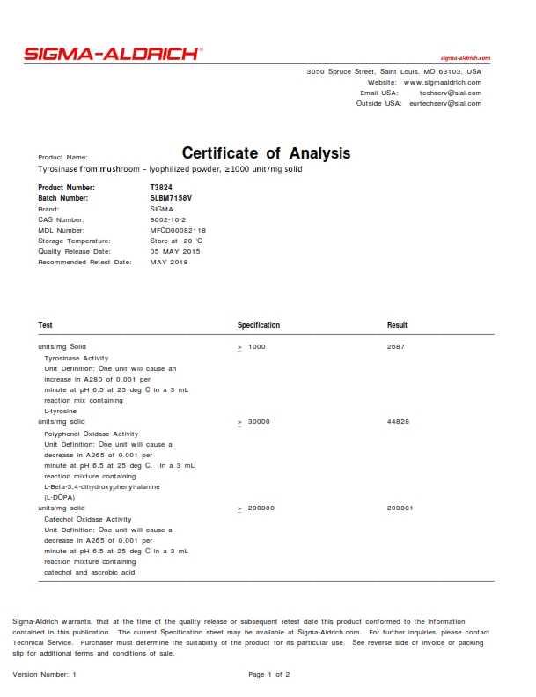
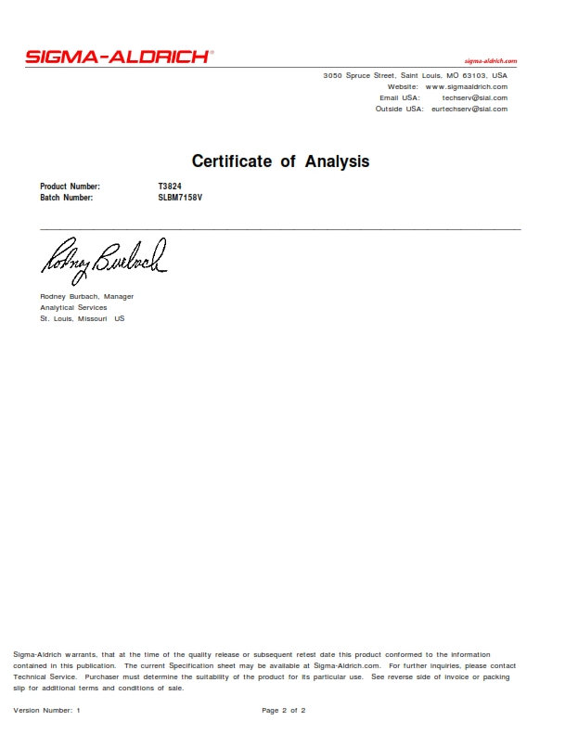

Serbuk Halus Daun Teh Hijau (a), Ekstrak Kental Daun Teh Hijau (b), Mikroskop Optik (c), Ektrak Cair Daun Teh Hijau (d), Ekstraksi dengan Refluks (e), Vaccum Rotary Evaporator (f).

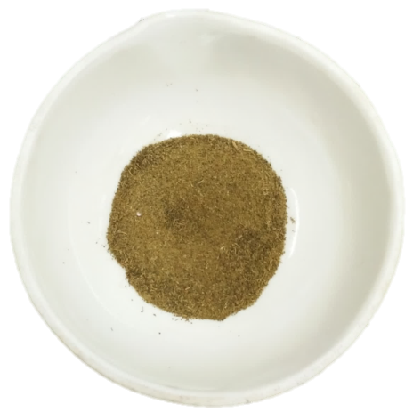  (a) | 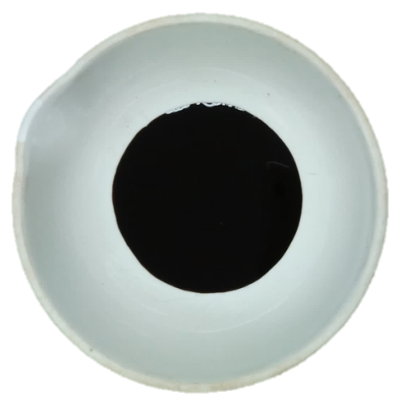  (b)
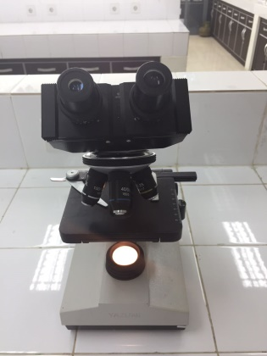  (c) | 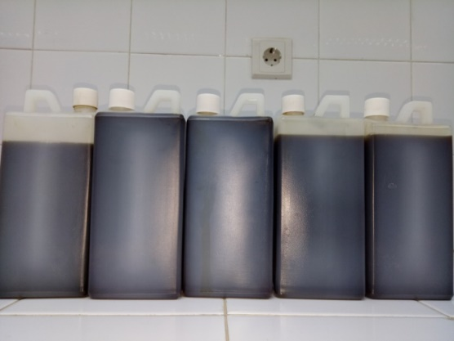  (d)
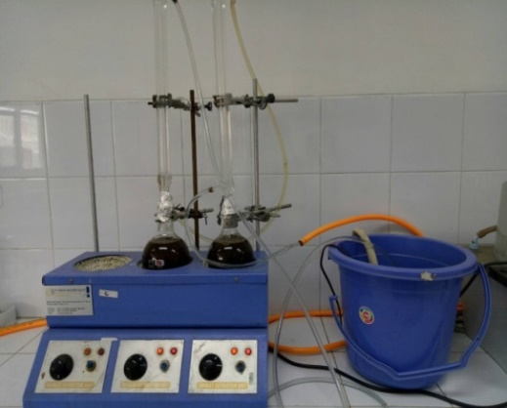  (e) | 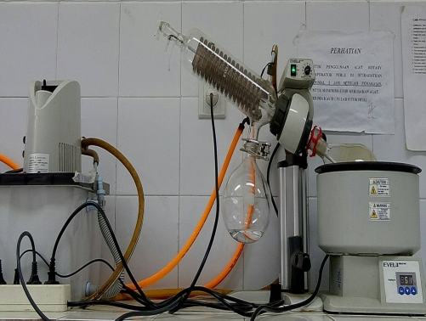  (f)

Hasil Identifikasi Tanin : Gelatin 10% (a), Gelatin-Nacl (b), FeCl₃ (c), Hasil Identifikasi Fenol (d), Reagent FeCl₃ (e), Reagent Folin Ciocalteu (f).
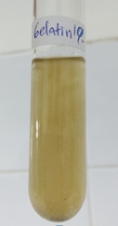  (a) | 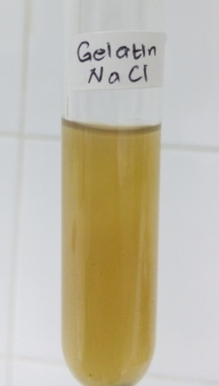  (b)
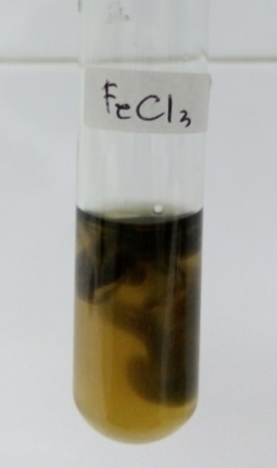  (c) | 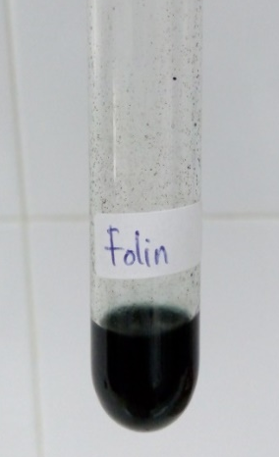  (d)
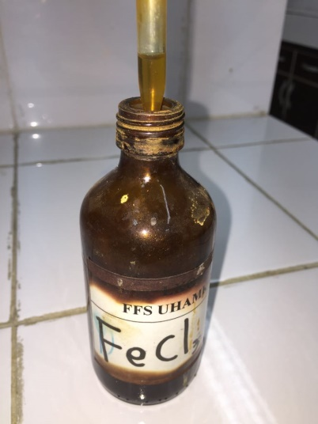  (e) | 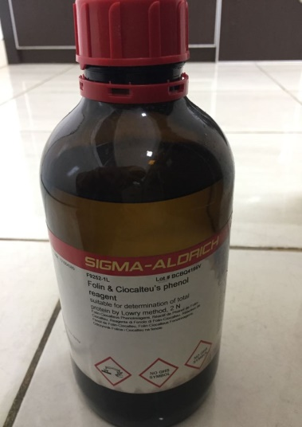  (f)

