*Analysis of Body Work Posture in Midwives During Placental Retention*

**Firdaus Ashari1,a), Rohmat Subodro2**

*1Industrial Engineering, Departement Faculty of Engineering, Universitas Nahdlatul Ulama Surakarta*

[1,a) *Corresponding author*: firdausashr9@gmail.com](mailto:1,a)%20Corresponding%20author:%20firdausashr9@gmail.com)

*2Mechanical Engineering, Departement Faculty of Engineering, Universitas Nahdlatul Ulama Surakarta*

[2rsubodro@gmail.com](mailto:2firdausashr9@gmail.com)

***ABSTRACT***

*The midwife's working posture when taking the placenta attached to the uterus of the laboring mother manually shows the body's posture which can cause musculoskeletal disorders. This research aims to know and study the assessment of the REBA method for midwife workers' posture in the prevention of musculoskeletal disorders. This research method is a type of observational analytic study that uses descriptive qualitative in total sampling among midwife workers. Data was collected using a REBA sheet. The results showed the results of the assessment using REBA with a final score of 13 has a level of risk "Very High" and requires immediate corrective action. This risk is caused by the back being bent and twisting laterally, the midwife's neck twisting laterally, the upper arm of the worker experiencing flexion, and the position of the arm is raised away from the body due to the position of the uterus being far and narrow. Suggestions given are efforts to control engineering, the provision of work procedures, and the procurement of healthy safety work.*

***Keywords: Musculoskeletal disorders; midwife; Rapid Entire Body Assessment (REBA).***

**INTRODUCTION**

Musculoskeletal disorders are widely recognized as a cause of severe long-term pain and physical disability affecting hundreds of millions of people worldwide. Work-related musculoskeletal disorders are common among healthcare workers including midwives or professional nurses and can lead to permanent disability, loss of working hours, as well as the need for long-term medical care (Akodu and Ashalejo, 2019). In the UK, data on nurses and midwives are reported collectively, the workforce profile is almost the same. More than 31% of registered nurses and midwives in 2008 were over 50 years old. Worryingly, the percentage of nurses and midwives over 40 years is less than 65%, while those aged less than 30 years represented more than 9% of the 2008 total (Nowotny-Czupryna *et al.*, 2012).

Therefore, this increased workload will of course increase the risk of the work such as physical complaints and fatigue due to increased work demands. The risk of skeletal muscle complaints in midwives is 40.8% complaints of pain in the neck and 24.5% in the upper back (Long, Johnston and Bogossian, 2012). This can lead to increased sickness and leave from work, of course, this creates a burden on the organization.

The physical complaints experienced by midwives can occur due to a lack of working awareness ergonomically and less supportive work equipment, forcing the user to adapt to an uncomfortable body position (Bazazan *et al.*, 2019). Currently, government midwives are confronted with work equipment that has been provided by their agency, which is not always comfortable and safe for its users, for example, a delivery room that is too narrow, a static delivery bed and a size that is too low for the working midwife's height, resulting in risk for musculoskeletal disorders (Wajdi and Cahyadi, 2016a).

Employability is defined as the capacity of workers to perform work taking into account the demands of the job, health, and mental resources. Workability is the number of factors that enable employees in a given situation to successfully manage the demands of their work. Musculoskeletal disorders at work are a significant cause of health problems among the working population (Tarwaka, 2015). Impaired workability is believed to be the result of an imbalance between job demands and individual resources (Akodu and Ashalejo, 2019). Therefore, job characteristics such as working conditions and job demands are the main determinants of employability (Nowotny-Czupryna *et al.*, 2012).

Retention of the placenta or manual placenta is an attempt to release the placenta manually by inserting the hand and "combing" and releasing the placenta that is sticky to the uterine wall manually. Midwives should wear sterile gloves up to the elbows, pour antiseptic over the gloved hands and insert their hands through the vagina and into the uterine os. Meanwhile, the other hand is the fundus to guard the uterus. To expel the placenta that has not yet separated the uterus is gently massaged, therefore it is well contracted, and by placing 4 fingers behind the uterus and the thumb in front of it, the uterus is squeezed between the fingers to release the placenta from the uterine wall and push it outward. This action is not always successful and should not be done roughly (Aprillia, 2020 <http://www.bidankita.com/plasenta-lengket-retensio-plasenta/>)

.

Before performing retained placenta, the patient was prepared in the lithotomy position. The general condition of the patient is improved as much as possible or infused with NaCl or *Ringer's lactate*. The operator stands or sits in front of the vulva with one hand (left hand) stretching the umbilical cord, while the other hand (right hand) with the fingers folded into a cone. With fingertips trace the umbilical cord to the placenta. If at the time of passing through the cervix there is resistance from the *constriction ring*, this can be overcome by slowly expanding the fingers to form a cone. Meanwhile, the left hand is placed on the uterine fundus from outside the mother's abdominal wall while holding or pushing the fundus down (Aprillia, 2020 <http://www.bidankita.com/plasenta-lengket-retensio-plasenta/>). Once the inner hand reaches the placenta, trace the fetal surface toward the edge of the placenta. In the third stage of bleeding, there is usually a detached edge of the placenta. Through the gap, slide the ulnar part of the hand that is between the uterine wall and the detached part of the placenta. With hand movements such as scraping water, the placenta can be completely released, while the outside hand still holds the uterine fundus, therefore, it should not be pushed up (Honestdocs, 2020 <https://www.honestdocs.id/retensio-plasenta>).

Measurement of physical stress is quite difficult because it involves various subjective factors such as; performance, motivation, expectations, and fatigue tolerance (Waters *et al.*, 1993). Many varied ergonomic measuring tools can be used. However, from the various measuring instruments and various existing methods, of course, each has its advantages and limitations. For that, we should be able to selectively choose and use the right method according to the purpose of the observation to be carried out, one of which is the Rapid Entire Body Assessment (REBA) method (Rinawati, 2016). The REBA method is a postural analysis tool that is very sensitive to jobs that involve sudden changes in position, usually as a result of unstable or unpredictable container handling . The purpose of this research was to find out and examine the assessment of the midwife's posture REBA method in the prevention of musculoskeletal disorders (Tarwaka and Sudiajeng, 2004).

**METHODS**

The methodology of this research is analytic observational research using qualitative descriptive on a total sampling of all midwives. The subjects involved 24 midwives from the Jogorogo District Health Center. Data collection was carried out using the REBA assessment sheet. The following is a table of respondent data:

Tabel 1. Respondent Data

|  |  |  |  |
| --- | --- | --- | --- |
| Characteristics | n | Mean | SD |
| Gender |  |  |  |
| Female | 24 |  |  |
| Age |  | 38,7 | 9,7 |
| Length of work (years) |  | 13,8 | 9,4 |
| Height (cm) |  | 156,5 | 2,6 |
| Weight (Kg) |  | 56 | 6,2 |
| Education |  | D4 |  |
| -College | 24 |  |  |
| Number of working days/week |  | 6 |  |

The Assessment using the REBA method through the following stages: **Step 1** Collecting worker posture data using photos. To get an idea of posture, neck, back, arms, as well as wrists to feet. **Step 2** determines the angles of the worker's body parts. After obtaining photos of the worker's body postures, the calculation of the angle of each body segment includes the back (torso), neck, legs (group A), upper arms, forearms, as well as wrists (group B). **Step 3** determines the weight of the object being lifted, *coupling*, and worker activities. **Step 4** calculates the REBA value for the posture in question. After getting the score from table A, it is added up with the score for the weight of the load being lifted, therefore it gets the value of part A (Wajdi and Cahyadi, 2016). Meanwhile, the score from table B is added up with the score from the *coupling* table to get the value of part B. the value of part A and part B can be used to find the value of part C from the existing table C. REBA value is obtained from the sum of the value of part C with the value of worker activity (Rinawati, 2016).

From the REBA value, it can be seen the level of musculoskeletal risk and the actions that need to be taken to reduce risk and improve work. The REBA value is obtained by looking at the values from categories A and B in table C to obtain a C value which is then added up with the value/score for the type of muscle activity.

**RESULTS AND DISCUSSION**

The results of this study are the results of the assessment sampling analysis based on REBA. Labor with retained placenta does not occur often, but all professional midwives should be able to properly master the manual practice of the placenta to patients. This is because the manual placenta in patients or mothers giving birth cannot be predicted whether the patient during delivery occurs bleeding and the placenta should be removed manually or the delivery process is normal or there is no retained placenta. The health and fitness conditions of all respondents are generally in good condition and quite good. Every midwife who will give birth needs to prepare personal protective equipment which has been provided by the Puskesmas, therefore, the conditions and places used for childbirth are clean and not contaminated by viruses or bacteria (Wajdi and Cahyadi, 2016). The personal protective equipment consists of masks, long *handscoon*, clothes for childbirth, face shields, google goggles, and boots. After all personal protective equipment is ready, furthermore, the midwife should check the patient's condition before delivery, therefore, the midwife can find out all the patient's conditions and can deal with any problems. Midwives carrying out placental retention activities are with working postures as shown in the following table:

Table 2. Midwife's work posture

|  |  |
| --- | --- |
| Activity | Work Posture |
| The labor with retained placenta | 1. Hand posture: |
|  | Insert the right hand in the obstetric position, the inner hand along the umbilical cord, the obstetric hand is opened, and move the hand left and right |
|  | 1. Neck posture: |
|  | Bend the neck and tilt to the right or left |
|  | 1. The posture of the torso: |
|  | Bend and tilt to the right |
|  | 1. Foot posture: |
|  | Straight leg and one leg bent back |

Factors that cause complaints by midwives include the curved position of the hands when inserted into the narrow uterus for a long time, and unnatural work attitudes such as being too bent back, as well as standing too long. The Assessments of labor activity with retained placenta are:

1. The Assessment of table A (group A)

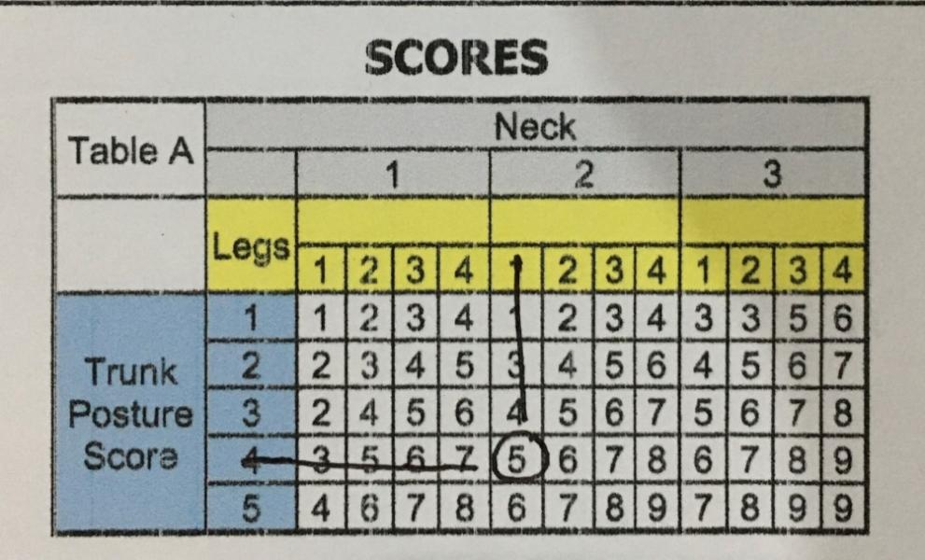

Figure 1. The Assessment of Group A

1. The Assessment of table B (group B)

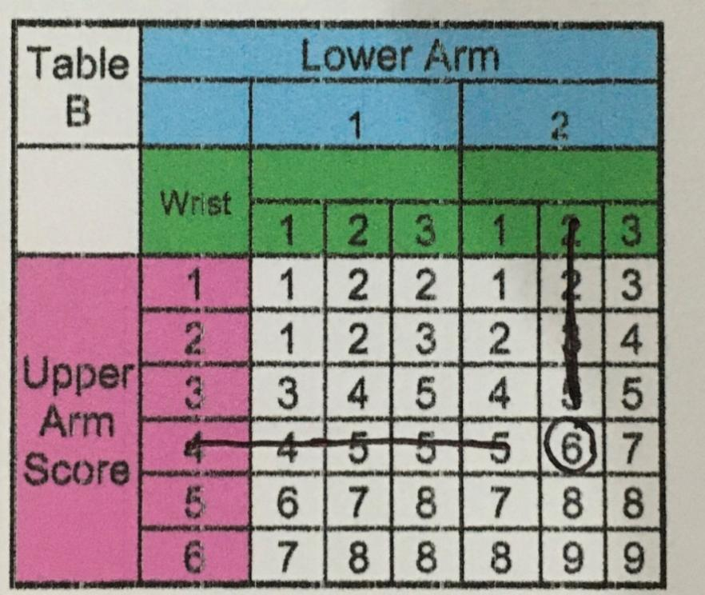

Figure 2. The Assessment of Group B

1. The Assessment of table C from table A and table B (group C)

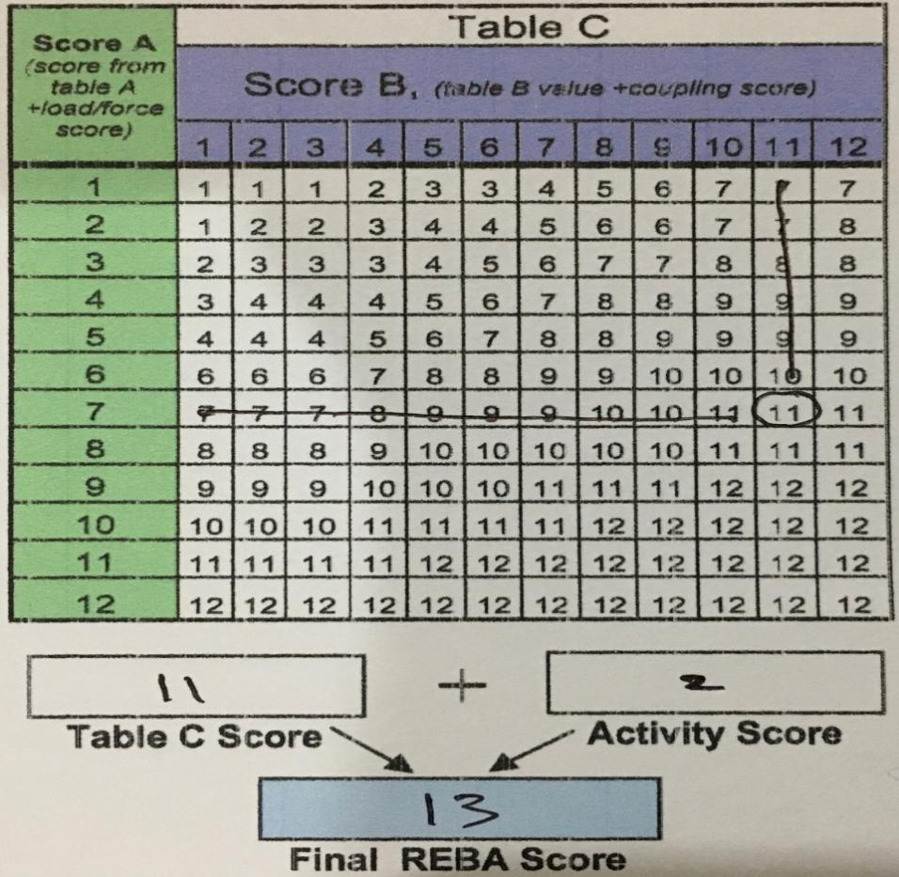

Figure 3. The Assessment of Group C

Using the performance standard table guideline based on the final score, furthermore, 13 has a “Very High” risk level and requires immediate corrective action. Meanwhile, in table A, the lowest final score is 5 which has a "Medium" risk level and further action is needed (Rinawati, 2016). The risk is caused by the back bending and twisting laterally, the midwife's neck twisting laterally, the worker's upper arm being flexed and the arm is lifted away from the body because the uterus is far and narrow, therefore, the midwife should reach it and the position of the forearm and wrist. The midwife's hand is flexed because the wrist is bent. Furthermore, one arm is bent over the patient's abdomen. As a result, it is difficult to control the position of the body.

**CONCLUSION**

The midwife's posture during the manual delivery of the placenta was included in the "Very High" risk category with a final REBA score of 11 and an action level of 2 which meant immediate corrective action was required. The risk is caused by the back bending and twisting laterally, the midwife's neck rotates laterally, the worker's upper arm is flexed and the arm is lifted away from the body because the uterus is far and narrow, therefore, the midwife should reach it and the position of the forearm and wrist. The midwife's hand is flexed because the wrist is bent. Moreover, one arm is bent over the patient's abdomen, making it difficult to control body position.

**REFERENCE**

Akodu, A.K. and Ashalejo, Z.O. (2019) ‘Work-related musculoskeletal disorders and work ability among hospital nurses’, *Journal of Taibah University Medical Sciences*, 14(3), pp. 252–261.

Bazazan, A. *et al.* (2019) ‘Association of musculoskeletal disorders and workload with work schedule and job satisfaction among emergency nurses’, *International emergency nursing*, 44, pp. 8–13.

Long, M.H., Johnston, V. and Bogossian, F. (2012) ‘Work-related upper quadrant musculoskeletal disorders in midwives, nurses and physicians: A systematic review of risk factors and functional consequences’, *Applied ergonomics*, 43(3), pp. 455–467.

Nowotny-Czupryna, O. *et al.* (2012) ‘Professional experience and ergonomic aspects of midwives’ work’, *International journal of occupational medicine and environmental health*, 25(3), pp. 265–274.

Rinawati, S. (2016) ‘Analisis Risiko Postur Kerja Pada Pekerja Di Bagian Pemilahan Dan Penimbangan Linen Kotor Rs. X’, *Journal of Industrial Hygiene and Occupational Health*, 1(1), pp. 39–52.

Tarwaka, E.I. (2015) ‘Dasar Dasar Pengetahuan Ergonomi dan Aplikasi di Tempat Kerja’. Solo: Harapan Press.

Tarwaka, S. and Sudiajeng, L. (2004) ‘Ergonomi untuk keselamatan, kesehatan kerja dan produktivitas’. Surakarta: Uniba Press.

Wajdi, F. and Cahyadi, D. (2016a) ‘Analisis Keluhan Fisik Bidan Akibat Menolong Partus’, *Prosiding Semnastek* [Preprint].

Wajdi, F. and Cahyadi, D. (2016b) ‘Analisis Keluhan Fisik Bidan Akibat Menolong Partus’, *Prosiding Semnastek* [Preprint].

Waters, T.R. *et al.* (1993) ‘Revised NIOSH equation for the design and evaluation of manual lifting tasks’, *Ergonomics*, 36(7), pp. 749–776.