Analysis of Student Errors in Solving HOTS-Type Sequence and Series Problems Based on Newman Error Analysis
Risky Illaina Septia Putri¹, Ratri Candra Hastari²
^{1.2}Pendidikan Matematika, Universitas Bhinneka PGRI
kikisaja89@gmail.com

Abstract

This study aims to analyze student errors in solving HOTS-type math problems using Newman's stages on sequence and series material. This research is qualitative. The subject of this research is class X DPIB 1 SMK "SORE" Tulungagung. Data collection techniques used are test questions and interviews. The data analysis technique was carried out by data reduction, data presentation, and conclusion. The results of this study showed that of the 29 students who were given the HOTS test questions, 3 students made the most mistakes based on the Newman stage. The three students who later became the research subjects made errors at each of Newman's stages, namely reading errors (T1), problem understanding errors (T2), transformation errors (T3), process skill errors (T4), and writing errors in the final answer (T5). Thus, it can be concluded that there are still many students in class X DPIB 1 SMK "SORE" Tulungagung who make mistakes in solving HOTS type sequences and series questions. The suggestions from the research for further research are that it is expected to be able to find more references, maximize the implementation of research, and be able to understand the mistakes made by students, especially in solving HOTS questions.
Keywords: Error Analysis, Sequence and Series, HOTS, Newman

Abstrak
Penelitian ini bertujuan untuk menganalisa kesalahan siswa pada penyelesaian soal matematika bertipe HOTS menggunakan tahapan newman pada materi barisan dan deret. Penelitian ini merupakan penelitian kualitatif. Subjek penelitian ini adalah kelas X DPIB 1 SMK “SORE” Tulungagung. Teknik pengumpulan data yang digunakan yaitu soal tes dan wawancara. Teknik analisis data dilakukan dengan reduksi data, penyajian data, dan penarikan kesimpulan. Hasil penelitian ini menunjukkan dari 29 siswa yang diberi soal tes HOTS terdapat 3 siswa yang melakukan kesalahan terbanyak berdasarkan tahapan Newman. Ketiga siswa tersebut yang selanjutnya menjadi subjek penelitian melakukan kesalahan pada setiap tahapan Newman, yaitu kesalahan membaca (T1), kesalahan memahami masalah (T2), kesalahan transformasi (T3), kesalahan keterampilan proses (T4), dan kesalahan penulisan jawaban akhir (T5). Dengan demikian, dapat disimpulkan bahwa siswa kelas X DPIB 1 SMK “SORE” Tulungagung masih banyak yang melakukan kesalahan pada penyelesaian soal barisan dan deret bertipe HOTS. Adapun saran dari penelitian untuk penelitian selanjutnya ialah diharapkan mampu mencari lebih banyak referensi, memaksimalkan pelaksanaan penelitian, serta mmapu memahami kesalahan yang dilakukan oleh siswa terutama dalam penyelesaian soal HOTS.
Kata kunci: Analisis Kesalahan, Barisan dan Deret, HOTS, Newman.

Received : /Revised :
/Accepted : / Published :

Introduction
Mathematics according to Fatimah et al (2019) is one of the branches of science that has an important role in various sciences and is the science that underlies the development of technology. Seeing the importance of the role of mathematics, mathematics subjects are given at every level of education from basic to higher education (Sumargiyani, Indah Yusnia, Rahmi Nurhasanah, n.d.). In line with what Susanti (2019) said that mathematics has an important role in education or other related disciplines and is a subject whose learning activities require a high level of understanding and not just memorizing (Kolins et al., 2020). Cockcroft suggests the importance of mathematics be taught to students because it is always used in everyday life, mathematical skills are needed in all fields of research, strong, concise, and clear communication advice is used to present information in various ways, improves logical thinking skills and thoroughness, and provide solutions to solve difficult problems (Mahmudah, 2018). To solve a problem, students in Indonesia have been given mathematics lessons with higher-order thinking skills, namely interpreting, analyzing, or even changing previous information so that it is not monotonous (Sa'adah et al., 2019).
The basis for higher-order thinking is Bloom's taxonomy, Pohl (Kusdianti et al., 2019) states that this rationale requires more cognitive processes than other types of learning but has the advantage of being more general. Krathwol & Anderson explained that based on Bloom's revised taxonomy, cognitive processes are divided into three categories, namely lower order thinking, medium order thinking, and higher order thinking (Kusdianti et al., 2019). Higher order thinking skills or HOTS is the ability to combine facts and ideas in the process of analysis, evaluation, and creation, namely in the form of providing an assessment of a fact that is learned or creating what has been learned (Saraswati & Agustika, 2020). Therefore, in the 2013 Curriculum which was revised in 2017, when studying mathematics students are not only able to use calculations and formulas in working on problems but are also able to logically and analytically solve problems in everyday life. HOTS type questions can train students to think at the level of analysis, evaluation, and creation. Research conducted by Refli Annisa and Kartini (Annisa & Kartini, 2021) "Students make mistakes in solving sequences and series questions based on Newman's stages, the percentage of reading error is 13%, comprehension error is 22%, transformation error is 35%, process skill error is 44%, and 9% end coding error”. A similar condition was also seen when the researchers conducted initial observations at SMK "SORE" Tulungagung. The reality that occurs in the field is that the main problem is that students make mistakes in solving the HOTS type series and series questions. These errors are presented in the following table:
Table 1. Analysis of Student Errors in Initial Observations

Student Initial | Completion | Error Analysis
MIA | 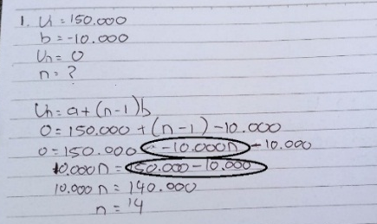 | Students with the initials MIAA made an error in changing the information/data, namely the sign (+) was changed to a minus sign (-), so that in the next solution, MIAA experienced an error.
NHE | 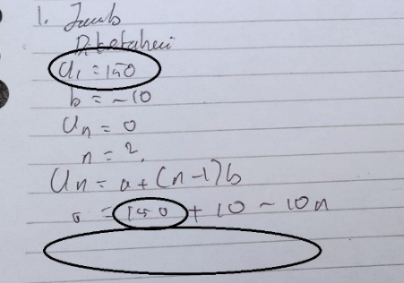 | Students with the initials NHE make mistakes in writing information/data so that it affects the numbers included in the formula. In addition, NHE does not know what procedure to use next, so NHE cannot solve the problem.
TR | 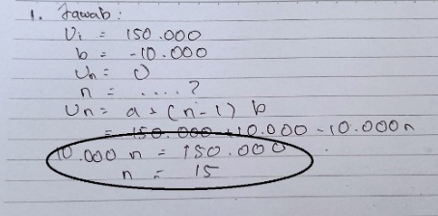 | Students with the initials TR make mistakes in the calculation process which will affect the results of the completion.

Errors made by students are caused because students have not been able to fully understand the questions and students also do not understand the purpose of the questions given. In addition, students still do not understand mathematical signs or notations so errors occur in solving problems, these errors can be described as follows: entering numbers in the formula, incorrectly performing arithmetic operations, and incorrectly working procedures. This will greatly affect the learning outcomes.
Several methods or steps can be used to analyze errors, one of which is the Newman method. The Newman method was first discovered by an Australian mathematics teacher named Anne Newman in 1977 which was later named Newman Error Analysis or Newman Error Analysis (NEA) (Endah & Dkk, 2015). Newman's method is designed as a simple diagnostic procedure for solving mathematical word problems. Newman (Mahmudah, 2018) explains that students' mistakes in doing math problems are divided into five types of errors, namely reading errors, these errors occur when students work on questions and the answers do not match what is intended in the questions, comprehension errors (comprehension). errors), this error occurs because students do not understand the concept, do not know what is asked in the question, and are wrong in capturing information on the problem, transformation errors occur because students have not been able to change the problem into mathematical form correctly and incorrectly in arithmetic operations, process skill errors, these errors occur because students are not yet skilled in doing calculations, errors in the completion process (end coding errors), occur because students are not able to write down answers correctly (Maheasy, 2018). This study uses an indicator to analyze student errors, the indicator is based on Newman's stages.

Table 2. Student Error Indicators based on Newman.

No. | Error Types by Newman | Indikator Error | Code
1. | Reading | - Unable to read and interpret the words posed in question | T1
2. | Comprehension | - Unable to explain what is meant in the problem  - Do not write down what is known and asked in the question  - Write down what you know but use self-created symbols or terms and whitout explanation  - Write down the question asked briefly but not clear | T2
3. | Transformation | - Does not change the informastion in the problem into a mathematical model  - Change the information in the problem into a mathematical sentence but it is incorrect  - Students do not know what operations are used in solving problems  - Did not complete or continue the troubleshooting solution | T3
4. | Process Skills | - Errors in computation/colculation  - Unable to continue settlement procedure | T4
5. | Endcoding | - Writing notation (negative sign, symbol, equal sign, etc) incorrectly  - Not/wrong in wiriting variabel/unit  - Can’t conclude the solution into math sentence | T5

Realizing that there are still many students at SMK "SORE" Tulungagung who make mistakes in solving HOTS-type sequences and series questions, the authors conducted a study entitled Analysis of Student Errors in Solving HOTS-Type Sequences and Series Problems based on Newman's Stages at Tulungagung "SORE" Vocational School with The aim is to analyze student errors in solving HOTS-type math problems based on Newman's stages of sequence and series material.

Research Methods
This type of research is a case study research with a qualitative approach. This study aims to analyze student errors in solving problems on the HOTS type sequence and series material using the Newman stage. The subjects of this study were students of class X DPIB 1 at SMK "SORE" Tulungagung. The data collection technique used is the HOTS-type row and series test method and the interview method. The expected data is in the form of student work on the answer sheet along with the completion steps. The HOTS test questions consist of three questions with sequences and series material used to find out student errors in solving HOTS questions, the results of which will then be analyzed using the Newman stage. From the test results that have been collected and analyzed based on Newman's stages, then selected subjects who are then interviewed. The results of the HOTS test and interview results are then used as training. The HOTS test questions given to students are as follows:

Table 3. HOTS Test Question

HOTS Verbs: Analyze, Evaluate, and Create
Question indicators: Students can determine the first term and the differentiator, calculate the number of the n-th terms and determine the formula for the n-th term.
Question 1:
Erwin stacked the bricks in a row. The number of bricks in the first line is one brick more than the number of bricks in the row above. The brick stack starts with 200 bricks in the first row and one brick in the last row. Count the number of all stacked bricks!
Question 2:
In a multi-purpose building, there are 20 rows of chairs. In the front row, there are 20 seats, the back row contains 3 more seats than the front row.
a) Determine the number of seats in the 15th row!
b) Determine the number of seats in the multi-purpose building!
c) Give a conclusion from solving the problem above!
Question 3:
If the sum of the first 6036 terms of a geometric series is 1141 and the sum of 4024 is 780, find the sum of the first 2012 terms!

Result and Discussion
The purpose of this study was to analyze student errors in solving HOTS-type math problems based on Newman's stages on the material of sequences and series at SMK "SORE" Tulungagung. The first step the researcher did was to give HOTS test questions to find out student errors. This test question was given to all students of class X DPIB 1, totaling 29 students. Next, an analysis of students' answers was carried out based on the Newman stages. The second step is to conduct interviews with research subjects that are used as triangulation.

Hasil Penelitian
Based on the results of student completion, 3 students were selected as research subjects, namely students with the initials AS with a total error of 11, ASN with a total error of 10, and DEP with a total error of 10. The reason for selecting the subject, the subject made an error in solving the HOTS test questions and was a communicative subject. and can collaborate. The three students were then selected as interview subjects. The following are the results of research analysis related to student errors in solving HOTS-type questions based on the Newman stage carried out by researchers in class X DPIB 1 SMK "SORE" Tulungagung. Researchers will describe the analysis of errors made by students on HOTS questions based on Newman's stages and analysis of the results of interviews from each selected subject.
- Subjek AS
AS subjects made a total of 11 errors. The error can be seen in the image below:
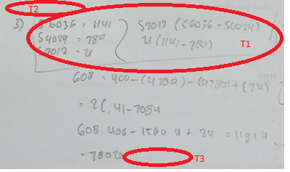
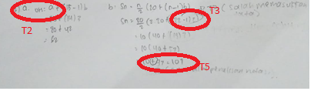
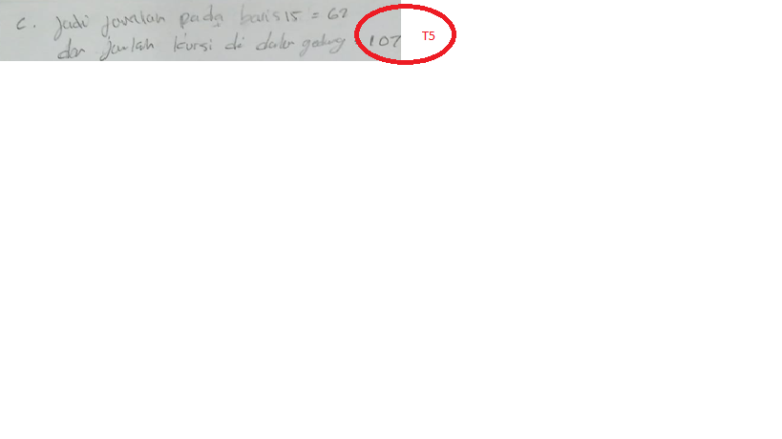
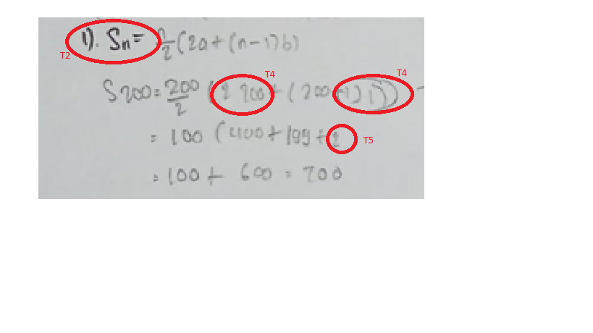
Figure 1. AS Results
Based on the AS subject's answer fragment, it appears that the US made several mistakes in each number. In number 1, the US made an error at the stage of understanding the problem (T2), namely the US did not write down what was known and asked in the question, at the process skills stage (T4) the US was wrong in doing the calculations, where the US calculated the results of (200-1)1 is 199+2, and at the stage of writing the final answer (T5) AS did not write times notation and closing brackets. In question number 2, AS made the same mistake at the stage of understanding the problem (T2), namely not writing down what was known and asked, at the problem transformation stage (T3) AS was wrong in entering data, at the stage of writing the final answer (T5) AS was wrong in writing The notation that should have been written with the notation times (×) was written with plus (+) notation, AS also did not write down the units in its conclusion. In question number 3, the US made an error at the reading stage (T1) where the US could not read the question, the understanding stage of the problem (T2) the US wrote down what was known and asked but briefly and unclearly, the US also made an error in the transformation stage (T3 ) i.e. the US cannot continue solving the problem. The following is a snippet of an interview on the US subject: AS cannot read 2 questions out of 3 numbers, so AS has an error at the reading stage. The US knows what is being asked in the question, but the US does not write it down on the answer sheet because the US is not sure about the known data. The US knew what formula was used but the US entered the data incorrectly and did not proceed with the settlement process because the US did not take it seriously. In the process skills stage, AS actually knows how to take the steps in solving problems, using any formula, but AS is confused in calculating the numbers based on the formula. At the stage of writing the final answer, the US can change the questions to mathematical models but the US is not careful in doing the test questions so that the US does not write units and notations in the answer.
- ASN Subject
The ASN subject made a total of 10 errors. The error can be seen in the image below:
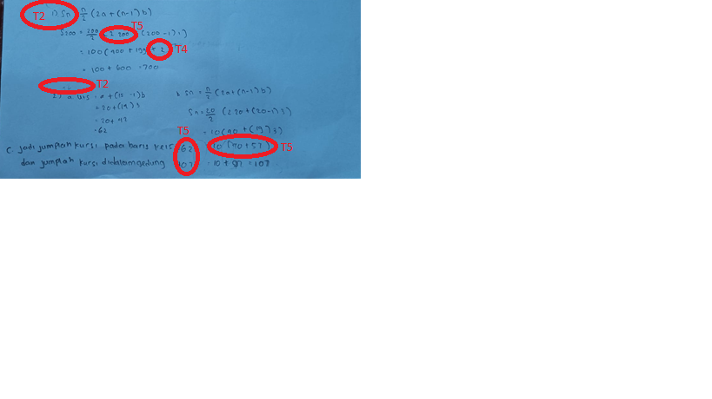
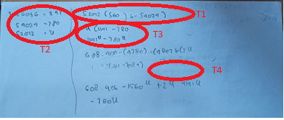
Figure 2. ASN Results

Based on fragments of ASN answers, it appears that ASN made an error in each number, namely at number 1 ASN made an error at the stage of understanding the problem (T2) where the ASN did not write down what was known and asked in the question, the process skills stage (T4) ASN was wrong in doing calculations, namely (200-1)1 is 199+2, and at the stage of writing the final answer (T5) ASN does not write down the notation of times. In question number 2, ASN repeats at the stage of understanding the problem (T2), which is not writing down what is known and asked, at the stage of writing the final answer (T5) ASN is wrong in writing the notation which should be written with the addition notation (+). ), ASN also does not appear to have written units in its conclusion. In number 3, the ASN made a mistake at the reading stage (T1) so that it was written carelessly, In the understanding stage of the problem (T2) the ASN wrote down what was known and asked but briefly and not clear, the transformation stage (T3) ASN made an error that was not precise in converting information into mathematical form, and at the process skills stage (T4) Asn cannot solve the problem. The following is a snippet of the interview with the ASN subject: At the reading stage, ASN can only read 2 questions out of 3 HOTS test questions, so ASN makes mistakes at the reading stage. At the stage of understanding the problem, the ASN knows what is being asked in the question, but the ASN does not write it down on the answer sheet because the ASN is not sure about the data or information they get. In the transformation stage, the ASN knows what formula to use, but the ASN entered the data incorrectly because he saw his friend's answer. In the process skills stage, ASN actually knows the steps in solving the problem, but ASN is not precise in doing it, besides that ASN also doesn't understand the problem and is confused about how to calculate it, and also doesn't memorize the formula. At the stage of writing the final answer, the ASN cannot change the question to a mathematical model because the ASN sees the answer of his friend. ASN also mistyped units and notations.

- Subjek DEP
DEP subjects experienced errors in solving HOTS questions with a total of 10 errors. These errors can be seen in the image below:
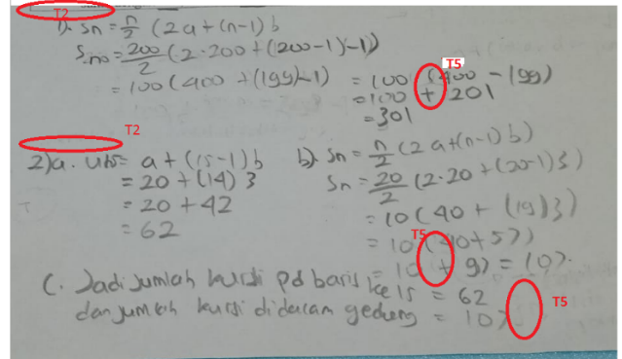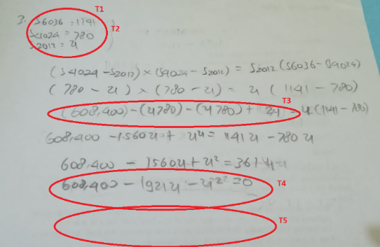
Figure 3. DEP Results

Based on the results of DEP's work, it can be seen that DEP made several mistakes on each number. In number 1, DEP made an error at the stage of understanding the problem (T2) where DEP did not write down what was known and asked in the question, in writing the final answer (T5) DEP was wrong in entering the notation which should have been notation times (×) written with plus notation ( +). At the completion of number 2, DEP made the same mistake at the stage of understanding the problem (T2), namely not writing down what was known and asked, at the stage of writing the final answer (T5) DEP was wrong in writing the notation which should be times (×) written plus notation (+) , DEP also does not write units or variables in the conclusion. In question number 3, DEP made an error at the reading stage (T1), namely not being able to read the question so he wrote it exactly as the question was written, at the problem understanding stage (T2) DEP wrote down what was known and asked but briefly and not clearly. in the transformation stage (T3) DEP changed the information on the question but it was not quite right, the process skills stage (T4) DEP could not continue the completion process so it could not provide a conclusion at the final answer writing stage (T5). The following is an excerpt from DEP's interview: At the reading stage, DEP could not read the questions because the numbers were too large, DEP also did not know about geometric series, so DEP made an error at the reading stage. In the next stage, understanding the problem, DEP actually knows what is being asked and what information is in the question but DEP doesn't write it down on the answer sheet because DEP is not sure about the information he gets. At the transformation stage, DEP can state the steps and formulas but DEP is not so sure of the data, so DEP makes mistakes at the transformation stage. At the process skill stage, DEP could not continue to the next process because it found difficulties, namely the number was too large and there were variables.

Discussion of Research Results
Based Errors at the reading stage are errors in reading and understanding the questions. Mistakes made at this stage will affect the next stage. The subject cannot read and understand the questions so that it will affect the completion of the HOTS test questions. According to Clemen (Maheasy, 2018) about students' reading skills in dealing with problems will affect these students in solving problems. This is evident from the work of the subject who made mistakes at the reading stage. In the results of their work, the three subjects had difficulty in reading terms, symbols or important information in the questions. Thus, the three subjects experienced errors in reading the questions.

An error at the stage of understanding the problem is an error in understanding the problem. This error can occur if the subject does not write down the data that is known in the question, that is, he does not write down what is known and asked in the question. Reading errors and misunderstood problems are continuous with each other. If there is an error in reading, then the student will experience an error at the stage of understanding. Oktavia (Endah & Dkk, 2015) explains in his research that at the stage of understanding the problem is related to reading errors. In the HOTS test questions that have been given, students are required to know what is given to the HOTS test questions as known data and know what is being asked in the questions. The error at this stage comes from the subject itself, where the subject feels that he does not understand what is contained in the problem. Thus the data contained in the question becomes unknown.

Transformation errors are errors in transforming data into mathematical sentences. Errors made by students are usually in the form of writing mathematical sentences that are less precise. This is in line with Fatahillah's research (Fatahillah et al., 2017) which states that students cannot convert questions into mathematical sentences, especially sentences related to multiplication operations. Research by (Endah & et al, 2015) also explains that students have not been able to transform the story questions in the questions into mathematical language, causing errors to occur. Errors at this stage occur because the subject is less precise in entering the data in the question. Thus the transformation to a mathematical sentence becomes less precise.

The process skills stage is an error during the problem solving process. The error that occurs at this stage is that the subject is wrong in doing calculations and cannot complete the test questions. Thus it will have an impact on determining the final answer where the final result does not match the answer. This is in line with research conducted by (Endah & et al, 2015) which states that students are not careful or focus less on the process of arithmetic operations such as multiplication, subtraction, division and addition. Then (Annisa & Kartini, 2021) stated that students' inaccuracy resulted in errors that occurred in arithmetic operations. This is also in accordance with research conducted by (Fatahillah et al., 2017) which states that the cause of students making errors in calculations is less thorough and less skilled students in counting. Students are not accustomed to re-checking the answer after finishing working even though the operation used is correct because an error in the calculation results in an error in the final answer. The cause of students making mistakes in not completing the test questions is because students are in a hurry to do it. This will have an impact on the final result of solving the problem.

Errors at the stage of writing the final answer are errors in writing symbols and conclusions in the final result. At this stage the error made by the subject is in the form of using the wrong notation or symbol and cannot conclude the final result. Errors in writing often occur in writing symbols or notations. While the error in the conclusion of the final result occurs because in the previous stage an error was made. This is in accordance with the results of research (Fatahillah et al., 2017) which states that errors at the stage of writing the final answer include errors in writing units, errors in not writing conclusions, and writing conclusions but not being correct. Thus, an error occurred at the stage of writing the final answer.

Conclusion
Based on the results of the study, it can be concluded that the analysis of student errors in solving HOTS-type sequences and series questions based on the Newman stage is that the three students make mistakes at each Newman stage. At the reading stage, the three subjects could not read the HOTS test questions, this was because the subjects had difficulty reading terms, symbols or important information on the questions. At the stage of understanding the problem, the three subjects made a mistake, namely not writing down what was known and asked in the question. The error that occurs comes from the subject itself, where the subject does not understand the information contained in the question. At the transformation stage, the three subjects made an error in transforming the data into mathematical sentences, namely the writing of mathematical sentences that were less precise. The process skills stage, the three subjects made mistakes during calculations and could not complete the test questions, students were not accustomed to re-checking their answers and were in a hurry to solve the questions. At the stage of writing the final answer, the three subjects made errors in the form of using the notation incorrectly and could not conclude the final result.

Bibliography
Annisa, R., & Kartini, K. (2021). Analisis Kesalahan Siswa Dalam Menyelesaikan Soal Barisan dan Deret Aritmatika Menggunakan Tahapan Kesalahan Newman. Jurnal Cendekia : Jurnal Pendidikan Matematika, 5(1), 522–532. https://doi.org/10.31004/cendekia.v5i1.506
Endah, N., & Dkk. (2015). Kesulitan Belajar Siswa Sekolah Dasar Dalam Menyelesaikan Soal Hots Matematika Berdasarkan Teori Newman. Jurnal Madrasah Ibtidaiyah, 3(2), 116–127.
Fatahillah, A., Wati, Y. F., & Susanto. (2017). Analisis Kesalahan Siswa dalam Menyelesaikan Soal Cerita Matematika Berdasarkan Tahapan Newman Beserta Bentuk Scaffolding yang Diberikan. Jurnal Kadikma, 8(1), 40–51. http://jurnal.unej.ac.id/index.php/kadikma/article/view/5229
Kolins, A. Y., Wahyuningsih, W., Safrudin, N., & Rusdin, M. E. (2020). Analisis Kesalahan Peserta Didik dalam Menyelesaikan Soal Matematika pada Fungsi Komposisi dan Fungsi Invers. AlphaMath : Journal of Mathematics Education, 6(2), 86. https://doi.org/10.30595/alphamath.v6i2.7866
Kusdianti, I., Sitompul, S. S., & Mahmuda, D. (2019). Analisis kemampuan peserta didik dalam menyelesaikan soal HOTS kelas XI SMAN 2 Sungai Raya. Jurnal Pendidikan Dan Pembelajaran Khatulistiwa, 8(6), 1–10.
Mahmudah, W. (2018). Analisis Kesalahan Siswa dalam Menyelesaikan Soal Matematika Bertipe Hots Berdasar Teori Newman. Unsida Journal of Mathematics and Computer Science, 4(2), 49–56.
Sa’adah, A., Misri, M. A., & Darwan. (2019). Analisis Kesalahan Siswa Dalam Menyelesaikan Soal HOTS Bertipe PISA. Jurnal Mathematic Paedagogic, 4(1), 12.
Saraswati, P. M. S., & Agustika, G. N. S. (2020). Kemampuan Berpikir Tingkat Tinggi Dalam Menyelesaikan Soal HOTS Mata Pelajaran Matematika. Jurnal Ilmiah Sekolah Dasar, 4(2), 257. https://doi.org/10.23887/jisd.v4i2.25336
Sumargiyani, Indah Yusnia, Rahmi Nurhasanah, B. N. (n.d.). Analisis Kesalahan Mahasiswa Dalam Menyelesaikan Soal Kalkulus. AlphaMath : Journal of Mathematics Education, 20–31.

