Suplemen file

Data SPSS Validitas dan reliabilitas instruemen

|  |  |  |  |  |  |  |  |  |  |  |  |  |
| --- | --- | --- | --- | --- | --- | --- | --- | --- | --- | --- | --- | --- |
| DATA UJI VALIDITAS DAN REABILITAS INSTRUMEN | | | | | | | | | | | | |
|  |  |  |  |  |  |  |  |  |  |  |  |  |
| No. Resp | Nama Responden | 1 | 2 | 3 | 4 | 5 | 6 | 7 | 8 | 9 | 10 | Skor Tot |
| 1 | Anindita K. | 4 | 3 | 4 | 3 | 2 | 4 | 4 | 4 | 3 | 1 | 32 |
| 2 | Fahri N. | 5 | 5 | 5 | 5 | 5 | 5 | 5 | 5 | 5 | 5 | 50 |
| 3 | Fairil A. Cholif | 5 | 5 | 5 | 4 | 4 | 5 | 5 | 5 | 4 | 4 | 46 |
| 4 | Fauzul Muna | 5 | 5 | 5 | 4 | 5 | 5 | 5 | 5 | 5 | 5 | 49 |
| 5 | Jessika I. | 5 | 5 | 5 | 5 | 5 | 5 | 5 | 5 | 5 | 5 | 50 |
| 6 | M. Abbar A | 5 | 5 | 5 | 4 | 4 | 5 | 5 | 5 | 4 | 4 | 46 |
| 7 | M. Andrean M | 5 | 5 | 5 | 5 | 5 | 5 | 5 | 5 | 5 | 5 | 50 |
| 8 | M. Azmi C | 5 | 5 | 5 | 5 | 5 | 5 | 5 | 5 | 5 | 5 | 50 |
| 9 | M. Baihaqi | 5 | 4 | 4 | 4 | 3 | 5 | 5 | 5 | 3 | 4 | 42 |
| 10 | M. Dalhar A | 5 | 5 | 5 | 5 | 5 | 5 | 5 | 5 | 5 | 5 | 50 |
| 11 | M. Hilmi Yahya | 5 | 5 | 5 | 5 | 5 | 5 | 5 | 5 | 5 | 5 | 50 |
| 12 | M. Izzur Asy'ari | 5 | 5 | 5 | 5 | 5 | 5 | 5 | 5 | 5 | 5 | 50 |
| 13 | M. Maulana Zaky F. | 5 | 5 | 5 | 5 | 5 | 5 | 5 | 5 | 5 | 5 | 50 |
| 14 | M. Y Annas | 5 | 5 | 5 | 5 | 5 | 5 | 5 | 5 | 5 | 5 | 50 |
| 15 | M.Izzun Naim | 5 | 4 | 5 | 4 | 3 | 5 | 5 | 5 | 3 | 4 | 43 |
| 16 | Miftahus S. | 5 | 5 | 5 | 5 | 5 | 5 | 5 | 5 | 5 | 5 | 50 |
| 17 | Nagita H | 5 | 5 | 5 | 5 | 5 | 5 | 5 | 5 | 5 | 5 | 50 |
| 18 | Radika Gibran | 5 | 5 | 5 | 5 | 5 | 5 | 5 | 5 | 5 | 5 | 50 |
| 19 | Raja sailendra | 5 | 5 | 5 | 5 | 5 | 5 | 5 | 5 | 5 | 5 | 50 |
| 20 | Sintia R | 5 | 5 | 5 | 5 | 5 | 5 | 5 | 5 | 5 | 5 | 50 |

**Correlations**

| [ **Correlations** | | | | | | | | | | | | |
| --- | --- | --- | --- | --- | --- | --- | --- | --- | --- | --- | --- | --- |
|  |  | Item1 | Item2 | Item3 | Item4 | Item5 | Item6 | Item7 | Item8 | Item9 | Item10 | TotalScor |
| Item1 | Pearson Correlation | 1 | .810** | .688** | .661** | .677** | 1.000** | 1.000** | 1.000** | .500* | .901** | .835** |
| Sig. (2-tailed) |  | .000 | .001 | .001 | .001 | .000 | .000 | .000 | .025 | .000 | .000 |
| N | 20 | 20 | 20 | 20 | 20 | 20 | 20 | 20 | 20 | 20 | 20 |
| Item2 | Pearson Correlation | .810** | 1 | .850** | .788** | .930** | .810** | .810** | .810** | .854** | .899** | .956** |
| Sig. (2-tailed) | .000 |  | .000 | .000 | .000 | .000 | .000 | .000 | .000 | .000 | .000 |
| N | 20 | 20 | 20 | 20 | 20 | 20 | 20 | 20 | 20 | 20 | 20 |
| Item3 | Pearson Correlation | .688** | .850** | 1 | .670** | .790** | .688** | .688** | .688** | .726** | .764** | .832** |
| Sig. (2-tailed) | .001 | .000 |  | .001 | .000 | .001 | .001 | .001 | .000 | .000 | .000 |
| N | 20 | 20 | 20 | 20 | 20 | 20 | 20 | 20 | 20 | 20 | 20 |
| Item4 | Pearson Correlation | .661** | .788** | .670** | 1 | .894** | .661** | .661** | .661** | .856** | .877** | .906** |
| Sig. (2-tailed) | .001 | .000 | .001 |  | .000 | .001 | .001 | .001 | .000 | .000 | .000 |
| N | 20 | 20 | 20 | 20 | 20 | 20 | 20 | 20 | 20 | 20 | 20 |
| Item5 | Pearson Correlation | .677** | .930** | .790** | .894** | 1 | .677** | .677** | .677** | .976** | .909** | .968** |
| Sig. (2-tailed) | .001 | .000 | .000 | .000 |  | .001 | .001 | .001 | .000 | .000 | .000 |
| N | 20 | 20 | 20 | 20 | 20 | 20 | 20 | 20 | 20 | 20 | 20 |
| Item6 | Pearson Correlation | 1.000** | .810** | .688** | .661** | .677** | 1 | 1.000** | 1.000** | .500* | .901** | .835** |
| Sig. (2-tailed) | .000 | .000 | .001 | .001 | .001 |  | .000 | .000 | .025 | .000 | .000 |
| N | 20 | 20 | 20 | 20 | 20 | 20 | 20 | 20 | 20 | 20 | 20 |
| Item7 | Pearson Correlation | 1.000** | .810** | .688** | .661** | .677** | 1.000** | 1 | 1.000** | .500* | .901** | .835** |
| Sig. (2-tailed) | .000 | .000 | .001 | .001 | .001 | .000 |  | .000 | .025 | .000 | .000 |
| N | 20 | 20 | 20 | 20 | 20 | 20 | 20 | 20 | 20 | 20 | 20 |
| Item8 | Pearson Correlation | 1.000** | .810** | .688** | .661** | .677** | 1.000** | 1.000** | 1 | .500* | .901** | .835** |
| Sig. (2-tailed) | .000 | .000 | .001 | .001 | .001 | .000 | .000 |  | .025 | .000 | .000 |
| N | 20 | 20 | 20 | 20 | 20 | 20 | 20 | 20 | 20 | 20 | 20 |
| Item9 | Pearson Correlation | .500* | .854** | .726** | .856** | .976** | .500* | .500* | .500* | 1 | .802** | .891** |
| Sig. (2-tailed) | .025 | .000 | .000 | .000 | .000 | .025 | .025 | .025 |  | .000 | .000 |
| N | 20 | 20 | 20 | 20 | 20 | 20 | 20 | 20 | 20 | 20 | 20 |
| Item10 | Pearson Correlation | .901** | .899** | .764** | .877** | .909** | .901** | .901** | .901** | .802** | 1 | .976** |
| Sig. (2-tailed) | .000 | .000 | .000 | .000 | .000 | .000 | .000 | .000 | .000 |  | .000 |
| N | 20 | 20 | 20 | 20 | 20 | 20 | 20 | 20 | 20 | 20 | 20 |
| TotalScor | Pearson Correlation | .835** | .956** | .832** | .906** | .968** | .835** | .835** | .835** | .891** | .976** | 1 |
| Sig. (2-tailed) | .000 | .000 | .000 | .000 | .000 | .000 | .000 | .000 | .000 | .000 |  |
| N | 20 | 20 | 20 | 20 | 20 | 20 | 20 | 20 | 20 | 20 | 20 |
| **. Correlation is significant at the 0.01 level (2-tailed). | | | | |  |  |  |  |  |  |  |  |
| *. Correlation is significant at the 0.05 level (2-tailed). | | | | |  |  |  |  |  |  |  |  |

**Reliability**

[DataSet2]

**Scale: ALL VARIABLES**

| **Case Processing Summary** | | | |
| --- | --- | --- | --- |
|  |  | N | % |
| Cases | Valid | 20 | 100.0 |
| Excludeda | 0 | .0 |
| Total | 20 | 100.0 |
| a. Listwise deletion based on all variables in the procedure. | | | |

| **Reliability Statistics** | |
| --- | --- |
| Cronbach's Alpha | N of Items |
| .937 | 10 |

| **Item-Total Statistics** | | | | |
| --- | --- | --- | --- | --- |
|  | Scale Mean if Item Deleted | Scale Variance if Item Deleted | Corrected Item-Total Correlation | Cronbach's Alpha if Item Deleted |
| Item1 | 42.95 | 18.471 | .819 | .936 |
| Item2 | 43.10 | 15.884 | .944 | .921 |
| Item3 | 43.00 | 17.895 | .808 | .933 |
| Item4 | 43.25 | 15.671 | .877 | .923 |
| Item5 | 43.35 | 13.187 | .950 | .923 |
| Item6 | 42.95 | 18.471 | .819 | .936 |
| Item7 | 42.95 | 18.471 | .819 | .936 |
| Item8 | 42.95 | 18.471 | .819 | .936 |
| Item9 | 43.30 | 14.642 | .847 | .926 |
| Item10 | 43.30 | 12.747 | .963 | .925 |

Data Perolehan Nilai Uji Pengguna (siswa kelas B) dengan penilaian skala observasi.

|  |  |  |  |  |  |  |  |  |  |  |  |  |  |  |
| --- | --- | --- | --- | --- | --- | --- | --- | --- | --- | --- | --- | --- | --- | --- |
| No | |  | | --- | | Item | | Hasil Perolehan Nilai | | | | | | | | | | | Prosentase |
| Nama | 1 | 2 | 3 | 4 | 5 | 6 | 7 | 8 | 9 | 10 | Skor Total |  |
| 1 | M. Rasya A. (AJ2) | 4 | 4 | 4 | 3 | 3 | 4 | 3 | 3 | 4 | 4 | 36 | 72% |
| 2 | A. Ghoni A. (AQYU) | 4 | 4 | 4 | 4 | 4 | 4 | 4 | 3 | 3 | 3 | 37 | 74% |
| 3 | Zumaila (NH) | 4 | 4 | 4 | 4 | 4 | 4 | 4 | 3 | 3 | 3 | 37 | 74% |
| 4 | Alina Moza P (AQYU) | 4 | 4 | 4 | 4 | 4 | 4 | 4 | 4 | 3 | 3 | 38 | 76% |
| 5 | M. Barokah(Ittihadul F) | 4 | 4 | 4 | 4 | 4 | 4 | 4 | 4 | 3 | 3 | 38 | 76% |
| 6 | Zahwatun (AJ2) | 4 | 4 | 4 | 4 | 4 | 4 | 4 | 3 | 3 | 4 | 38 | 76% |
| 7 | A. Arka N. H (AJ2) | 4 | 4 | 4 | 4 | 4 | 4 | 4 | 4 | 4 | 3 | 39 | 78% |
| 8 | M. Bima A.S (Ittihadul F) | 4 | 4 | 4 | 4 | 4 | 4 | 4 | 3 | 4 | 4 | 39 | 78% |
| 9 | Althaf Nabil (AQYU) | 4 | 4 | 4 | 4 | 4 | 4 | 4 | 4 | 4 | 4 | 40 | 80% |
| 10 | M. Ibrohim (MH) | 4 | 4 | 4 | 4 | 4 | 4 | 4 | 4 | 4 | 4 | 40 | 80% |
| 11 | A. Latif (NH) | 4 | 4 | 4 | 4 | 4 | 4 | 4 | 4 | 4 | 4 | 40 | 80% |
| 12 | A. Fawwas (NH) | 4 | 4 | 4 | 4 | 4 | 4 | 4 | 4 | 4 | 4 | 40 | 80% |
| 13 | M. Azka R.A. (AJ2) | 5 | 4 | 4 | 4 | 4 | 4 | 4 | 4 | 4 | 4 | 41 | 82% |
| 14 | Fatimah A. (AJ2) | 5 | 4 | 4 | 4 | 4 | 4 | 4 | 4 | 4 | 4 | 41 | 82% |
| 15 | Jihan. M. F. ( MH) | 5 | 4 | 4 | 4 | 4 | 4 | 4 | 4 | 4 | 4 | 41 | 82% |
| 16 | M Febrian P (MH) | 5 | 4 | 4 | 4 | 4 | 4 | 4 | 4 | 4 | 4 | 41 | 82% |
| 17 | Alya Septiani (AQYU) | 5 | 4 | 4 | 4 | 4 | 4 | 4 | 4 | 4 | 4 | 41 | 82% |
| 18 | Aufi Lana H (AQYU) | 5 | 5 | 4 | 4 | 4 | 4 | 4 | 4 | 4 | 4 | 42 | 84% |
| 19 | M. Ilham (MH) | 5 | 5 | 4 | 4 | 4 | 4 | 4 | 4 | 4 | 4 | 42 | 84% |
| 20 | Aiza P. S. (NH) | 5 | 5 | 4 | 4 | 4 | 4 | 4 | 4 | 4 | 4 | 42 | 84% |
| 21 | Amalina Z (NH) | 5 | 5 | 4 | 4 | 4 | 4 | 4 | 4 | 4 | 4 | 42 | 84% |
| 22 | Yoshi S.R (AJ2) | 5 | 5 | 4 | 4 | 4 | 4 | 4 | 4 | 4 | 4 | 42 | 84% |
| 23 | Silvi N. A (AJ2) | 5 | 5 | 5 | 4 | 4 | 4 | 4 | 4 | 4 | 4 | 43 | 86% |
| 24 | M. Rafasya (MH) | 5 | 5 | 5 | 4 | 4 | 4 | 4 | 4 | 4 | 4 | 43 | 86% |
| 25 | Hawa J (NH) | 4 | 5 | 5 | 4 | 4 | 4 | 4 | 4 | 4 | 5 | 43 | 86% |
| 26 | Khalilah (NH) | 5 | 5 | 4 | 4 | 4 | 4 | 4 | 4 | 5 | 4 | 43 | 86% |
| 27 | Mutia H (MH) | 5 | 5 | 5 | 4 | 4 | 4 | 4 | 4 | 4 | 4 | 43 | 86% |
| 28 | Aulya R. Y (AQYU) | 5 | 5 | 4 | 4 | 4 | 4 | 4 | 4 | 5 | 4 | 43 | 86% |
| 29 | Fariza (AQYU) | 5 | 5 | 4 | 5 | 4 | 4 | 4 | 4 | 4 | 5 | 44 | 88% |
| 30 | Salma N. (MH) | 5 | 5 | 5 | 5 | 4 | 4 | 4 | 4 | 4 | 4 | 44 | 88% |
| 31 | M. Haidar H. (Ittihadul F) | 5 | 5 | 4 | 5 | 4 | 4 | 4 | 4 | 5 | 4 | 44 | 88% |
| 32 | M. Ilham C (Ittihadul F) | 5 | 4 | 5 | 5 | 4 | 4 | 4 | 4 | 4 | 5 | 44 | 88% |
| 33 | Fatimahus S (AQYU) | 5 | 5 | 5 | 5 | 4 | 4 | 4 | 4 | 4 | 4 | 44 | 88% |
| 34 | Shaqueena A. S (MH) | 5 | 5 | 5 | 5 | 5 | 4 | 4 | 4 | 4 | 4 | 45 | 90% |
| 35 | Maryam A.C (NH) | 5 | 5 | 5 | 5 | 4 | 4 | 4 | 4 | 4 | 5 | 45 | 90% |
| 36 | Melida (NH) | 5 | 5 | 5 | 5 | 4 | 4 | 4 | 4 | 5 | 4 | 45 | 90% |
| 37 | Putri A.C (AJ2) | 5 | 5 | 5 | 5 | 5 | 4 | 4 | 4 | 4 | 4 | 45 | 90% |
| 38 | Nimas A.G (AJ2) | 5 | 5 | 5 | 5 | 5 | 5 | 4 | 4 | 4 | 4 | 46 | 92% |
| 39 | M. Nabil A. (Ittihadul F) | 5 | 5 | 4 | 5 | 5 | 5 | 4 | 4 | 4 | 5 | 46 | 92% |
| 40 | M. Ya'lal H. (Ittihadul F) | 5 | 5 | 4 | 5 | 4 | 5 | 4 | 5 | 5 | 4 | 46 | 92% |
| 41 | Hannania (AQYU) | 5 | 5 | 5 | 5 | 5 | 5 | 4 | 4 | 4 | 4 | 46 | 92% |
| 42 | Hayfa A.Z (AQYU) | 5 | 5 | 5 | 5 | 5 | 4 | 4 | 4 | 5 | 5 | 47 | 94% |
| 43 | Rizqi Ardan (Ittihadul F) | 5 | 5 | 5 | 5 | 5 | 5 | 5 | 4 | 4 | 4 | 47 | 94% |
| 44 | M. Althaf (NH) | 5 | 5 | 4 | 5 | 5 | 5 | 5 | 4 | 5 | 4 | 47 | 94% |
| 45 | Triya N. K (MH) | 5 | 5 | 4 | 5 | 5 | 5 | 5 | 5 | 5 | 4 | 48 | 96% |
| 46 | Nur Said (AJ2) | 5 | 5 | 5 | 5 | 5 | 5 | 5 | 4 | 4 | 5 | 48 | 96% |
| 47 | Ulimta S. S (MH) | 5 | 5 | 5 | 5 | 4 | 5 | 5 | 4 | 5 | 5 | 48 | 96% |
| 48 | Salsa Najwa (Ittihadul F) | 5 | 5 | 5 | 4 | 5 | 5 | 5 | 5 | 5 | 5 | 49 | 98% |
| 49 | Syaiful Annas (Ittihadul F) | 5 | 5 | 5 | 5 | 5 | 5 | 5 | 4 | 5 | 5 | 49 | 98% |
| 50 | Adeeva K. M (Ittihadul F) | 5 | 5 | 5 | 5 | 5 | 5 | 5 | 5 | 5 | 5 | 50 | 100% |

FOTO DOKUMENTASI

RA AL FURQON YANBUUL ULUM

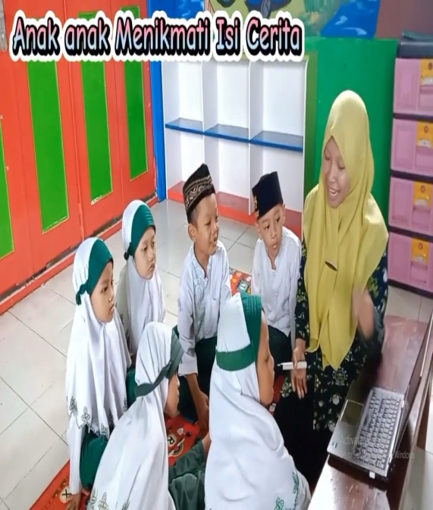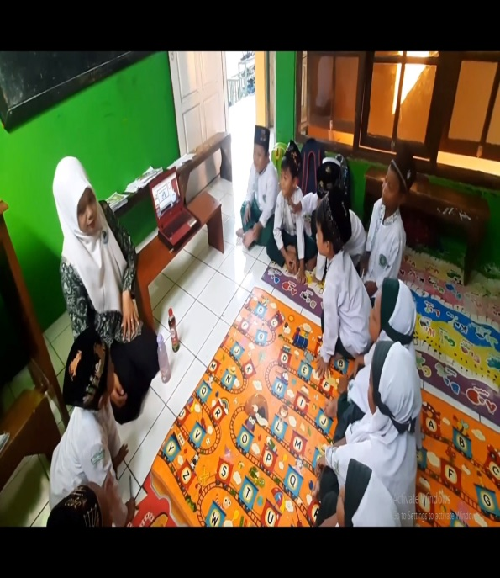



RAMNU NURUL HUDA

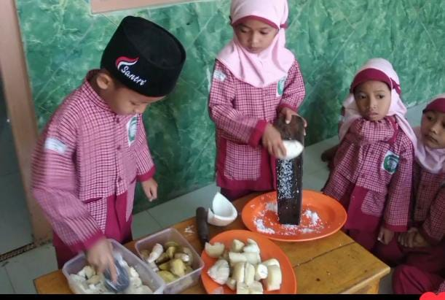

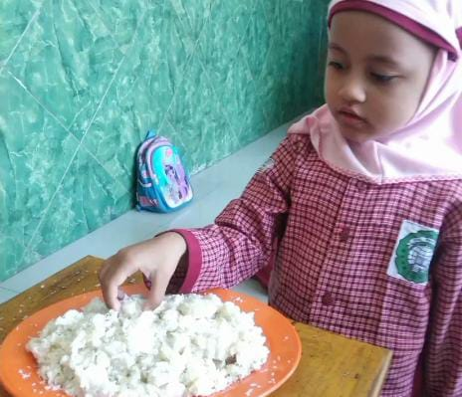

RA ITTIHADUL FALAH



