**PengujianEViews**

**Uji Chou**

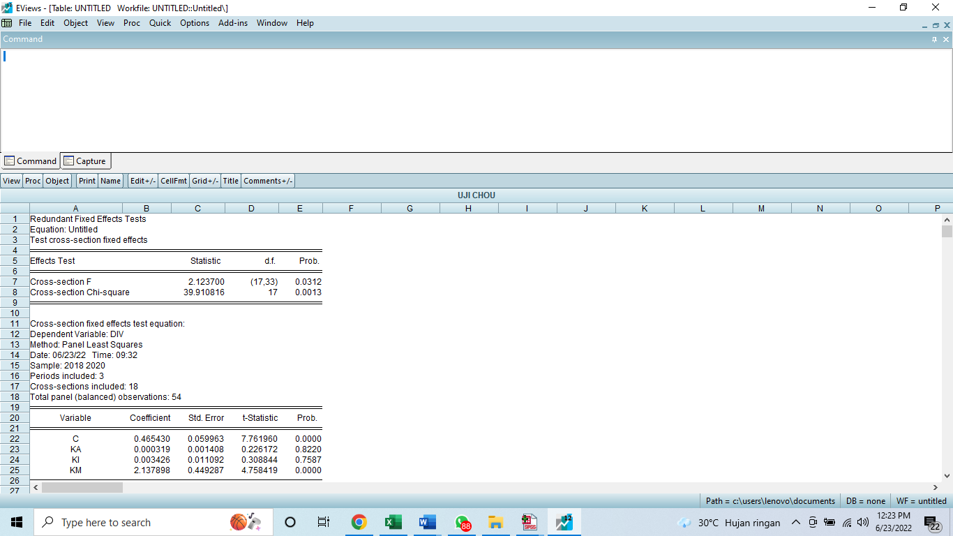

Prob Chi Square nya 0.013 > 0.05 menggunakan CEM

**Uji Lagrange**

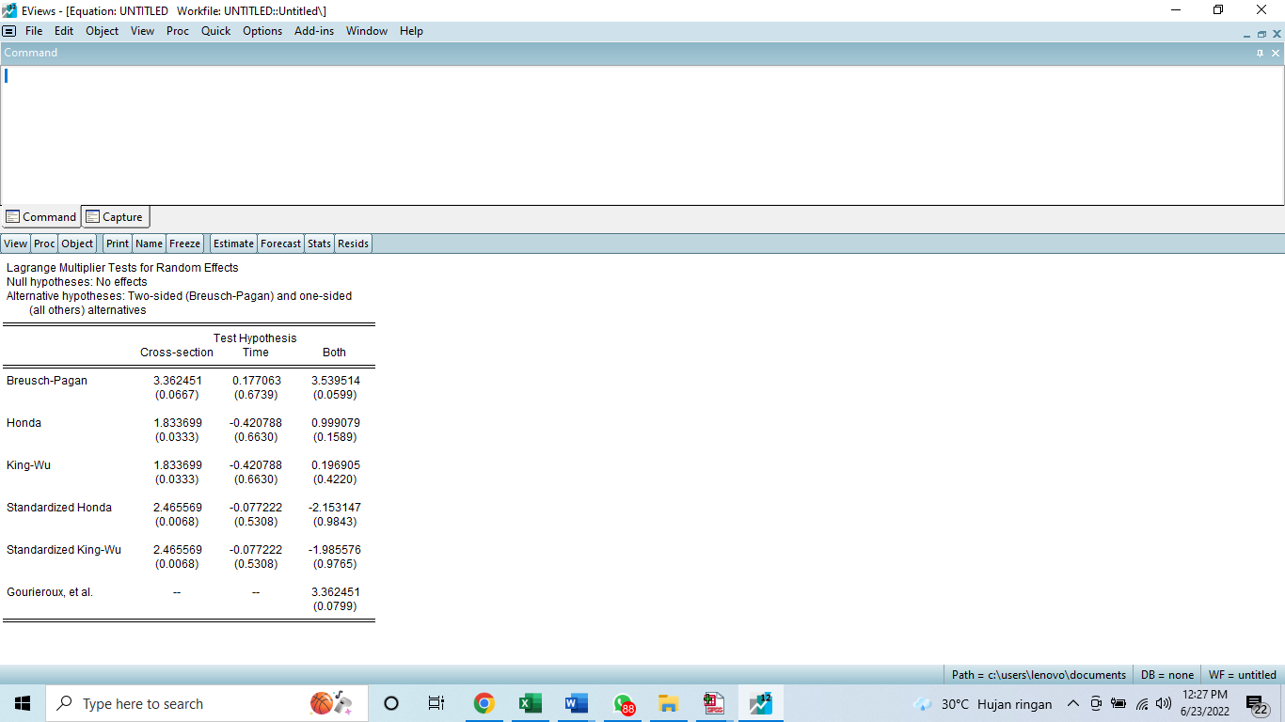

Nilai prob Breusch Pagan 0.6739 > 0.05 menggunakan CEM

CEM tidak memperhatikan dimensi waktu dan indivdu

**Pengujian SPSS ke 2**

**Normalitas**

**One-Sample Kolmogorov-Smirnov Test**

|  |  |  |
| --- | --- | --- |
|  | | Unstandardized Residual |
| N | | 54 |
| Normal Parameters(a,b) | Mean | .0000000 |
| Std. Deviation | .27530503 |
| Most Extreme Differences | Absolute | .116 |
| Positive | .116 |
| Negative | -.067 |
| Kolmogorov-Smirnov Z | | .852 |
| Asymp. Sig. (2-tailed) | | .462 |

a Test distribution is Normal.

b Calculated from data.

Nilai Asymp Sig 0.462 > 0.05

**Multikolinearitas**



Nilai VIF < 10 tidak terdapat multikolerasi

**Coefficient Correlations(a)**

|  |  |  |  |  |  |
| --- | --- | --- | --- | --- | --- |
| Model |  |  | KM | KA | KI |
| 1 | Correlations | KM | 1.000 | .009 | .145 |
| KA | .009 | 1.000 | -.683 |
| KI | .145 | -.683 | 1.000 |
| Covariances | KM | .073 | 2.03E-006 | .000 |
| KA | 2.03E-006 | 7.19E-007 | -3.87E-006 |
| KI | .000 | -3.87E-006 | 4.46E-005 |

a Dependent Variable: RES1

nilai koefesien korelasi < 0.8 tidak multikol

**Heteroskidastisitas**



Niai sig semua variable > 0.05 jadi tidak terdapat masalah hetero

**Uji hipotesis**



KM < 0.05 sig positif terhdap D

Variable lain tidak signifikan

**MRA**

**Coefficients(a)**

|  |  |  |  |  |  |  |
| --- | --- | --- | --- | --- | --- | --- |
| Model |  | Unstandardized Coefficients | | Standardized Coefficients | t | Sig. |
| B | Std. Error | Beta | B | Std. Error |
| 1 | (Constant) | .266 | .119 |  | 2.236 | .030 |
| KA | .001 | .003 | .140 | .433 | .667 |
| KI | .034 | .018 | .502 | 1.851 | .071 |
| KM | 2.980 | .744 | .794 | 4.008 | .000 |
| L | .218 | .127 | .721 | 1.721 | .092 |
| KAxL | -.001 | .002 | -.251 | -.465 | .644 |
| KIxL | -.030 | .011 | -.893 | -2.802 | .007 |
| KMxL | -1.009 | 1.064 | -.200 | -.949 | .348 |

a Dependent Variable: D

KM jadi 0.348 > 0.05 jadi tidak sig

**Uji model**

**ANOVA(b)**

|  |  |  |  |  |  |  |
| --- | --- | --- | --- | --- | --- | --- |
| Model |  | Sum of Squares | df | Mean Square | F | Sig. |
| 1 | Regression | 1.822 | 3 | .607 | 7.558 | .000(a) |
| Residual | 4.017 | 50 | .080 |  |  |
| Total | 5.839 | 53 |  |  |  |

a Predictors: (Constant), KM, KA, KI

b Dependent Variable: D

nilai sig 0.00< 0.05 model diterima

**ANOVA(b)**

|  |  |  |  |  |  |  |
| --- | --- | --- | --- | --- | --- | --- |
| Model |  | Sum of Squares | df | Mean Square | F | Sig. |
| 1 | Regression | 3.031 | 7 | .433 | 7.092 | .000(a) |
| Residual | 2.808 | 46 | .061 |  |  |
| Total | 5.839 | 53 |  |  |  |

a Predictors: (Constant), KMxL, KI, L, KA, KM, KIxL, KAxL

b Dependent Variable: D

nilai sig 0.00< 0.05 model diterima

**Determinan koefesiesi**

**Model Summary**

|  |  |  |  |  |
| --- | --- | --- | --- | --- |
| Model | R | R Square | Adjusted R Square | Std. Error of the Estimate |
| 1 | .559(a) | .312 | .271 | .28344388 |

a Predictors: (Constant), KM, KA, KI

Rsquare 0.312 atau 31.2% variable independent dapat mempengaruhi dependen

**Model Summary**

|  |  |  |  |  |
| --- | --- | --- | --- | --- |
| Model | R | R Square | Adjusted R Square | Std. Error of the Estimate |
| 1 | .720(a) | .519 | .446 | .24707593 |

a Predictors: (Constant), KMxL, KI, L, KA, KM, KIxL, KAxL

Rsquare naik setelah moderasi menjadi 0.519 atau 51.9% variable independent dapat mempengaruhi dependen